Press release

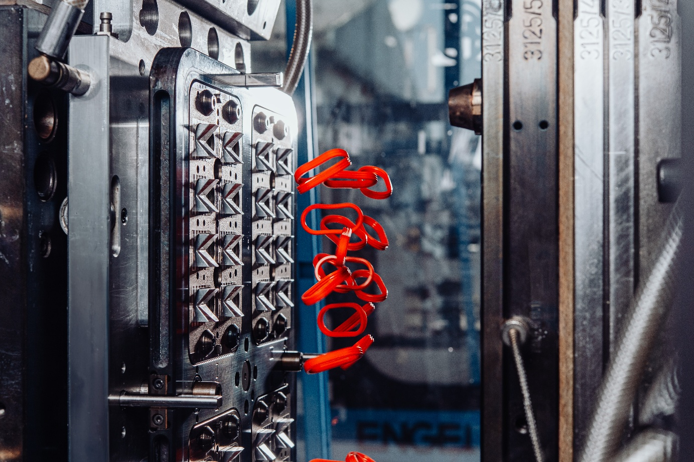
Picture 1: Discover the true potential of silicone elastomers
(Photo: Karin Lohberger Photography)

New international conference on silicone elastomers technology to launch in Munich
SELASTEC will be held on September 1 and 2, 2027. Save the date, book one of the limited exhibition spots, or submit an abstract.
Aachen, November 2, 2026. TEMA AG announces SELASTEC 2027. This new international conference on Silicone Elastomers Technology will take place for the first time on September 1 and 2, 2027, in Munich. Directed by a board of relevant industry experts, the two-day event is aimed at engineers who develop and specify silicone parts, as well as material producers, compounders, processors, equipment suppliers, and mold makers. The conference language is English, and the conference will be held every two years. SELASTEC addresses a gap in the field: silicone elastomers are used in a growing number of applications and megatrends, but dedicated international forums are declining or have recently been discontinued. SELASTEC will focus on applications and processing, prioritizing personal interaction over virtual meetings while maintaining affordable pricing.

Application side sets the direction
The program covers four areas: Processing and Manufacturing, Materials and Innovation, Applications across Industries, and Trends and Outlook. Approximately 30 presentations are planned in a single track, without parallel sessions. Contributions are expected from along the entire value chain, with a focus on processors, tier suppliers, OEMs, and research. The applications discussed will span innovations in both liquid silicone rubber (LSR) and high consistency rubber (HCR) for molding and extrusion, including supporting technologies. Two evening events and an accompanying exhibition area will fuel face-to-face discussions among exhibitors, speakers, and delegates.
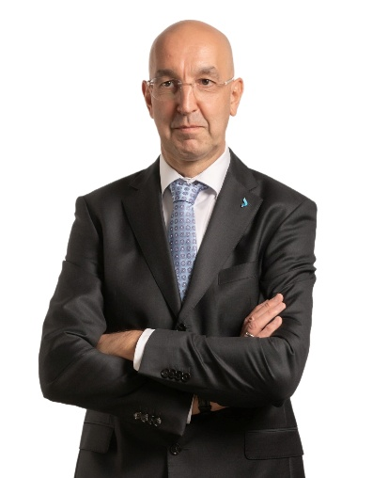  Picture 2: Karl Grossalber, Vice President Marketing & Sales at starlim, is a member of the SELASTEC program committee  (Photo: Starlim Spritzguss GmbH) | “The engineers who design silicone parts often lack the know-how for sustainable application development,” says Karl Grossalber, Vice President Marketing & Sales at starlim, on behalf of the program committee. “Success with silicone elastomers takes expertise in materials, processing, and secondary operations like inspection and assembly. SELASTEC brings experts from across the value chain together for a two-day technical program, without sales pitches.”

Call for Papers is open
Papers can now be submitted through the conference website. The deadline is April 9, 2027. The program committee will review the submissions and decide on the final lineup. The committee includes representatives of the SELASTEC partners: Dr. Gerhard Dimmler (ENGEL), Oliver Franssen (SIGMASOFT), Dr. Ralf-Urs Giesen (UNIpace), Karl Grossalber (starlim), and Dr. Thorsten Häuser (ELMET).

About SELASTEC
SELASTEC – Silicone Elastomers Technology Conference – is an international conference on silicone elastomers technology along the value chain. The first edition will take place on September 1 and 2, 2027, in Munich, Germany. The conference is organized by TEMA Technologie Marketing AG, Aachen, Germany.
Further information: www.selastec.com

Press contact
TEMA Technologie Marketing AG · Svenja Hildebrandt · event@selastec.com · +49 241 88970-314

