Sustainable design of plastic packaging with plastship and RecyClass
plastship offers a Europe-wide proof of recyclability as official certification body of the RecyClass initiative.
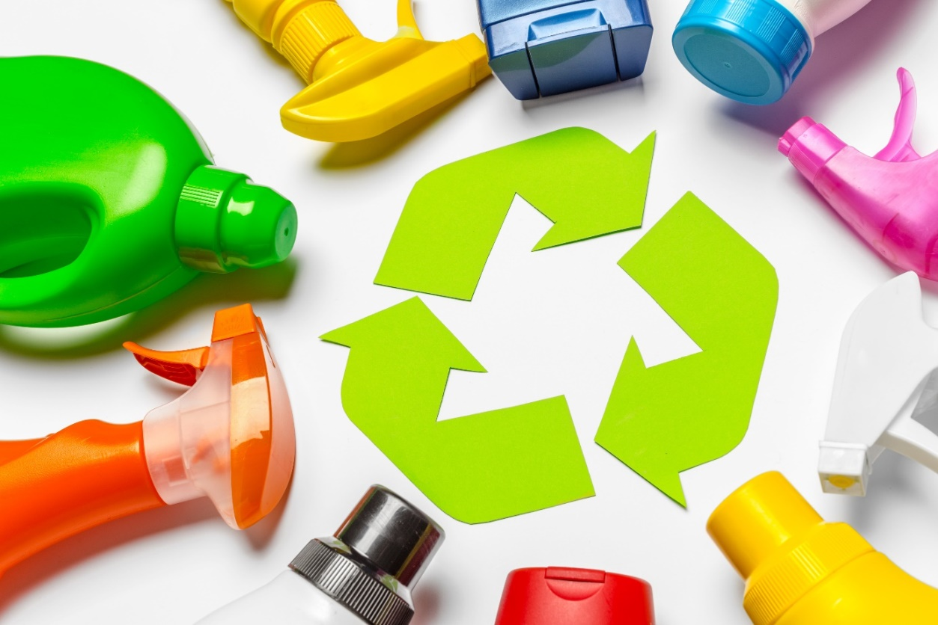
plastship and RecyClass together provide an answer to the question: How well is plastic packaging suitable for recycling? © iStock.com/FabrikaCr
Waldems, September 2020 - - plastship, a platform for the procurement and quality assurance of recycled plastics, and RecyClass, an initiative to improve the recyclability of packaging, combine their offerings. Manufacturers and distributors of plastic packaging can thus meet the growing consumer demand for more sustainability by using RecyClass, an evaluation standard for recyclability developed from the perspective of European plastics recyclers. As a certification body, plastship evaluates and certifies the recyclability of plastic packaging based on the RecyClass method and supports brands and manufacturers in the design of recyclable packaging solutions. For consumers, easily recyclable packaging can be labeled. The result is the classification in a recyclability class (A to F) by certificate, a result report and a logo including certificate number.

Andreas Bastian, founder and managing director of plastship: "When I buy a product, I want its packaging to be recycled. However, up to now I as a customer cannot really tell if a packaging is recycled, and if so, how well. For commercial or private end users, the question of recyclability refers directly to the input quality in recycling. If this improves, the quality of recycled plastics will also improve. This, in turn, determines, if legally possible, their possible uses in new applications. In order to approach the issue of sustainability as a brand, ensuring that the used packaging arrives in the recycling process as a high-quality resource and promotes circular economy is therefore a good first step."

A key figure to promote the circular economy
Recyclability can be the focus indicator for the recyclability and thus for a functioning recycling economy in the field of plastic packaging, if it not only ensures recycling but also simultaneously increases the to be achieved recyclate quality. The challenge is to ensure that reality is reflected in a standard that delivers valid and comparable results, allows a wide range of applications and is scalable. Thus, effects can be felt across regions and the effectiveness of optimization measures can be tracked. This requires an international approach. Since material flows often cross borders and plastics processors and brands are often internationally active, it makes sense to pursue a European standard in the assessment of recyclability. This will make it easier for all players to orient themselves towards an assessment basis for the joint pursuit of sustainable goals and the promotion of the recycling economy for plastic packaging.
A European standard for the assessment of recyclability
For Bastian, RecyClass is "the most promising instrument to create a comprehensive, EU-wide standard for the assessment of recyclability and thus provide clarity to plastics converters, brand owners and end users regarding recyclability". The 2019 initiative brought together various players in the plastic packaging value chain to create uniform guidelines for the Design for Recycling, a standardized assessment method and test protocols for evaluating the recyclability of plastic packaging and new packaging technologies on the European market.
During a test, specifications from manufacturers are collected and analyzed using an online tool. Accredited auditors confirm the results by means of defined analyses and issue a certificate. The data and information on the collection, sorting, separability and recycling of packaging are considered EU-wide. They are systematically examined using realistic criteria and practical recyclability is proven. In addition, the reasons for an evaluation are explained in a comprehensible manner and alternatives and best practices are communicated. Possible conflicting objectives between recyclability and the functions of the packaging are taken into account.
Sustainability - far more than just a marketing aspect
The sustainability of packaging is increasingly becoming an economic necessity for Bastian. "Already today, sustainable management and the use of recyclable packaging are key elements in the corporate strategy of many brands. Through packaging, companies can visibly implement sustainability measures and communicate them to their customers. Many industrial companies are also orienting themselves towards new sustainability goals, which are leading to supply chains being optimized and thus to previous packaging solutions being reconsidered. Ultimately, the importance of the circularity of a product and packaging will continue to increase with regard to sustainability. Recyclability provides the reliable key figure for alignment with the circular economy. The establishment of recyclable packaging is an elementary step towards achieving sustainability goals.“

RecyClass is a comprehensive cross-industry initiative that works to advance plastic packaging recyclability within Europe. RecyClass assesses recyclability and provides specific recommendations on how to improve packaging design to fit current recycling technologies. Activities within RecyClass include the development of Recyclability Evaluation Protocols and testing of innovation materials. Findings are used to update the RecyClass Design for Recycling guidelines and the online free tool.
Press contact: Mireia.Boada@plasticsrecyclers.eu, www.recyclass.eu
plasthip is a subsidiary of RIGK GmbH, a German recycling scheme operator with more than 25 years of experience in plastics recycling, offering digital services to make plastics more circular. The company is providing a service network to increase plastics recyclate uptake and to foster European circular economy. It addresses three major challenges: To simplify procurement with fitting plastics recyclate qualities by use of a digital platform, to assess and to optimize the recyclability of products and packaging, and to create individual recycling concepts involving the recycling services of the network. By combining digital approaches with a maximum of service orientation, plastship is a project partner for business customers, helping to structure, to perform, and to communicate activities regarding plastics recycling and the use of plastics recyclates.

Further information:
Andreas Bastian, plastship GmbH
Auf der Lind 10, 65529 Waldems
Tel.: +49 (0) 6126/58 980-12, Mobil: +49 (0)151/42 10 10 53
bastian@plastship.com; www.plastship.com
Editorial contact and voucher copies:
Philipp Lubos, KONSENS Public Relations GmbH & Co. KG
Im Kühlen Grund 10, D-64823 Groß-Umstadt
Tel.: +49 (0) 60 78/93 63-12, Fax: +49 (0) 60 78/93 63-20
mail@konsens.de; www.konsens.de
This press release as a Word file in German and in English together with the photo in print-ready resolution can be downloaded from: https://www.konsens.de/plastship

