Kraton, Chemetall and Baerlocher unlock opportunities to improve recyclate performance with plastship’s Additive Selector

- Towards higher-performance recyclates with the Additive Selector -

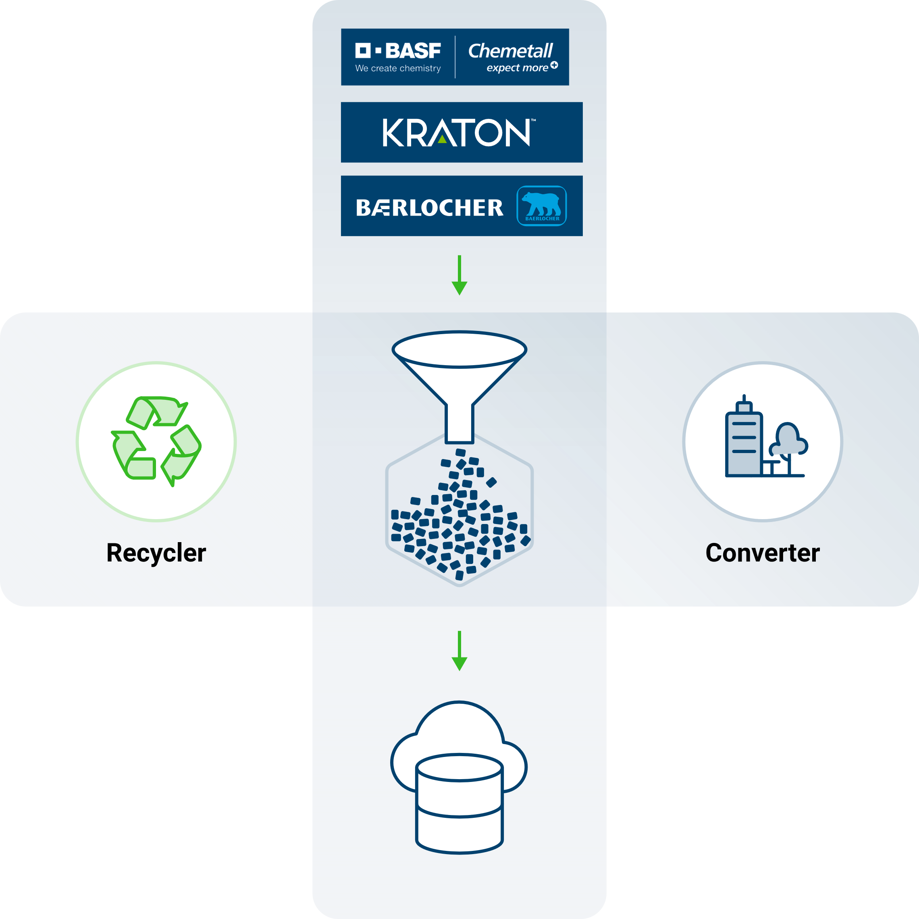

A new digital service developed by plastship in cooperation with Kraton, Chemetall and Baerlocher provides an overview of the interaction between recyclates and additives. With the additives being offered, the properties of recycled plastics can be improved and thus be used for higher-value applications. With the new addition to plastship's offering, the Additive Selector on plastship.com, combines data on recyclates and additives to facilitate the use of recyclates. © 2021 plastship GmbH

plastship, a leading European platform for recyclate procurement, is expanding its offerings to facilitate plastics converters' use of recyclates in high-value applications by refining plastic recyclates with additives from selected partners. In addition to design for recycling and sortation technology, improving recyclate quality and performance is critical for increasing recyclate usage in the future. Performance enhancing additives designed for the circular economy help improve recyclate quality and processability, and preserve recyclability for multiple reuse cycles.

Additive effects at a glance

The Additive Selector on the plastship portal provides an overview of the effects of various additives, and offers producers and users of recycled plastics indications of potential performance improvements through the use of additives. "The new feature offers our customers a variety of additives to choose from that can improve the material performance for a selected recyclate and predicts the properties of the material-additive combination. " says Andreas Bastian, Managing Director of plastship.

The Additive Selector includes a comprehensive customer engagement approach. All requests via plastship are directly handled by the additive partners. To meet specific end-use performance objectives and individual requirements for the end application, it is possible to contact specialists from the additive manufacturers via the Additive Selector.

Creating value for plastics circular economy

One of the main challenges in plastics recyclates is material performance and quality fluctuations, which is inhibiting the use of recycled resins. Material quality in plastics recycling is greatly dependent on the quality of the input material and the type of process used in recycling. For a circular economy, it's pertinent that recycled raw materials can be reused again. Here, additives can play a crucial role in developing recycled raw materials that fit application requirements, enabling usability, increasing the value of recyclates, and ensuring their circularity.

"By recombining business intelligence of two quite complex areas – additive effects and data on recycled plastics – and choosing a digital approach, the Additive Selector and the involved partners provide easy orientation for producers and users of plastics recyclates. The collaboration creates new opportunities for material streams, which might not fit a desired application until now, and enables improved recyclate quality and new recipes. In the future, the data-based approach help make opportunities visible, predict additive effects, and recommend solutions based on best practices and formerly solved challenges in recyclate quality for the benefit of the industry. It was a pleasure to develop the Additive Selector together with leading industry experts as partners and it won’t end there. We will continue working on a project basis to actively address recyclate uptake. We will also create validated performance enhancement data to feed the system, going from analysis to prediction, possibly with AI. We see these collaborations as long-term partnerships and only the beginning of a very promising journey." Bastian states.

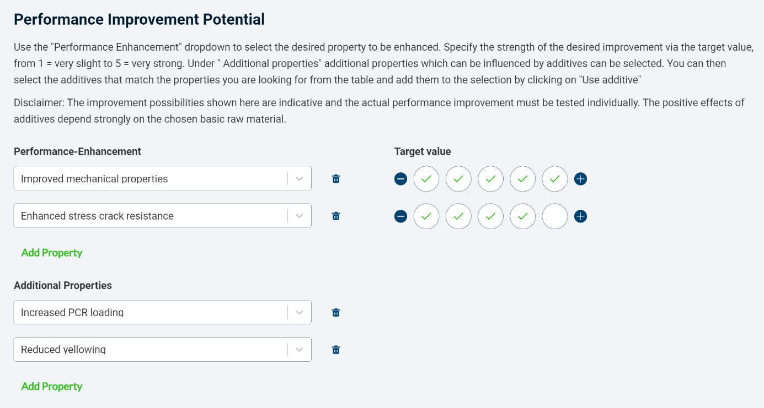
The Additive Selector lists additives that match a selected material based on the desired performance improvement © 2021 plastship GmbH

Partners provide expertise for additives to improve recyclate performance

With a holistic approach to the end of the product lifecycle, Kraton’s CirKular+ product line enables plastics upcycling and circular economy solutions by facilitating compatibilization and performance enhancement of versatile multi-resin post-consumer (PCR) and post-industrial (PIR) plastic waste streams in various applications. “I’m excited about the Kraton collaboration with plastship to promote CirKular+™ solutions for plastics upcycling and circular economy. Industry collaborations like these are key to making a positive difference on our path to enhancing circularity.“ says Specialty Europe Sales Director, Anissa Brahmi.

The Surface Treatment global business unit of BASF's Coatings division, operating under the Chemetall brand, offers integrated cleaning agents to optimize the quality, productivity and safety of plastics recycling processes. Carlo Bouwmeester, Global Segment Manager Plastics Recycling at Chemetall, comments as follows: "The development of plastship's unique additive selector puts the needs of the market into focus. Together, we are working to create new business models and shape sustainable material cycles through innovative solutions.”

With its global production sites and long experience in the field of plastics, Baerlocher individually develops tailor-made solutions to support its customers to deliver the quality and sustainability needed by their customers. Andreas Holzner, Head of Business Unit Special Additives, explains: „Working with technology companies, polymer producers, recyclers, converters and brand owners, Baerlocher successfully supports its customers in upcycling of post-consumer and post-industrial wastes. Connecting all these industry players via plastship as digital platform, we expect to accelerate the development of tailor-made additive solutions enabling real circular product streams. Here the Additive Selector helps visualize opportunities for all players along the value chain."

The Additive Selector is now online at plastship.com. More information is also available at PRSE 2021 in Amsterdam, stand J13.

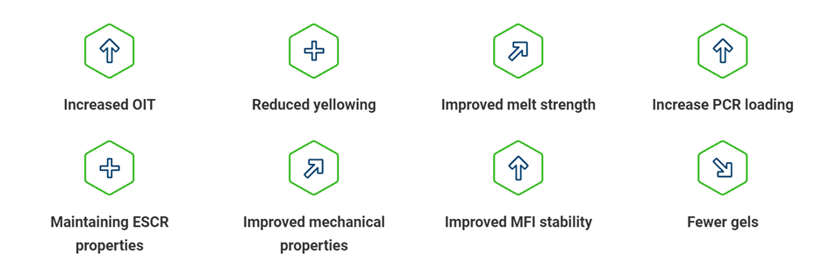

Achievable performance increases through the selection of a material-additive combination (exemplary) © 2021 plastship GmbH

The Additive Selector cooperation partnership is committed to enabling:
- Data-driven performance enhancement opportunities for plastics recyclates and recyclables,
- Evaluation of recyclate performance enhancements and product reformulation and development projects,
- Increased recyclate use by improving the ability for recyclates to meet target specifications across various applications.

Kraton is a leading global producer of styrenic block copolymers (SBC) and pine chemicals. Our global footprint, reliable supply, extensive expertise and integrated portfolio of high-quality products enable our customers to push the boundaries of performance to power the future of innovation. Kraton has more than 800 customers across a diverse range of end markets in over 70 countries worldwide. The CirKular+™ product line enables a holistic approach to the plastic product life cycle and the circular economy.
Press contact:
Media Inquiries: Mariam Ottun; T: (281) 504 2574
Investor Relations Contact: Gene Shiels; T: (281) 504-4886

The Surface Treatment global business unit of BASF's Coatings division, operating under the Chemetall brand, is a leading supplier of applied surface treatment technologies for metal, plastic, and glass substrates. For the field of plastic recycling, Chemetall develops solutions for sustainable cleaning processes.
Press contact: Jessica Giordano, T: (069) 7165 3155, E-Mail: jessica.giordano@basf.com

The Baerlocher Group of Companies is one of the leading suppliers of additives for the plastics industry and looks back on a history of over 190 years. The family-owned group employs more than 1,150 employees in its production sites and joint ventures which are strategically located around the globe in all key markets for plastics processing. Metal stearates are fundamental as acid scavengers for the production of polyolefins and serve as the backbone of our Special Additive portfolio. Combining Baerlocher’s proprietary resin stabilizer technology with lubricants and additional functional additives, Baerlocher adds value along all steps of the plastic processing chain, as well as offering innovative solutions for the rubber, construction and lubricant industries.
Press contact: Baerlocher.info@baerlocher.com

plastship is a subsidiary of RIGK GmbH, a German recycling scheme operator with more than 25 years of experience in plastics recycling. The company is providing a service network to increase plastics recyclate uptake and to foster European circular economy. It addresses three major challenges: To simplify procurement with fitting plastics recyclate qualities by use of its digital platform, to support quality assurance processes with its digital system, and to assess and optimize the recyclability and the recycled content of products and packaging. By combining digital approaches with a maximum of service orientation, plastship is a project partner for business customers, helping to structure, to perform, and to communicate activities regarding plastics recycling and the use of plastics recyclates.
Press contact: Andreas Bastian - bastian@plastship.com, www.plastship.com

Further information:
Andreas Bastian, plastship GmbH
Auf der Lind 10, 65529 Waldems
Tel.: +49 (0) 6126/58 980-12, Mobil: +49 (0)151/42 10 10 53
bastian@plastship.com; www.plastship.com

Editorial contact and specimen copies:
Philipp Lubos, KONSENS Public Relations GmbH & Co. KG
Im Kühlen Grund 10, D-64823 Groß-Umstadt
Tel.: +49 (0) 60 78/93 63-12, Fax: +49 (0) 60 78/93 63-20
mail@konsens.de; www.konsens.de
You can download this press release as a Word file and the graphics in printable quality at: https://www.konsens.de/plastship

