plastship 2.0 closes the loop for recycled plastics
Creating new connections and simplifying recycled plastics use
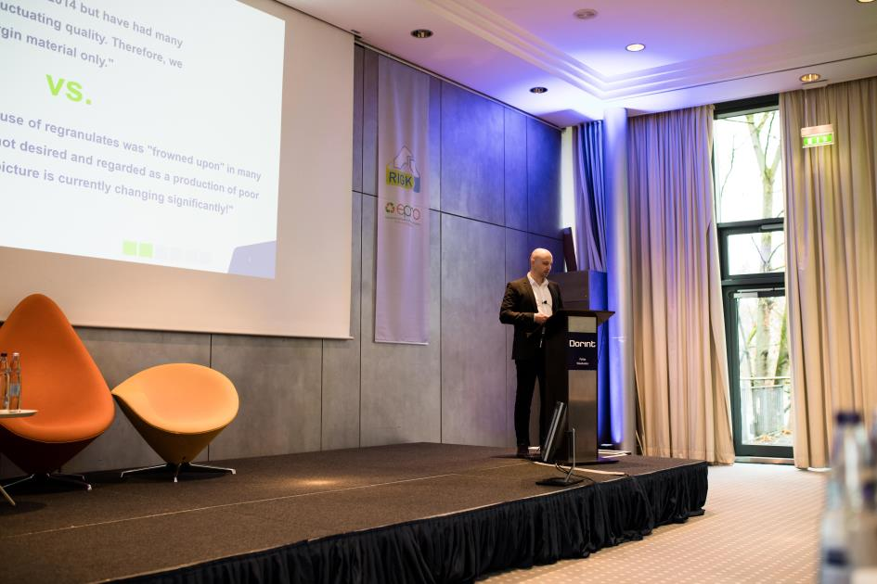
There was considerable interest in plastship's offer at the Recycling Forum in Wiesbaden; © plastship
Waldems, December 2019 - - A joint approach gets the best out of plastics recycling and needs to be transparent if use of recycled materials is to increase. About that, everyone was in agreement at the International Recycling Forum in Wiesbaden. 120 delegates from 22 countries representing businesses, associations and academia met up in late November 2019. It is, however, often not straightforwardly possible to replace or supplement virgin material with recycled pellets since no comparable data about their service and moulding characteristics is available. Networks capable of sourcing standards-compliant materials can help out here. Andreas Bastian is the Managing Director of plastship, a young company whose principal shareholder is RIGK GmbH. Bastian and Co-Managing Director Konstantin Humm took this as their starting point for developing concepts for boosting the use of recycled materials.
Data exchange, standards and structure fundamental to recycled pellet use
Bastian explains where stumbling blocks often still remain in the way of recycling plastics: "There are many good approaches to collecting plastic scrap from various sectors and to establishing closed loops. Some improvements are also being made in terms of the quality of post-consumer recycled materials. But we still haven't arrived at uniform standards in terms of grades or created a transparent market for recycled materials."
According to Bastian, information is primarily what is missing. All too often, there is a quality and information gap between application and recycled raw material and there is no uniform way of making comparisons with virgin material. "The recycled pellets which are currently commercially available have, by definition, all already been used once. If the application is now to be changed, new and different requirements apply", is how Bastian explains the problem.
plastship connects businesses
plastship's offer plugs this gap between recycled material manufacturers and processors. Bastian explains the advantages: "We offer manufacturers of recycled material a sales tool with the possibility of performance analysis, while, for purchasers of recycled materials, we simplify procurement and enable comparisons. Our platform provides details about recycled plastics in a standardised form and gives an overview of which recycled pellet grades are suitable for specific applications, so processors can quickly and reliably find what they're looking for. If necessary, we can have technical parameters checked by our partners in polymer analysis."
Bastian and Humm have adopted specifications in their nomenclature which only apply to recycled materials. Humm outlines the advantages: "Recycled pellet manufacturers can, for example, promote their products by particular features in the process while polymer processors can assess the quality of a raw material. We can, of course, provide personal advice and for instance obtain approvals and conformity certificates." The company's founders are currently drawing up standard grades for recycled pellets on the basis of real market data.
Comprehensive range of services benefits entire recycling sector
But plastship's offer does not stop there. Plastics processors can, for example, also market their recyclable materials or surpluses directly to recyclers. Offers for specific services, such as converting recyclable materials into recycled pellets or toll grinding can be generated via calls for proposals. Offers for individual raw material preparation or for carrying out audits can also be obtained via the platform. All the stated functions will be available to every user from version 2.0 of the platform, which will be launched in early 2020.
plastship can also assist its customers with recycling-friendly product design: "We can offer services independently of the platform", explains Bastian: "We can certify and optimise packaging and product recyclability in a scalable and standardisable assessment method which includes the minimum Central Agency Packaging Register (ZSVR) standard and is in the process of being certified by TÜV. Our seal is a way of communicating successes to customers."
"Our intention is to create sustainable resource loops", is how Humm outlines future developments. "RIGK, our principal shareholder, has been creating loops in the plastics sector for 25 years. This means we can use the network and integrate RIGK services in order to develop individual recycling solutions for our customers and so make material flows traceable and establish resource loops. In 2020, we aim to develop into a fully self-sufficient model with the possibility of direct links with our users and to integrate some further functions and automated features. We will, of course, continue to act on feedback so we stay as customer-focused as possible."
Further information:
Andreas Bastian, plastship GmbH
Auf der Lind 10, 65529 Waldems
Tel.: +49 (0) 6126/58 980-12, cellular: +49 (0)151/42 10 10 53
bastian@plastship.com; www.plastship.com
Editorial contact and voucher copies:
Philipp Lubos, KONSENS Public Relations GmbH & Co. KG
Hans-Kudlich-Straße 25, D-64823 Groß-Umstadt
Tel.: +49(0) 60 78/93 63-13, Fax: +49(0) 60 78/93 63-20
mail@konsens.de
This press release as a Word file in German and in English together with the photo in print-ready resolution can be downloaded from: http://www.konsens.de/plastship.html

