Recycling with active product stewardship:
pekutherm’s rPC is climate-neutral
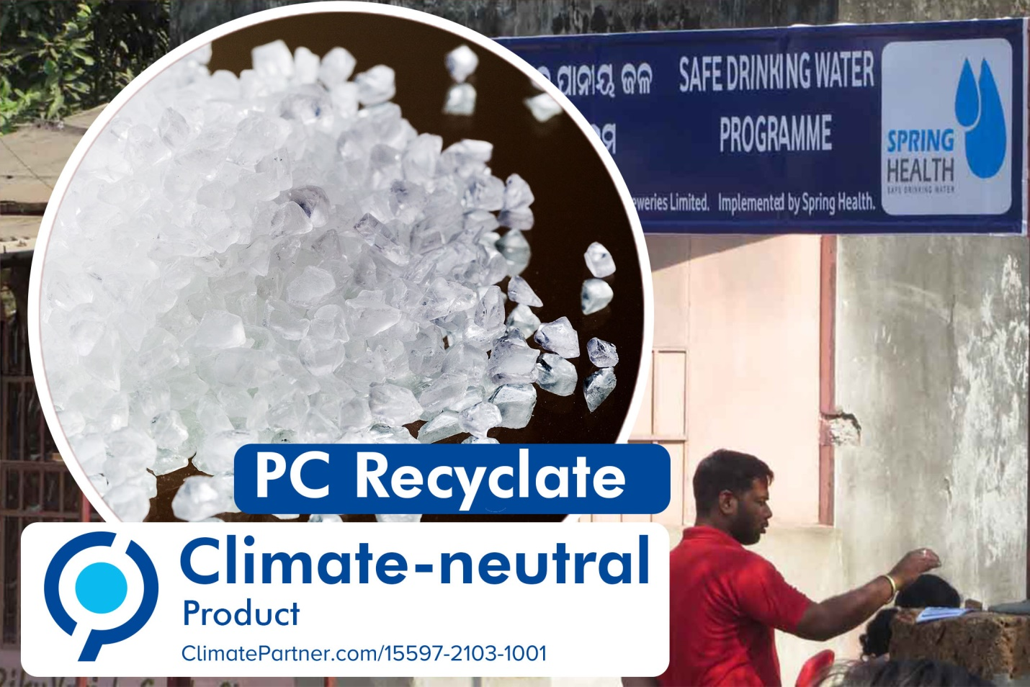
Thanks to climate protection projects in India, pekutherm's recycled polycarbonate has been awarded a “climate-neutral” certificate. © pekutherm
Geisenheim/Germany, May 2021 – pekutherm GmbH, a specialist recycler of acrylic sheet (PMMA) and polycarbonate (PC) scrap, is working toward complete climate neutrality. Although many climate protection measures have already been put into practice, factors such as raw materials, packaging, logistics and disposal continue to generate CO₂ emissions which it has not so far been possible to avoid. Working with the consulting firm ClimatePartner, pekutherm has worked out that, just for the PC line, this product carbon footprint adds up to 33,640 kg of CO₂ over the course of a year. Pekutherm is offsetting this by supporting a recognized climate protection project in India, which is certified according to international standards and saves this amount of CO₂. This means its recycled PC can be labeled “climate-neutral”. Preparatory work is currently under way to support a climate protection project in Germany, also registered with ClimatePartner, for its recycled PMMA.
The aim of the climate protection project supported by pekutherm, “Clean drinking water Odisha, India”, is to eliminate the need for the open fires used throughout rural areas to boil and so sterilize contaminated water. The resultant smoke causes respiratory disease while the consumption of large volumes of firewood leads to the increasing deforestation of entire regions and the release of large amounts of CO₂ and other greenhouse gases. The project organizes water treatment, by both mechanical filtration and chemical purification using a chloride solution produced on site. The treated water is available at low cost in small village shops or is delivered to homes.
As Managing Director Heiko Pfister explains, “For over three decades, pekutherm has been helping other companies produce resource-efficiently by reusing natural resources. Our operational procedures are designed to be environmentally friendly and we use 100% green electricity. Wherever possible, we avoid CO₂ emissions from our recycled material manufacturing operations. By supporting climate protection projects to offset any remaining CO₂ emissions which it has not so far been possible to avoid, we are taking a major step on our way to becoming a climate-neutral company. After all, it ultimately makes no difference to the climate where greenhouse gases are released into the atmosphere and where emissions are reduced. What is important is that global emissions go down overall.”
pekutherm Kunststoffe GmbH, Geisenheim/Germany, a certified waste management company, collects post-production polycarbonate (PC) and acrylic sheet (PMMA) scrap from semi-finished product processors via a pan-European collection system and then, using a special process, reprocesses the scrap into pure, high-grade recycled materials. The company’s core workforce of some forty employees and its six high-precision blade granulators reprocess over 5,000 metric tons of recyclable plastics each year. The crystal-clear PC and PMMA recyclates produced by pekutherm combine purity, cleanliness and unclouded brilliance with processing characteristics equivalent to virgin material.
Further information:
Heiko Pfister, pekutherm GmbH
Chauvignystraße 19, D-65366 Geisenheim
Tel.: +49 6722 937703-0, email: info@pekutherm.de
For voucher copies and editorial queries, please contact:
Dr. Jörg Wolters, Konsens PR GmbH & Co. KG
Im Kühlen Grund 10, D-64823 Groß-Umstadt
Tel.: +49 (0) 60 78/93 63-13, email: mail@konsens.de
This press release as a Word file together with the photo in a print-ready version can be downloaded from: https://www.konsens.de/pekutherm

