1997-2022 – Distributor KUNSTSTOFFEXPRESS Celebrates 25th Anniversary
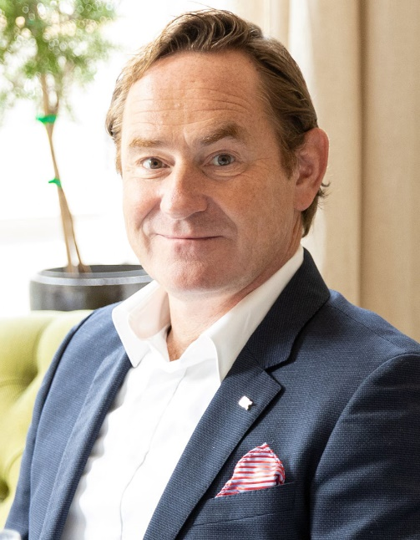 | Marcus Mahnecke has developed KUNSTSTOFFEXPRESS Handel GmbH, which he founded in 1997, from an ordinary commercial agency into a major distribution and trading company turning over some 50,000 tonnes of stock each year  © KUNSTSTOFFEXPRESS
Bielefeld, Germany, June 2022
KUNSTSTOFFEXPRESS Handel GmbH (KX) can look back on 25 years of successful trading. Back in 1997, Marcus Mahnecke, owner and Managing Director, founded a sales agency under this name on the site of the company headquarters in Bielefeld. Today, the company also has a service and logistics center in nearby Löhne, which came on-stream in 2020 and has warehouse capacity of over 5,000 tonnes, as well as six sales offices, eight additional forwarding warehouses with up to 20,000 slots and various home offices in the D-A-CH region. With twenty-seven staff and an annual trading volume of 50,000 tonnes, KX is now one of the ten largest distributors in the German-speaking world. The company is divided into the business units Distribution, International Trading, Healthcare, Special Compounds and Reprocessed Products. Its product portfolio, some under exclusive supply agreements, includes polyolefins, styrene and engineering polymers from global raw material manufacturers, compounds from Repsol and Ravago, together with compounds and recompounds produced in-house.
As Mahnecke explains, “From the very outset, consistently applying our industry expertise has meant we’ve been able to help our customers select and efficiently process the right materials for their applications and that’s been the key to our continuous growth. One example of the esteem in which we are held is the vote of confidence from the Spanish company Repsol Quimica, which in 2021 entrusted us with distributing its polyolefins for the highly demanding healthcare sector throughout Germany. Long-established relationships with our suppliers and customers mean we’re confident that KX’s growth curve will maintain its upward trend even in the face of the current, tense situation in the raw materials sector. Our aim is accordingly to break through the 60,000 tonne mark in German-speaking countries in 2022. Our course is set and we’re looking forward to the challenges ahead.”
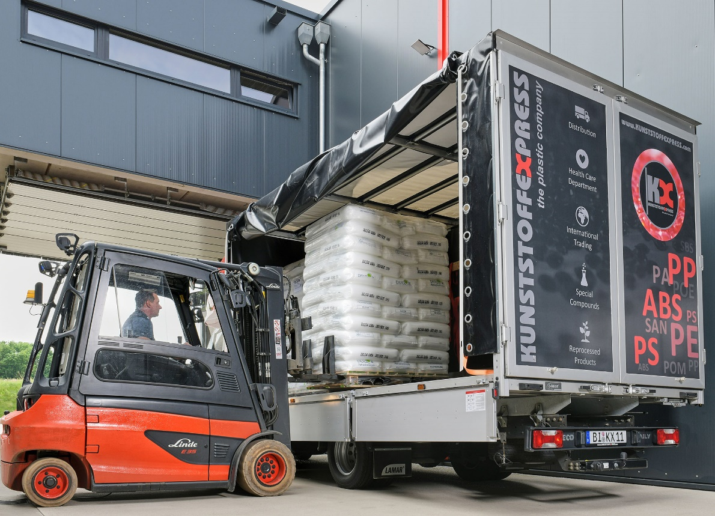
With its own trucks, KX delivers to its customers within 24 hours in the event of bottlenecks. © KUNSTSTOFFEXPRESS
Polyolefins, Engineering Polymers, Compounds and Recompounds
Apart from the broad range offered by Repsol Quimica, KX’s polyolefin portfolio also includes PE and PP grades manufactured by Carmel Olefins (Israel), LG Chem and Ducor Petrochemicals (Netherlands). Engineering polymers are also supplied by LG Chem and by Formosa Plastics Corporation (POM). KUNSTSTOFFEXPRESS Prime grades include PA 6, PP compounds, PP GF- and mineral-filled grades as well as electrically conductive and carbon black compounds. KUNSTSTOFFEXPRESS Recompounds range from ABS via PE, PP, PS and PP mineral-filled grades to moisture absorbers. Flame retardant, UV stabilized, antistatic, black, white and color masterbatches from Tosaf fill out the range.
In addition to virgin materials, recycled products have been a significant focus for over 20 years. KUNSTSTOFFEXPRESS markets over 20,000 tonnes of ABS, PS, PP and PE recompounds every year – a volume corresponding to annual CO₂ savings in excess of 35,000 tonnes. This makes the company one of the largest suppliers to this market and is how it contributes to protecting the environment.
The Trading business unit’s network of over forty PS, PP and PE manufacturers offers customers access to a still wider range of products and KX an opportunity for further growth.
Please send voucher copies and editorial queries to:
KUNSTSTOFFEXPRESS Handel GmbH
Patricia Rieke
patricia@kunststoffexpress.de
+49 521/9678921
This press release as a Word file can be downloaded from: https://www.konsens.de/en/press-releases/kunststoffexpress-handel-gmbh

