NEO 2 from iDTRONIC with HID and VCP for IoT applications:
New RFID desktop reader captures data automatically and contactlessly
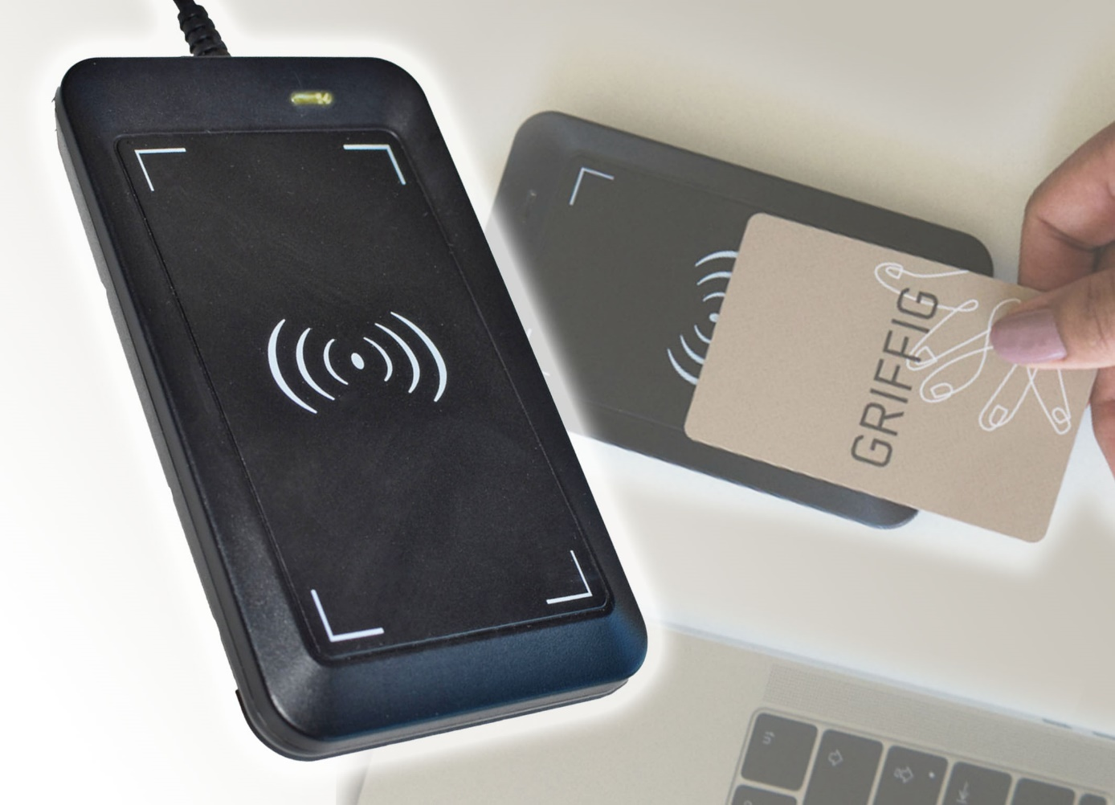
iDTRONIC’s compact NEO 2 RFID reader NEO 2 was developed for desktop use in IoT environments. Typical applications include points of sale, single sign on (SSO) authentication, vending machines, time and attendance, access control and document management. © iDTRONIC
Ludwigshafen/Germany, March 2022 - NEO 2 is a new, compact RFID reader from iDTRONIC for desktop use that has been specially developed for IoT environments in the cloud network. A USB 2.0 interface enables easy integration via plug and play into existing systems with immediate readiness for use. The device is available for the RFID HF/NFC (13.56 MHz) and LF (125 kHz) ranges, as well as for both ranges combined, and can read parts of the user memory in addition to various UID formats (serial numbers). NEO 2 is certified according to RoHS 2 and REACH.
Typical areas of application include businesses as well as retail, telecommunications, banking, and healthcare, where NEO 2 can be used, for example, at points of sale (POS), for single sign on (SSO) authentication, at vending machines, in time and attendance, access control and document management.
Increased flexibility when reading out and reading in data
A special feature in this segment is the increased flexibility in reading out and reading in data. Data output via NEO 2’s USB port can be configured with the help of the supplied software development kit for Windows systems. NEO 2 can operate in either VCP mode (virtual serial port) with full read and write access or HID mode (human machine interface).
- HID mode is a keyboard emulation mode that provides read-only access to user data and is especially suitable for web applications in heterogeneous IT cloud environments. The reader validly reads serial number formats, membership numbers, names and other data. Both the transponder serial number (UID) and the user memory can be selected for HID output. The reader supports output formats such as HEX (MSB), DEC (MSB), HEX (LSB), DEC (LSB) or ASCII.
- In VCP read-write mode, the unit can be controlled with a USB driver on various Windows operating systems. Operation under Linux and other operating systems can also be configured. The supplied software allows cards to be easily written with unique user IDs, membership numbers and membership data. The Software Development Kit (SDK) contains programming examples and a serial protocol for easy integration into customized software.
RFID antenna for RFID tag identification
Using the integrated RFID antenna, NEO 2 can read 98% of commercially available RFID transponders in the HF/NFC as well as in the LF range. It supports HF transponders of the ISO standards ISO/IEC 14443A/B, ISO 15693 and ISO 18000-3M3 and can read and write RFID tags with MIFARE® Classic, MIFARE® DESFire, NTAG, EMxxxx and I-Code ILT-M. Support for Google's Wallet & Apple's NFC Wallet is currently under development. The LF technology reads tags with RFID chip EM4200 and can write and read Hitag-1 and Hitag-S chips. Depending on tag orientation and transponder type, the reading range is up to 3 cm in both frequency ranges. An integrated buzzer and an LED display indicate successful tag communication.
Application example Intranet logon in a company network
When using iDTRONIC’s NEO 2 USB RFID reader, it is possible to ensure that only authorized staff can log on to PCs and terminals, so meeting an essential requirement of the latest data protection regulations. The member of staff identifies themselves with an RFID transponder or an RFID card directly at the desktop reader. Only after successful tag communication is access to internal company data and drives provided, which is indicated by the integrated buzzer and the red LED signal.
iDTRONIC GmbH, Ludwigshafen/Germany, was founded in 2003 and is now a leading global supplier of innovative RFID products. Its core competence is the development and manufacture of high-performance RFID reader hardware. Its innovative RFID products guarantee fast and secure identification for a wide range of applications. They meet all the requirements of system integrators and developers by serving the common RFID standards UHF (868 MHz), HF / NFC (13.56 MHz) and LF (125 kHz).
www.idtronic-group.com

Further information:  Patrick Kochendörfer  Senior Product Manager  – Professional RFID –  Tel.: +49.621.66900 94–21  patrick.kochendoerfer@idtronic.de | Editorial contact  and please send voucher copies to:  Dr. Jörg Wolters, Konsens PR  Im Kühlen Grund 10, D-64823 Groß-Umstadt  Tel.: +49.6078.9363-13  joerg.wolters@konsens.de
This press release as a docx file as well as the picture in printable resolution can be downloaded from https://www.konsens.de/en/press-releases/idtronic-gmbh

