Tunnel gate inserts at the focus of the new i-mold
Hot runner systems supplement portfolio
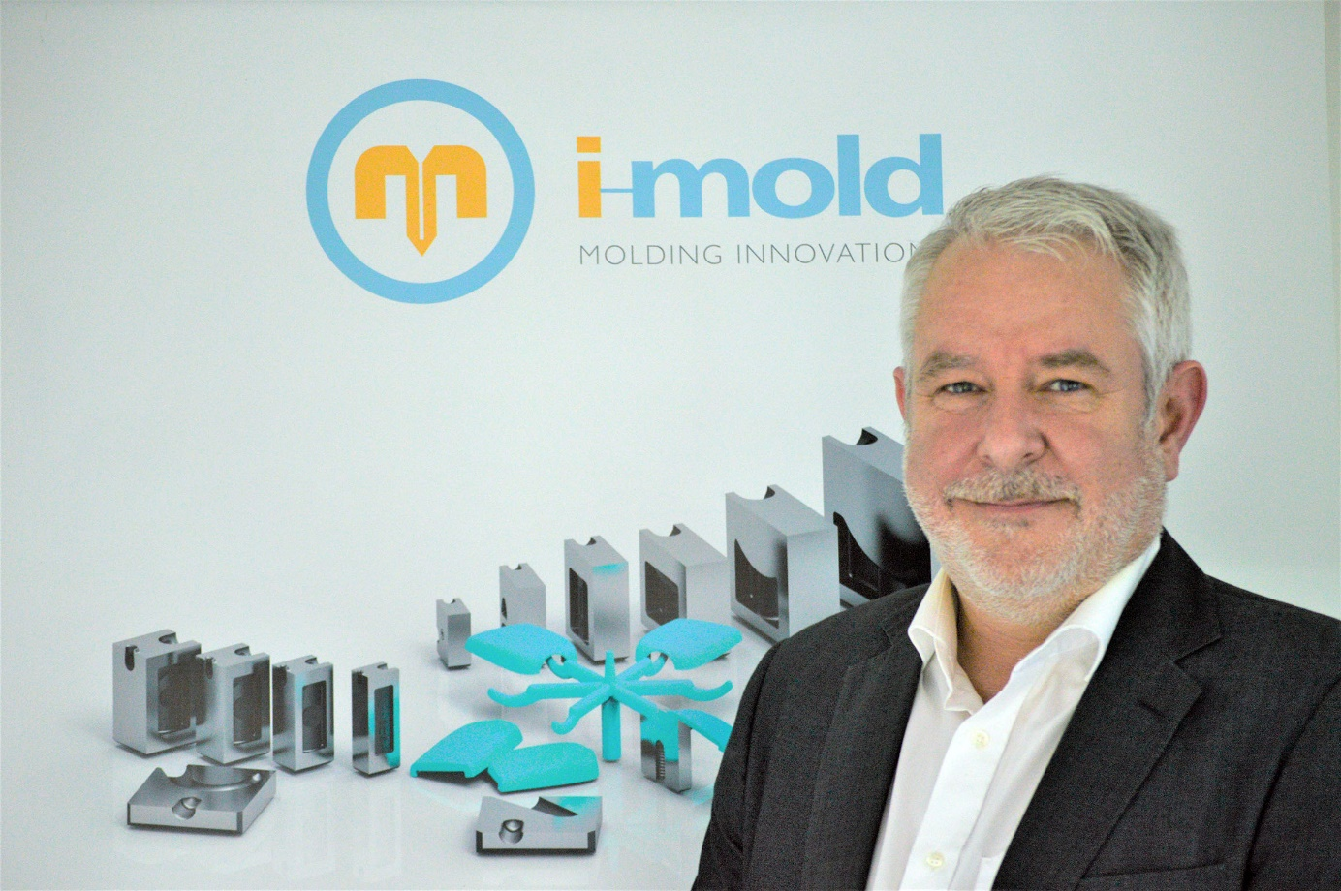
Andy Walter, CEO of the new i-mold company, is focusing the portfolio on tunnel gate inserts for injection molding tools. © i-mold
Erbach, Germany, February 2022 – i-mold molding innovations has been re-founded under a known name as of 1 February 2022. CEO Andy Walter is now focusing the company on the patented tunnel gate inserts that are developed in-house for injection molding tools. Hot runner systems from Heatlock round off the company’s product portfolio.
Tunnel gate inserts offer convenient solutions for applications in which moldings – not recognizable from the outside – must be gated from the back or from the side, which is a particular advantage with visible areas. The gating point is then usually below the mold parting line so that it is unreachable with conventional gate designs. Tunnel gate inserts solve the problem by guiding the melt through the mold parting line to the gating point.
Andy Walter comments: “Over a period of 20 years, i-mold has collected the comprehensive knowledge for producing such inserts. The result is low-wear products with good flow properties that, even in changing temperatures, ensure a precise fit in the mold without any play." Today, tunnel gate inserts from i-mold are being used in 33 countries across all sectors of the industry. He continues: "At present, the demand from our customers is for around 15,000 units a year, with the inserts being supplied in different geometries and dimensions. We see a continuously growing demand for the future, which we will meet with the help of our global network of distributors."
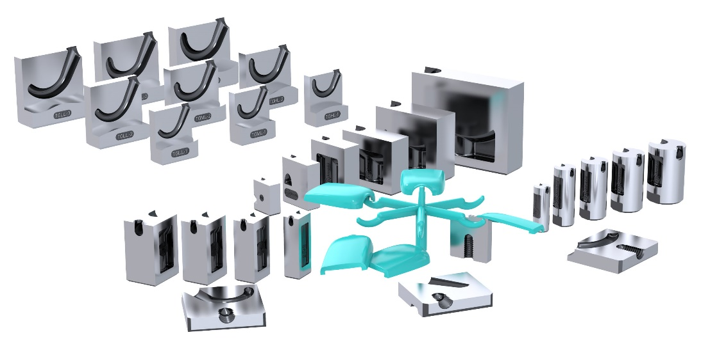
The variety of tunnel gate inserts from i-mold allows for individual optimisation
The hot runner product range from Heatlock covers not only application-oriented nozzles but also fully integrated and wired hot runner systems, modular control units, and ceramic insulation to reduce the transfer of heat between the hot runner system and the mold plate.
i-mold molding innovations has been newly founded in 2022 with over 20 years of experience in mold-making. With seven employees at its company headquarters in the Odenwald region of Germany and distributors in 33 countries worldwide, i-mold develops and markets tunnel gate inserts and also supplies hot runner systems, mold accessories and coatings.
Further information:
Andy Walter, i-mold molding innovations GmbH & Co. KG
Gewerbepark Gräsig 72, D-64711 Erbach
Phone: +49 6062 80914-0, office@i-mold.com, www.i-mold.com
Editorial contact, and please send voucher copies to:
Dr.-Ing. Jörg Wolters, KONSENS Public Relations GmbH & Co. KG
Im Kühlen Grund 10, D-64823 Groß-Umstadt
Phone: +49(0) 60 78/93 63-13, mail@konsens.de
Please find this press release as Word-file in German and English as well as the image in printer-ready resolution at http://www.konsens.de/i-mold.html

