  Press release |   Hall A2 – Stand A2-2111
Compact, flexible, fast, and straightforward
New hot runner controller generation scores where it counts
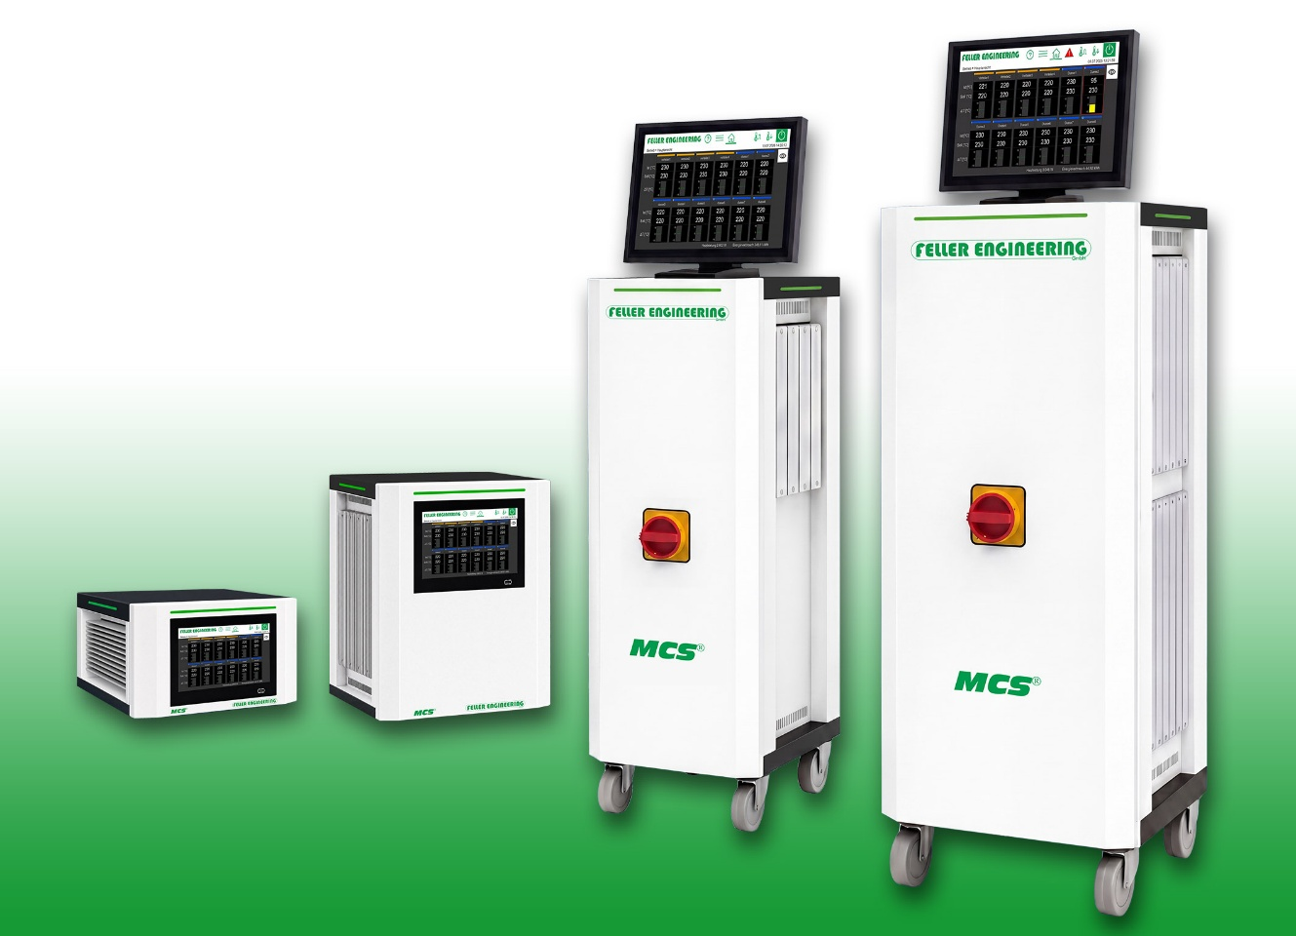
The new generation of MCS hot runner controllers for applications from 6 to 144 zones
© Feller Engineering
Rödermark/Germany, September 2026: On the occasion of Fakuma 2026, Feller Engineering GmbH is presenting a completely revised generation of its proven MCS hot runner controllers in Hall A2, Booth A2-2111. While maintaining the same high level of control quality, they offer a whole range of advantages over previous models. The design is more compact, operation is more flexible, and setup takes less time. In addition, when problems occur, the new, straightforward troubleshooting option via smartphone helps save both time and money.
With four coordinated housing sizes, the new MCS generation covers applications from 6 to 144 control zones (compared to the previous 120 zones). For even more extensive applications, multiple units can be networked to connect up to 480 zones and operated centrally. From tabletop units to powerful towers, the right compact controller solution is available for virtually any mold size and the most demanding production requirements.
Less space required, intuitive operation, fast troubleshooting
The footprints of the new generation are significantly smaller across all four versions than those of their predecessors. For example, the new tabletop units for up to 24 zones require over 25% less space, measuring 323 x 411 mm (W x D). The same applies to the new mini-tower for applications with up to 48 zones, which—thanks to its slim design—requires an identical footprint of just 323 x 411 mm (W x D). This leaves more free space in the production environment, improves access to machines and molds, and facilitates integration into existing systems. All functions and connection options of the previous versions remain available.
Following a mold change, the new quick-start assistant guides the user step-by-step through the wiring test, automatic group assignment, as well as temperature, boost, and function settings. This reduces operating errors and speeds up commissioning. Interaction now takes place via durable capacitive displays, which can be read from a wider angle and operated more reliably than the previous resistive versions. Depending on the model, an integrated 7-inch display or external panels with a 7- or 12-inch diagonal are available. The latter two are equipped with USB and Ethernet ports and can be positioned flexibly using interface cables up to 10 m long, for example directly on the injection molding machine.
In the event of a fault, the controller's display shows a QR code. Scanned with a smartphone, it opens a web application with image-based, step-by-step instructions for fault detection and resolution directly on site. This simplifies troubleshooting and helps reduce downtime.
A new mains voltage measurement enables the precise calculation and display of heating power and energy consumption for both individual zones and the entire controller. Proven functions such as a wiring check, continued heating in the event of a sensor break, leakage and short-circuit detection, comprehensive monitoring functions, as well as communication via OPC UA and operation in 14 languages, are retained.
Based in Rödermark, Feller Engineering GmbH has been developing and manufacturing control and regulation technology for plastics processing for more than 45 years. The product range includes hot runner controllers and control systems for valve gate applications. The solutions are used worldwide in demanding industrial production processes.
For more information:
Manuel Hinkelmann, Sales Manager
Feller Engineering GmbH
Carl-Zeiss-Straße 14, D-63322 Rödermark
Tel.: +49 (0) 60 74 / 8949-30; info@fellereng.de, www.fellereng.de
Editorial contact and sample copies:
Dr.-Ing. Jörg Wolters, KONSENS Public Relations GmbH & Co. KG
Hans-Böckler-Straße 20, D-63811 Stockstadt am Main
Tel.: +49 (0) 60 27 / 99005-13, mail@konsens.de
Please find this press release in German and English as well as the image in printable quality for download at: https://www.konsens.de/en/press-releases/feller-engineering

