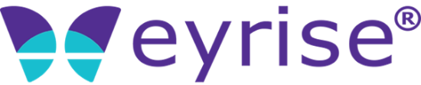

News release
19 July 2021

eyrise® liquid crystal glass to provide solar shading for
CAMPUS GERMANY at Expo 2020 Dubai
eyrise® liquid crystal glass is to provide solar shading for CAMPUS GERMANY at Expo 2020 in Dubai, which will take place from 1 October 2021 to 31 March 2022.
The dynamic glass specialist has been appointed a Premium partner by the German Pavilion Expo 2020 Dubai Consortium, comprising facts and fiction GmbH and NUSSLI Adunic AG.
Expo 2020 Dubai, which was postponed for a year due to the global pandemic, will showcase scientific, technological, economic and social progress from over 190 countries, each with a national pavilion.
Designed by Berlin-based architects LAVA, CAMPUS GERMANY’s focus is on sustainability to align with the event’s central theme, ‘Connecting Minds, Creating the Future’. Situated in the Expo’s ‘Sustainability’ district, the pavilion is built around these principles and features an interactive exhibition on creative sustainable solutions alongside new innovations.
“The German Pavilion puts an important spotlight on one of the key issues of our time,” said Céline Glipa, CEO at eyrise B.V.. “Our instant solar shading glass contributes to this focus on sustainability by creating a comfortable environment for visitors to the exhibition while supporting the building’s energy efficiency ambitions.”
A total of 61 panels of eyrise® Liquid Crystal Glazing have been installed at CAMPUS GERMANY, comprising 28 fixed glass panels, four standard doors and 29 folding doors. Powered by proprietary licrivision® technology, the dynamic glass can be tinted to provide instant solar shading without compromising on natural daylight, helping to reduce energy consumption.
World Expos have been held every five years since the inaugural Great Exhibition in London, in 1851. Expo 2020 Dubai is the first to be hosted in the Middle East, Africa and South Asia (MEASA) region.

About eyrise®
eyrise® glass uses advanced licrivision® liquid crystal technology developed by Merck to produce smart transparent windows that can be tinted to provide instant solar shading without compromising on natural daylight. The windows provide lightwellness - visual comfort, thermal regulation and colour neutrality - for occupants on demand, while helping to reduce energy consumption.
Architects and building designers worldwide use eyrise® to create bespoke glass structures and facades in a large variety of shapes, sizes and colours. Recent projects include BAFTA’s headquarters in London, Orkla City in Oslo, Merck’s conference centre in Darmstadt and Niemeyer Sphere in Leipzig designed by modern architecture pioneer Oscar Niemeyer.
eyrise® won the innovation award at Material Prize (MaterialPreis) 2020 and was named CES 2021 innovation award honouree.
Merck, Licrivision and Eyrise are registered trademarks of Merck KGaA, Darmstadt, Germany and its affiliates.

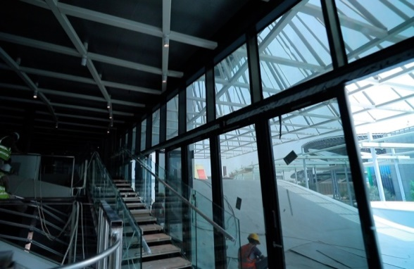 | Installation of the eyrise® Liquid Crystal Glazing modules at the German Pavilion at Expo Dubai 2020 is completed.  Picture: Björn Lauen
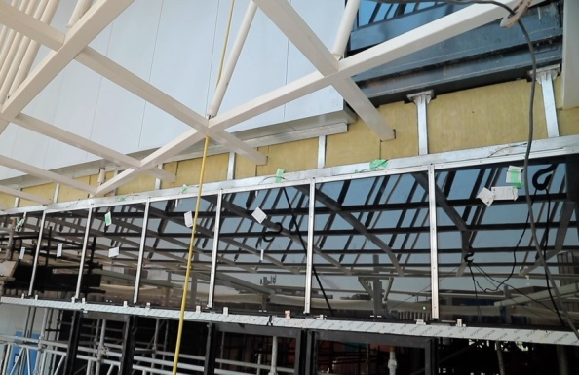 | A total of 61 eyrise® panels have been installed, making up a total area of 113 m².  Picture:Björn Lauen
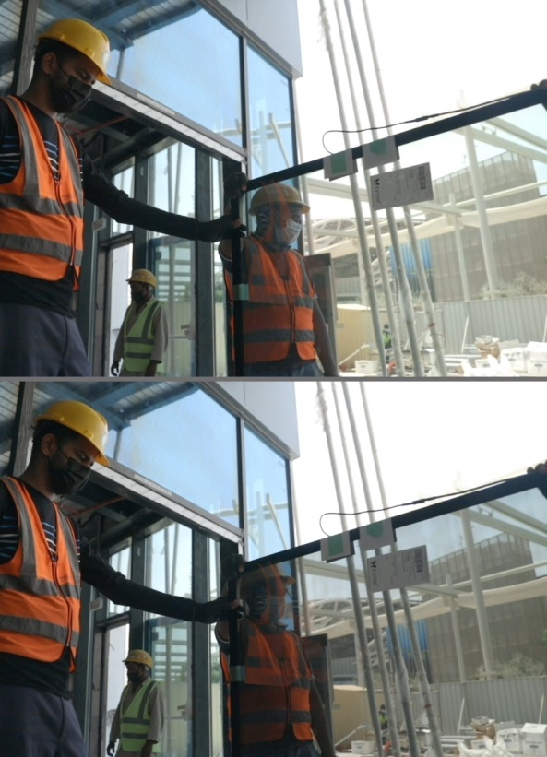 | eyrise® Liquid Crystal Glazing remains highly transparent and color neutral in bright (top) and tinted state bottom).  Picture: Björn Lauen

For further information:
Barbara Welsch
Konsens PR GmbH & Co. KG
+49 (0)60 78/93 63 14
mail@konsens.de

