News release
14 September 2020

eyrise® to provide instant solar shading
at refurbished BAFTA headquarters
eyrise® will provide instant solar shading at BAFTA 195 Piccadilly, as part of a comprehensive refurbishment to improve facilities and double the building’s capacity, enabling BAFTA to dramatically increase its charitable programme.
The British Academy of Film and Television Arts is installing recently developed smart liquid crystal windows to glaze two restored Victorian rooflights on a newly constructed top floor at its Grade II listed headquarters in London.
Proprietary licrivision® liquid crystal technology enables eyrise® glass to be tinted to provide solar shading immediately without compromising on natural daylight. The windows will provide lightwellness - visual comfort, thermal regulation and colour neutrality - for occupants on demand, while also helping to reduce energy consumption.
“New technologies are helping us transform and grow the infrastructure of our headquarters which in turn will enable us to expand our important work in supporting emerging and under-represented talent,” said Kevin Price, BAFTA’s Chief Operating Officer. “By raising the roof and re-integrating the rooflights with eyrise®’s innovative glazing, we are able to open up a bright new space and deliver a greater variety of initiatives, learning events and activities.”
The refurbishment will reveal the hidden rooflights, built in 1883, for the first time since 1975 when they were covered to create a dark space for a 227-seat cinema.
“This major project is a testament to BAFTA’s progressive vision,” said Celine Glipa, Managing Director of eyrise®. “By integrating the latest technology to breathe new life and light into this iconic landmark, it is creating a superior stage for emerging talent.”
Designed by Benedetti Architects, work on the project has already begun and is due to be completed in 2021.
“BAFTA chose us for our centrepiece idea to transform its capacity with a new top floor, created by raising and restoring the magnificent ‘lost’ Victorian rooflights to prominence,” said Renato Benedetti, Director of Benedetti Architects. “We knew this required an extraordinary smart-glass solution. As our design developed, it was soon clear the only bespoke, innovative smart glass capable of elegantly resolving every technical and perceptual challenge to bring this vision to life was eyrise®.”

About eyrise®
eyrise® Dynamic Liquid Crystal Windows is an innovative product from science and technology company Merck.
eyrise® glass uses advanced licrivision® liquid crystal technology developed by Merck to produce smart transparent windows that can be tinted to provide instant solar shading without compromising on natural daylight. The windows provide lightwellness - visual comfort, thermal regulation and colour neutrality - for occupants on demand, while helping to reduce energy consumption.
Architects and building designers worldwide use eyrise® to create bespoke glass structures and facades in a large variety of shapes, sizes and colours. Recent projects include BAFTA’s headquarters in London, Orkla City in Oslo, Merck’s conference centre in Darmstadt and Techne Sphere in Leipzig designed by modern architecture pioneer Oscar Niemeyer.
Merck, licrivision® and eyrise® are registered trademarks of Merck KGaA, Darmstadt, Germany or its affiliates.

About BAFTA
The British Academy of Film and Television Arts (BAFTA) is a world-leading independent arts charity (no. 216726) that brings the very best work in film, games and television to public attention and supports the growth of creative talent in the UK and internationally. Through its Awards ceremonies and year-round programme of learning events and initiatives – which includes workshops, masterclasses, scholarships, lectures and mentoring schemes in the UK, USA and Asia – BAFTA identifies and celebrates excellence, discovers, inspires and nurtures new talent, and enables learning and creative collaboration. For advice and inspiration from the best creative minds in working in film, games and television, visit http://www.bafta.org/guru. For more, visit http://www.bafta.org/guru.
BAFTA 195 Piccadilly, owned by the Crown Estate, is a Grade II listed building that has been BAFTA’s headquarters since 1974. It was originally built in 1883 as a gallery space for the Royal Institute of Painters in Water Colours, a medium then overlooked by the neighbouring Royal Academy of Arts.

Benedetti Architects
The redevelopment work at BAFTA’s headquarters will be designed by internationally renowned Benedetti Architects, founded by Renato Benedetti in 2016 following 20 years of award-winning success as McDowell+Benedetti Architects.

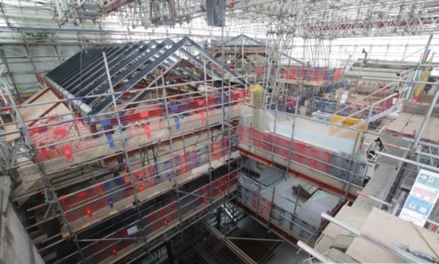 | BAFTA is installing eyrise® glass to provide instant solar shading for two restored Victorian rooflights on a newly constructed top floor. Picture: BAFTA
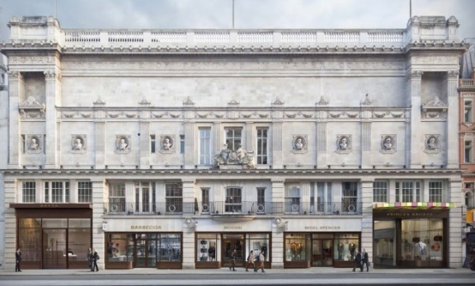 | BAFTA proposed elevation. Picture: Benedetti Architects

For further information:
Barbara Welsch
Konsens PR GmbH & Co. KG
+49 (0)60 78/93 63 14
mail@konsens.de

