Brüggemann at K2022:
Upcycling of polyolefins with innovative stabilizers
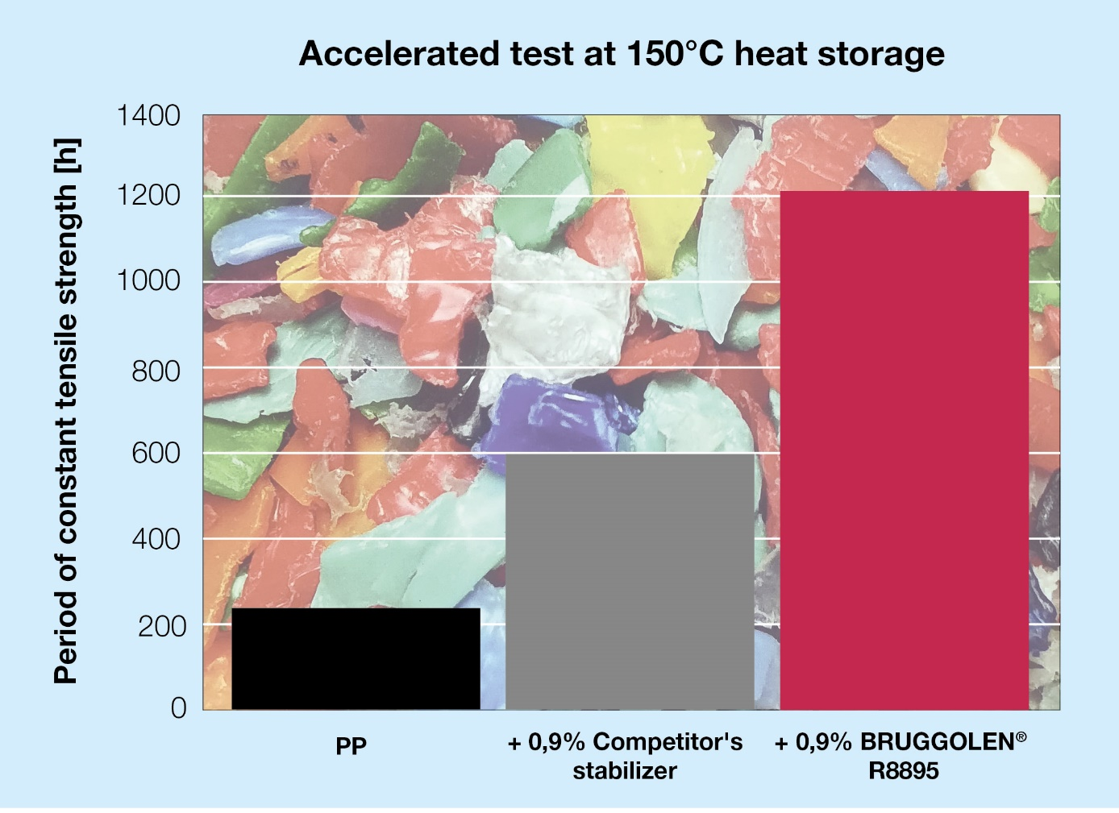
BRUGGOLEN® TP-R8895 significantly improves the retention of mechanical properties in polypropylene recyclates after accelerated testing at 150 °C heat storage. © Brüggemann
Heilbronn and Düsseldorf/Germany, October 19th, 2022 – At K 2022, Brüggemann will present three new additives for improved stabilization of polyolefin recyclates. These additives result in recyclates with very good mechanical and processing properties, making the need for the addition of virgin material unnecessary. All BRUGGOLEN® R grades are supplied as dust-free additive blends in compacted granule form for easy and homogeneous distribution.
Two of the new stabilizers are intended for polypropylene recycling. BRUGGOLEN® TP-R2090 can be used to recycle post-industrial and post-consumer waste, whereas BRUGGOLEN® TP-R8895, through its increased acid scavenger content, is especially suitable for recycling polypropylene from battery cases. Both additives result in recyclates of quality that cannot be achieved via conventional re-stabilization.
For polyethylene recycling, Brüggemann has developed BRUGGOLEN® TP-R2162, which also contains the new repair technology and is particularly suitable for LLDPE recyclates used in film extrusion. Here, the repair mechanism results in film with increased initial mechanical strength and a significantly reduced number of defects. Laboratory tests, for example, show an increase of around 25% in tensile strength and 10% in elongation at break, even at minimal dosage levels of 0.3%.
These outstanding properties of the polyolefin recyclates are made possible by a specially developed technology. For the first time, it is possible to repair defects to the molecular chains that occur during processing and subsequent use and which impair quality. The recyclate is not only protected from further damage by re-stabilization, but, by repairing the polymer chains, the resultant mechanical strength more closely matches that of virgin polymer.
With the newly introduced BRUGGOLEN® R grades, Brüggemann complements its broad portfolio of additives for mechanical recycling of polyamides. These include long-term heat stabilizers, process stabilizers, flow improvers, reactive chain modifiers, nucleating agents and other process auxiliaries.
L. Brüggemann GmbH & Co. KG, an independent family-owned company headquartered in Heilbronn (Germany), offers tailor-made solutions in the areas of polymer additives, industrial chemicals and ethanol. Brüggemann specializes in the development and production of high-performance additives for engineering thermoplastics with a focus on polyamides, as well as zinc derivatives and sulfur-based reducing agents. Customers have come to value the company's flexibility and innovative product solutions, while subsidiaries in the USA and Hong Kong emphasize its international outlook. The cornerstones of corporate policy are in-house research and development activities, a consistent focus on customer requirements, and major investments in know-how and production plants. Founded in Heilbronn in 1868, Brüggemann now supplies customers in more than 60 countries.

Further information:
Dr. Klaus Bergmann, Business Unit Manager Polymer Additives
L. Brüggemann GmbH & Co. KG, Salzstraße 131, 74076 Heilbronn, Germany
Phone: +49 (0) 71 31 / 15 75 – 235, email: klaus.bergmann@brueggemann.com

Editorial contact and please send voucher copies to:
Dr.-Ing. Jörg Wolters, Konsens PR GmbH & Co. KG,
Im Kühlen Grund 10, 64823 Groß-Umstadt, Germany – www.konsens.de
Phone: +49 (0) 60 78 / 93 63 - 13, email: joerg.wolters@konsens.de
Press releases from Brüggemann including text and pictures in printable resolution can be downloaded from: www.konsens.de/brueggemann.html

