Brüggemann at K2022:
Longer service life at high temperatures:
“Best in Class” stabilisation of aliphatic polyamides
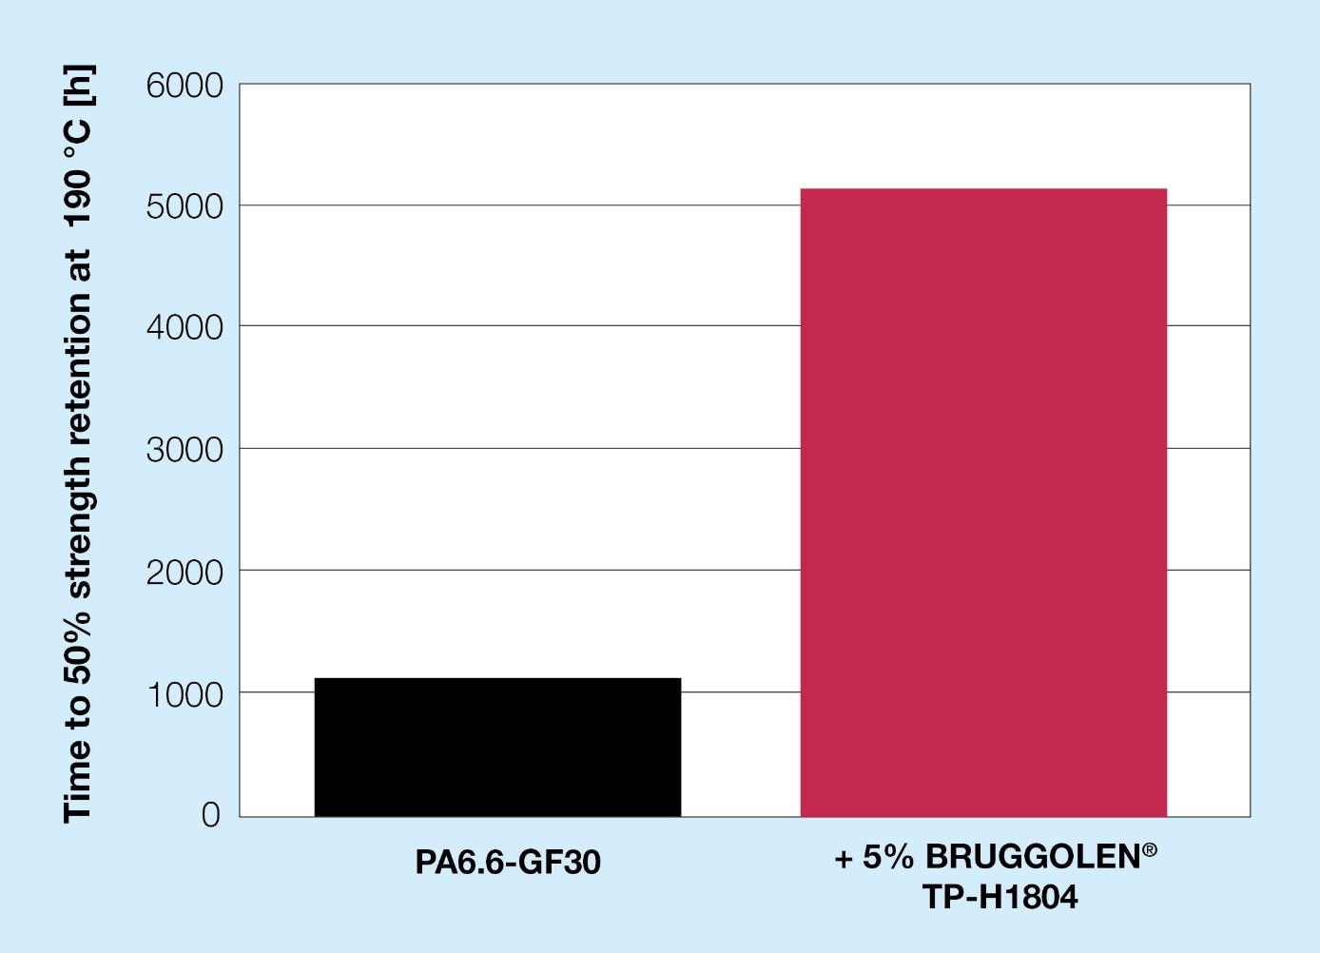
At elevated continuous service temperatures BRUGGOLEN® TP-H1804 offers the most effective stabilisation of aliphatic polyamides. © Brüggemann
Heilbronn and Düsseldorf/Germany, October 19th, 2022 – BRUGGOLEN® TP-H1804 is a new, highly effective heat stabiliser from Brüggemann for use with aliphatic polyamides at continuous service temperatures between 160 °C and 190 °C. It complements BRUGGOLEN® TP-H1805, introduced at K 2019, which stabilises reinforced polyamides at temperatures above 200 °C. The masterbatch, supplied in granular form, can be dosed very precisely, and thus in a very targeted manner.
As “best in class”, BRUGGOLEN® TP-H1804 significantly outperforms previously available copper salt-based stabilisers in terms of maintaining mechanical properties. For example, the tensile strength of a glass fibre reinforced PA6.6 with the addition of 5 % is still over 50 % of the initial value after 5,000 hours of heat ageing at 190 °C; the un-stabilised material barely reaches this limit at 1,000 hours. At 170 °C, thanks to its outstanding efficiency, even 2.4 % is sufficient to exceed the 5,000-hour mark. Thus, BRUGGOLEN® TP-H1804 is a product which, through its flexible dosing capability, allows moulded component service life to be adapted to expected thermal loads.
L. Brüggemann GmbH & Co. KG, an independent family-owned company headquartered in Heilbronn (Germany), offers tailor-made solutions in the areas of polymer additives, industrial chemicals and ethanol. Brüggemann specializes in the development and production of high-performance additives for engineering thermoplastics with a focus on polyamides, as well as zinc derivatives and sulfur-based reducing agents. Customers have come to value the company's flexibility and innovative product solutions, while subsidiaries in the USA and Hong Kong emphasize its international outlook. The cornerstones of corporate policy are in-house research and development activities, a consistent focus on customer requirements, and major investments in know-how and production plants. Founded in Heilbronn in 1868, Brüggemann now supplies customers in more than 60 countries.

Further information:
Dr. Klaus Bergmann, Business Unit Manager Polymer Additives
L. Brüggemann GmbH & Co. KG, Salzstraße 131, 74076 Heilbronn, Germany
Phone: +49 (0) 71 31 / 15 75 – 235, email: klaus.bergmann@brueggemann.com

Editorial contact and please send voucher copies to:
Dr.-Ing. Jörg Wolters, Konsens PR GmbH & Co. KG,
Im Kühlen Grund 10, 64823 Groß-Umstadt, Germany – www.konsens.de
Phone: +49 (0) 60 78 / 93 63 - 13, email: joerg.wolters@konsens.de
Press releases from Brüggemann including text and pictures in printable resolution can be downloaded from: www.konsens.de/brueggemann.html

