Avoiding contact corrosion:
New metal and halogen free heat-stabilizer for PA in E&E applications
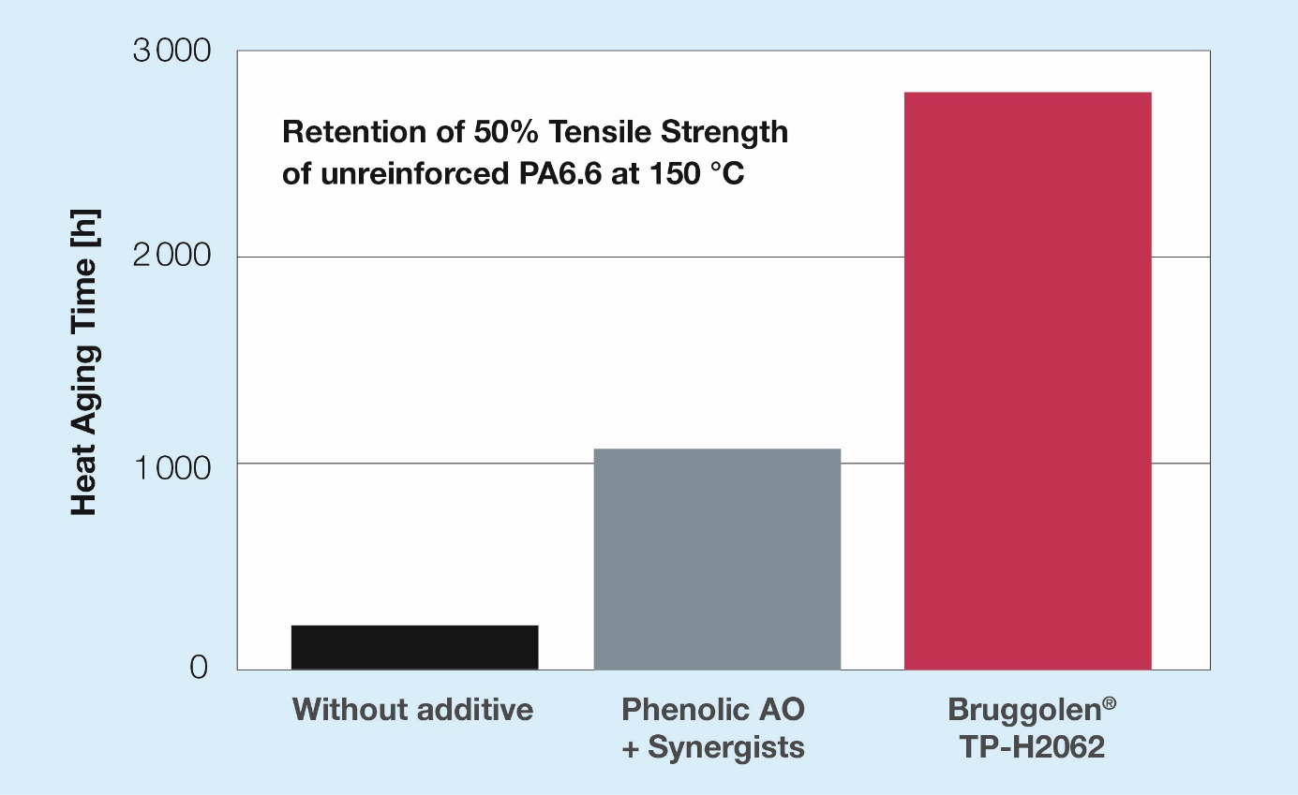
Brüggemann’s newly developed Bruggolen® TP-H2062 is a very powerful metal and halogen free heat stabilizer which enables electrically neutral PA compounds for electrical and electronic devices at elevated temperatures. © Brüggemann
Heilbronn, Germany, March 2021 – Developed with E&E applications in mind, BRUGGOLEN® TP-H2062 is a new metal and halide free heat stabilizer for polyamides offering sustained protection in a temperature range of 120 °C to 170 °C. Providing electrically neutral stabilization it prevents contact corrosion while at the same time keeping the mechanical properties of the compounds high even after long-term aging. TP-H2062 is available as a dust-free, highly dispersible masterbatch. Depending on the application, its dosage can be adjusted to meet a wide range of temperature levels and profiles.
Compounders supplying the E&E industry have for long been searching for a metal and halide free heat stabilizing additive to preserve the integrity of polyamide components at elevated temperatures as well as electrical properties like CTI, without causing electrical corrosion. Now, BRUGGOLEN® TP-H2062 overcomes the drawbacks of both classic copper iodide and phenolic based antioxidants. The first mentioned offer a superior long term protection for polyamides all the way up to 180°C, but they contain halides which can promote electrical corrosion as a reason for component failure, being highly critical for sensitive sensors, connectors and similar applications. This is not the case for phenolic based additive packages, but their protection capability rapidly decreases at temperatures above 120 °C, losing their effectiveness beyond 150 °C.
Dr. Kristina Frädrich, Product Manager Polymer Additives, comments: “With our new BRUGGOLEN® TP-H2062 we are now able to offer a highly efficient and cost competitive product, satisfying an urgent need of the industry. It is a powerful addition to our heat-stabilizer portfolio for E&E applications.”
L. Brüggemann GmbH & Co. KG, an independent family owned company headquartered in Heilbronn (Germany), offers tailor-made solutions in the areas of polymer additives, industrial chemicals and ethanol. With more than 250 employees, Brüggemann specializes in the development and production of reducing agents on the basis of sulfur, zinc derivatives, AP-NYLON® Additives and high-performance additives for polyamides and polyester. Furthermore, Brüggemann is an innovative partner in the field of ethanol, for example in the pharmaceutical, chemical and cosmetic industries, as well as in the area of disinfectants. Founded in Heilbronn in 1868, Brüggemann now supplies customers in more than 60 countries. With subsidiaries in Lutherstadt Wittenberg, the USA and Hong Kong, the company has an annual turnover of over 150 million EUR.

Further information:
Dr. Klaus Bergmann, Business Unit Manager Polymer Additives
L. Brüggemann GmbH & Co. KG, Salzstraße 131, 74076 Heilbronn, Germany
Phone: +49 (0) 71 31 / 15 75 – 235, Email: klaus.bergmann@brueggemann.com

Editorial contact and please send voucher copies to:
Dr.-Ing. Jörg Wolters, Konsens PR GmbH & Co. KG,
Im Kühlen Grund 10, 64823 Groß-Umstadt, Germany – www.konsens.de
Phone: +49 (0) 60 78 / 93 63 - 0, Email: joerg.wolters@konsens.de
Press releases from Brüggemann including text and pictures in printable resolution can be downloaded from: www.konsens.de/brueggemann.html

