New flow enhancer for semi-aromatic polyamides
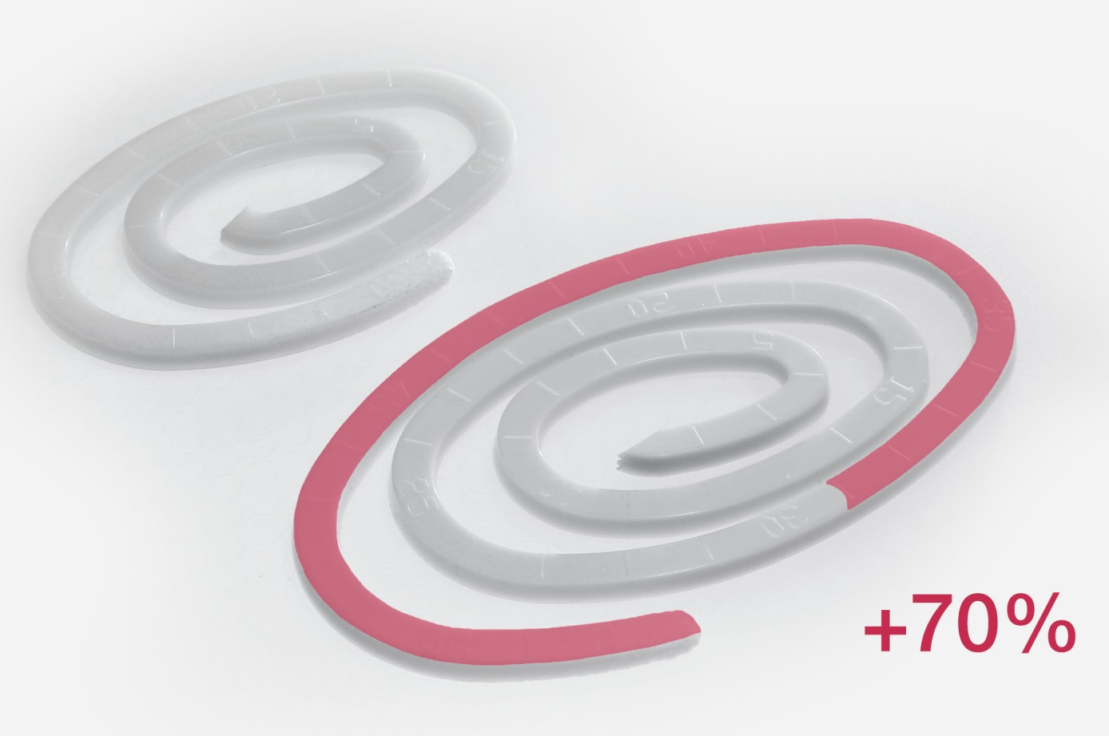
BRUGGOLEN®TP-P1810 significantly enhances the flow of semi-aromatic polyamides such as PA6T, PA6T/6I, PA6T/6.6 while maintaining mechanical properties. © Brüggemann
Heilbronn, Germany, February 2020 – BRUGGOLEN® TP-P1810 from Brüggemann is the first flow enhancer for semi-aromatic polyamides which is available on the market. This product joins BRUGGOLEN® TP-P1507, which is already used worldwide for aliphatic polyamides such as PA6, PA6.6 and PA12. As a result, the company now offers flow enhancers for the entire polyamide spectrum. Both BRUGGOLEN® TP-P1810 and BRUGGOLEN® TP-P1507 demonstrate very significant improvement in melt flow while retaining the mechanical properties of finished components. Supplied in pellet form, they are easy to dose and disperse during direct injection molding and compounding.
Trials carried out with RJG Technologies, a well-known independent testing laboratory, clearly revealed that BRUGGOLEN® TP-P1810 enabled in excess of 20% cycle time reduction during molding and, significantly, allowed filled compounds containing 50% and more of glass fiber to be injection molded into very intricate and complex shapes. For instance, during molding tests, the flow spiral of a semi-aromatic polyamide reinforced with 50 wt.% glass fiber was lengthened by 70% at a dosing rate of BRUGGOLEN® TP-P1810 of only 1.5%. Much-improved color and appearance of the resultant molded parts are a welcome result of the excellent processing enabled by BRUGGOLEN® TP-P1810. Alternatively, by allowing a 30°C reduction in melt temperature, the additives clear the way to gentler processing and reduced energy consumption.
Dr. Klaus Bergmann, Head of Polymer Additives at Brüggemann: “With the continually tightening emissions regulations we are seeing the pursuit for ever lighter components. BRUGGOLEN® TP-P1810 and BRUGGOLEN® TP-P1507 are key tools to help our customers make this happen.”
L. Brüggemann GmbH & Co. KG is a renowned manufacturer of specialty chemicals with some 200 staff. Founded in 1868, the company, headquartered in Heilbronn/Germany, specializes in developing and manufacturing of high-performance additives for engineering thermoplastics with a focus on polyamides, as well as zinc derivatives and sulfur-based reducing agents. Customers from more than 60 countries have come to value the company's flexibility and innovative product solutions, while subsidiaries in the USA and Hong Kong emphasize its international outlook. The cornerstones of corporate policy are in-house research and development activities, a consistent focus on customer requirements, and major investment in know-how and plant.

Further information:
Dr. Klaus Bergmann, Business Unit Manager Polymer Additives
L. Brüggemann GmbH & Co. KG, Salzstraße 131, 74076 Heilbronn, Germany
Phone: +49 (0) 71 31 / 15 75 – 235, Email: klaus.bergmann@brueggemann.com

Editorial contact and voucher copies:
Dr.-Ing. Jörg Wolters, Konsens PR GmbH & Co. KG,
Im Kühlen Grund 10, 64823 Groß-Umstadt, Germany – www.konsens.de
Phone: +49 (0) 60 78 / 93 63 - 0, Email: joerg.wolters@konsens.de
Press releases from BrüggemannChemical including text and pictures in printable resolution can be downloaded from: www.konsens.de/brueggemann.html

