Brüggemann at K2022:
High-performance Additives for Polyamides and Recycled Polyolefins
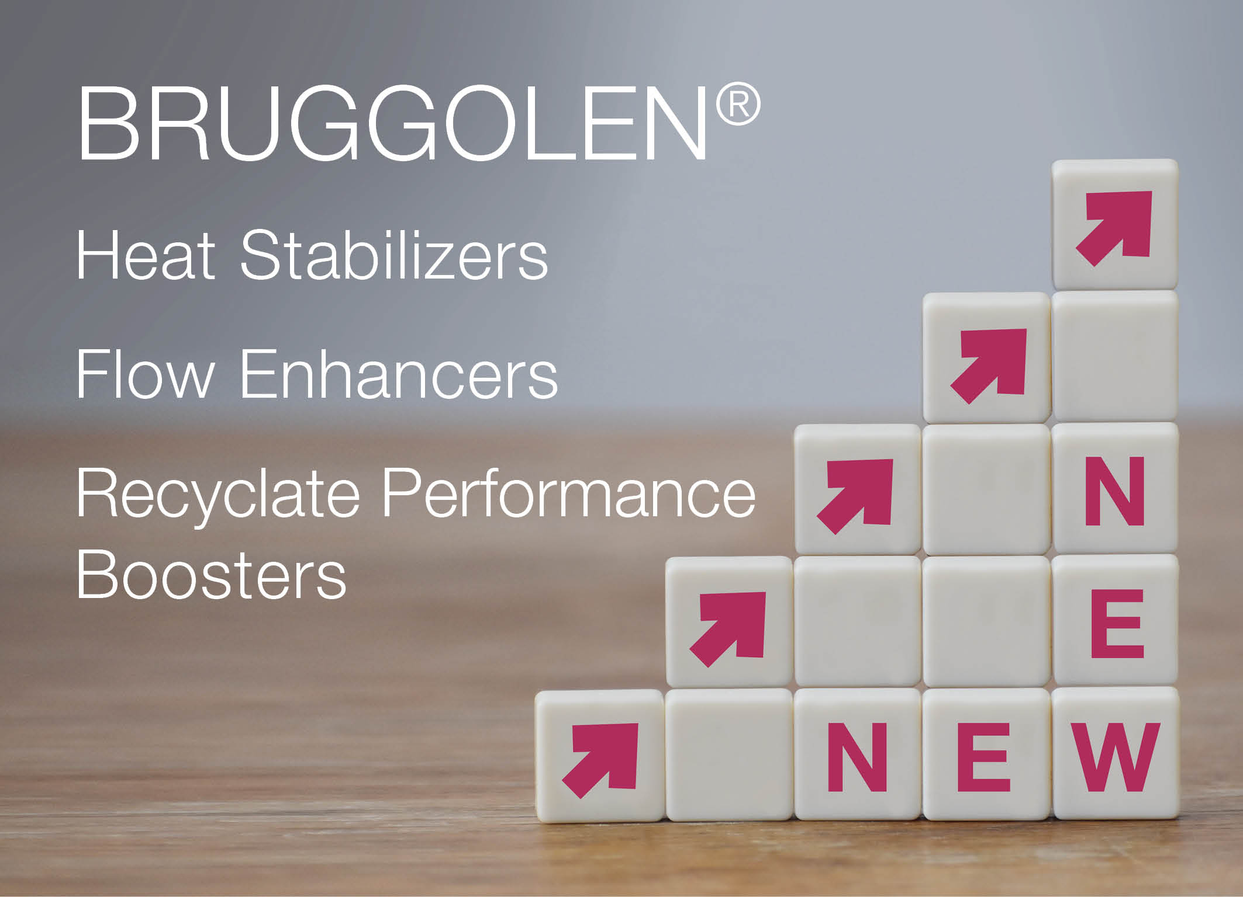
Brüggeman’s newly developed additives enable compounders to produce materials with properties surpassing previous performance limits. © Brüggemann.
Heilbronn/Germany, July 2022 - Brüggemann (www.brueggemann.com) is presenting performance-enhancing additive innovations at K 2022. These range from electrically neutral heat stabilizers for polyamides in electrical and electronic applications, for example for e-mobility, to high-performance stabilizers for exposure to moderate to very high temperatures and additives for stabilizing recycled polyolefins. A further focus is on efficiency-boosting flow enhancers which enable shorter cycle times and low wall thicknesses for components made of polyamides and polyesters (PBT).
Electrically Neutral Heat Stabilizers for Polyamides
BRUGGOLEN® TP-H2062 and TP-H2217 are opening up a new class of metal- and halogen-free heat stabilizers for reinforced and unreinforced polyamides in E/E applications. They do not corrode metallic components such as overmolded sensors and have no impact on the polymer’s electrical properties. They also enable continuous service temperatures of 170°C with peaks of 200°C, so meeting more stringent automotive industry requirements and surpassing the limits of conventional systems, such as phenol- and copper-based stabilizers. Both BRUGGOLEN® additives are available as easy-to-process masterbatches.
BRUGGOLEN® TP-H2217 is particularly suitable for heat-stabilizing halogen-free flame retardant polyamides. Brüggemann has thus made it possible for compounders to produce polyamide materials specifically tailored for e-mobility which have a V-0 classification to UL94, electrical neutrality and long-lasting heat resistance at 180°C.
“Best in Class” at 190°C
BRUGGOLEN® TP-H1804 is a new heat stabilizer for aliphatic polyamides used at continuous service temperatures of 160°C to 190°C. It distinctly outperforms copper salt-based stabilizers in terms of mechanical property retention of the materials to which it is added. BRUGGOLEN® TP-H1804 thus complements BRUGGOLEN® TP-H1805, which was presented at K 2019 and stabilizes reinforced aliphatic polyamides for continuous service at 200°C for PA6 and at 230°C for PA6.6.
Efficiency-boosting Flow Enhancers
BRUGGOLEN® TP-P2201 is a new addition to Brüggemann’s range of flow enhancers which will be presented at K 2022 and is specifically tailored for applications in e-mobility and flame retardant polyamides. BRUGGOLEN® TP-P1810 is particularly suitable for processing partially aromatic polyamides, while BRUGGOLEN® P1507 is optimized for aliphatic polyamides and TP-P1924 for PBT. All these additives help to save energy during production while simultaneously enabling very high fiber contents for injection molded parts with long flow paths and/or low wall thicknesses.
Polyolefin Recycling
Brüggemann had already presented its wide range of additives for the mechanical recycling of polyamides at K 2019. These include long-term heat stabilizers, process stabilizers, flow promoters, reactive chain modifiers, nucleating agents and other processing auxiliaries. Products for recycling polyolefins will now also be presented at K 2022. Specially developed technology repairs defects in the molecular chains which arise during the processing and use of polyolefins and degrade quality. The result is recycled polymers with improved mechanical properties which do not require the addition of virgin material.
Using BRUGGOLEN® TP-R2090, it is possible to recycle polypropylene from post-industrial and post-consumer waste. TP-R8895 is specifically suited to recycling polypropylene from battery cases. Both additives result in recycled materials of a quality which cannot be achieved by conventional re-stabilization, even at high rates of addition.
For recycling polyethylene, Brüggemann has developed BRUGGOLEN® TP-R2162 which again includes the new repair technology and is particularly suitable for recycled LLDPE for use in film extrusion. All the stated additives are supplied in the form of compact, dust-free blends.
L. Brüggemann KG is a renowned manufacturer of specialty chemicals with some 255 staff at its headquarters in Heilbronn, Germany. Founded in 1868, the company has specialized in the development and production of high-performance additives for engineering thermoplastics with a focus on polyamides and on zinc derivatives and sulfur-based reducing agents. Customers from more than 60 countries have come to value the company's flexibility and innovative product solutions, while subsidiaries in the USA and Hong Kong emphasize its international outlook. The cornerstones of corporate policy are in-house research and development, a consistent focus on customer requirements and major investment in know-how and plant.

Further information:
Dr. Klaus Bergmann, Business Unit Manager Polymer Additives
L. Brüggemann GmbH & Co. KG, Salzstraße 131, 74076 Heilbronn, Germany
Phone: +49 (0) 71 31 / 15 75 – 235, email: klaus.bergmann@brueggemann.com

Editorial contact and please send voucher copies to:
Dr.-Ing. Jörg Wolters, Konsens PR GmbH & Co. KG,
Im Kühlen Grund 10, 64823 Groß-Umstadt, Germany – www.konsens.de
Phone: +49 (0) 60 78 / 93 63 - 13, email: joerg.wolters@konsens.de
Press releases from Brüggemann including text and pictures in printable resolution can be downloaded from: www.konsens.de/brueggemann.html

