Reliably separating residues:
With AI, DiscSpreader® automove continuously ensures optimum distribution on the conveyor belt
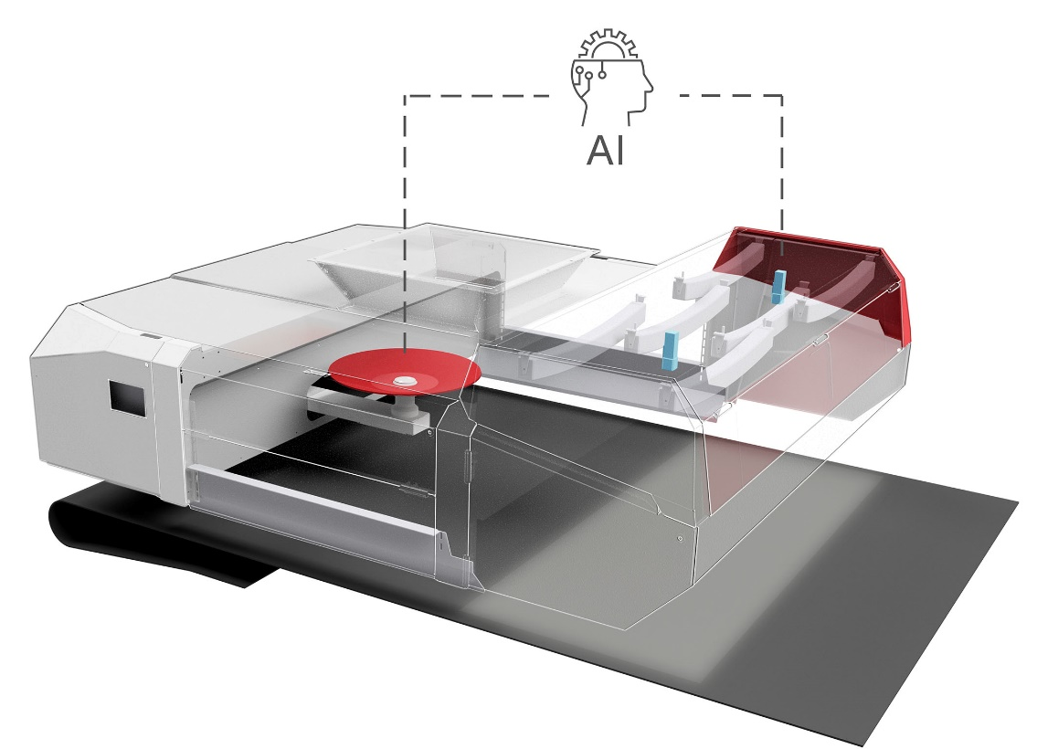
The newly developed DiscSpreader® automove, which optimises itself with the help of artificial intelligence; ©Westeria
Ostbevern/Germany, 30. May 2022
With the development of the DiscSpreader® automove, Westeria shows how recycling plants can be further optimised using artificial intelligence (AI). Equipped with this technology, the newly introduced disc spreader distributes all kinds of recyclables such as plastics, wood, compost, scrap, slag, with optimal uniformity, especially on accelerator belts of optical sorters and non-ferrous separators. As a result, the material distributed in this way can be separated even more easily during subsequent sorting and with considerable increases in efficiency and throughput. Furthermore, its use reduces disturbances in the process flow and thus increases the overall quality of the processing.
Reliable sorting is essential for the successful recycling of mixed material streams. At the same time, the use of high-performance separation units requires high investments. However, due to non-optimal material distribution, these machines often remain far below their potential. Felix Poth, Managing Director of Westeria, says: "Today, plant operators often tolerate a mediocre material spread due to non-optimal maintenance of the distribution aggregates. This is one reason why our low-maintenance DiscSpreader quickly became a big success."
To further optimise this system so that changes in the material flow do not cause a deterioration of the distribution, the company has developed the DiscSpreader automove together with AI experts from TH-Köln. This new single-disc spreader reacts immediately to varying material flows and sets a new benchmark in terms of continuously uniform distribution. The system has a space-saving design and can thus be mounted directly on the infeed belt of the sorting unit, for example.
Poth continues: "Two cameras positioned behind the disc in the direction of conveyance record the current material distribution on the belt and make the images available to the artificial intelligence. This uses its self-learned knowledge to generate control signals to vary the position and alignment of the disc in real time, so that even minor irregularities in the distribution are compensated for in the shortest possible time. Manual readjustment is no longer necessary. In this way, we create optimal conditions for subsequent steps such as NIR sorting or wind sifting, even with highly varying material flows."
The technical implementation is done with the help of a servo-electrically driven carriage via lifting cylinders, which runs in guide profiles above the conveyor belt and can be moved longitudinally and transversely to the belt movement. Attached to this is a support arm aligned in the direction of conveyance, which can be rotated around its axis to change the inclination of the disc suspended at its end. Like its predecessor, the new DiscSpreader automove can be fed flexibly from all directions and is even suitable for distributing vibration-absorbing ultra-light materials. It is equipped as standard with tools for sensor data transmission, remote maintenance, documentation, and evaluation. At IFAT 2022, Westeria presented the new system in operation for the first time.
Westeria® GmbH, with headquarters and production in Ostbevern, Westphalia/Germany, combines more than 60 years of experience in the manufacture of innovative, high-quality machines for the recycling industry with technical know-how and excellent service. The portfolio includes stationary and mobile windsifters, flat, chain and troughed belt conveyors, hopper systems and material distribution systems. The robust, durable and reliable products are used worldwide wherever piece or bulk materials are conveyed, dosed, separated or sorted. With 145 employees and a strong dealer network, Westeria is represented globally and stands for quality and individuality from planning to assembly, including after-sales service. The company tests separation results of customers' materials in its own technical centre, analyses the results and provides detailed evaluations. As a plant integration partner, the manufacturer also provides detailed support for plant planning and ensures optimal integration of machines into complete processing plants
Further Information:  Hanno Jenkel, Marketing Manager  Westeria® GmbH  Raiffeisenstr. 2, D-48346 Ostbevern  Phone +49 2532/ 88-177  h.jenkel@westeria.de | Editorial Contact and please send voucher copies to:  Dr.-Ing. Jörg Wolters  Konsens PR GmbH & Co. KG  Im Kühlen Grund 10, D-64823 Groß-Umstadt  Phone +49 6078/9363-13  joerg.wolters@konsens.de
Please find text and image of this press release for download at
https://www.konsens.de/en/press-releases/westeria-gmbh

