New screen changer enables sustainable use of recyclate
Troisdorf/Germany, July 22nd 2021. The blow molding specialist W. MÜLLER has developed a new generation of screen changers for its extruders in extrusion blow molding. It is designed to be particularly space-saving. It is also suitable for installation in vertically oriented extruders, can easily be retrofitted and operated safely. When using PCR, a screen changer is recommended.
Filtering the melt is an essential element of controlled extrusion – especially when using Post-Consumer-Recyclates (PCR). The filtering screen consists of a fixed perforated carrier plate, which is covered by several interchangeable grids with different mesh sizes. If the differential pressure on this grid exceeds a certain value, the screen must be changed.
Johannes Schwarz, sales manager at W. MÜLLER explains: "The screen changer ensures, that impurities are kept away from the extrusion head. In addition to the use of PCR, which can be contaminated with other plastics or particles, it is, for example, abrasion from the mill, degraded plastic material or today often sections of cable ties, which are to be absorbed by the screen changer from the material flow. Such impurities interfere with the process and may lead to interruptions in production. It would be even more problematic if a leaking container would be produced and ended up in the filling station."
Managing Director Christian Müller specifies: "Of course, we are also talking about the usage of recyclates. In the processing of recycled material, in particular PCR materials, the risk of contamination increases, which does not enter the production process from the outside but from the used material itself. These can be, for example, snippets of aluminum lids or sleeves of bottles. In operation, the screen is slowly getting clogged and must be changed regularly. How often, depends on the quality of the processed material. W. MÜLLER has designed its own system for this change."
The screen changer can be retrofitted and does not require any special safety precautions, as it does not have its own drive. It can be operated manually or e.g., by using a cordless screwdriver without effort.
For PCR processing, W. MÜLLER offers the ReCo3 system for its extrusion units, consisting of three independent extruders. The PCR layer is enclosed in the middle by two layers of virgin material. The extruders are mounted vertically for this process. Christian Müller explains: "Traditionally, there are no screen changers for such extruders, we are one of the very few suppliers on the market. Normally, the changers are too long to install vertically without risking the stability of the extruder.
Also a retrofit of a ReCo3 system with the matching screen changers in most cases is possible without any problems. In This way, we are able to offer every interested company to get started with PCR processing."
Johannes Schwarz adds: "The compact design is possible because the screen changer is integrated into the connection piece between extruder and extrusion head. By retrofitting a screen changer, the

extruder is not significantly extended. In addition, it can be installed in any orientation, which further increases flexibility."
Jens Schlueter, President of W. MÜLLER USA, Inc. explains: "We are also receiving more and more inquiries from North, South and Central America about systems for safe recyclate-processing. I expect a further significant increase here, also because of the changing raw material situation. The production of gasoline and diesel is declining. Accordingly, less ethylene and propylene is present for polymerization. This will further drive the demand for alternative materials."
W. MÜLLER constantly carries out tests with PCR and other recyclates in their in-house technical centers in Germany and the US and deepens its expertise in this area.
Pictures:
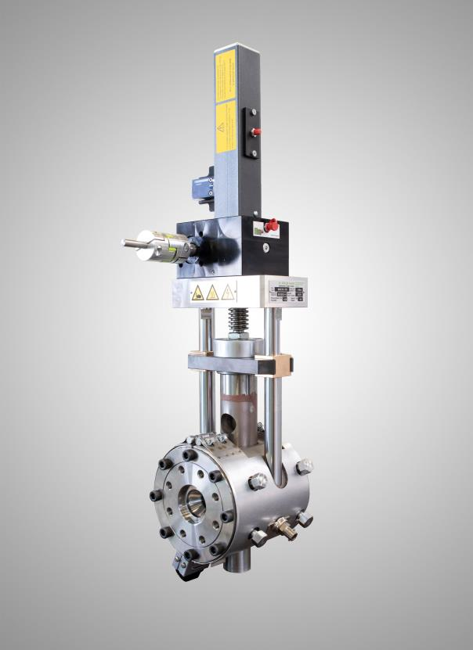
Caption: The new vertically constructed screen changer from W. MÜLLER is particularly compact and makes the processing of PCR easier in blow molding systems. Photo: W.MÜLLER

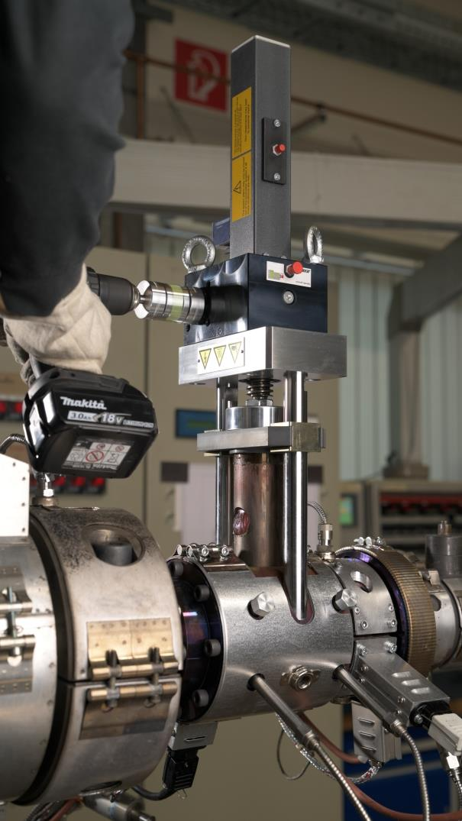
Caption: The screen changer is safe to operate manually. To simplify the process, for example, a cordless screwdriver can be used. Photo: W. MÜLLER
For further Information:  Annina Schumann  W. MÜLLER GmbH  Am Senkelsgraben 20  D-53842 Troisdorf-Spich  Tel.: +49 (0) 22 41 / 96 33-0  a-schumann@w-mueller-gmbh.de  Visit our new website:  www.mueller-ebm.com | Editorial contact and copies:  Konsens PR GmbH & Co. KG  Philipp Lubos  Im Kühlen Grund 10  D-64823 Groß-Umstadt  Tel.: +49 (0) 60 78/93 63-0, Fax: -20  mail@konsens.de  www.konsens.de

You can find this press release as a doc file as well as the images in printable resolution for download at
https://www.konsens.de/pressemitteilungen/w-mueller

