Ultrapolymers / RAVAGO Manufacturing:
DIN EN ISO 13485 certified medical compounds
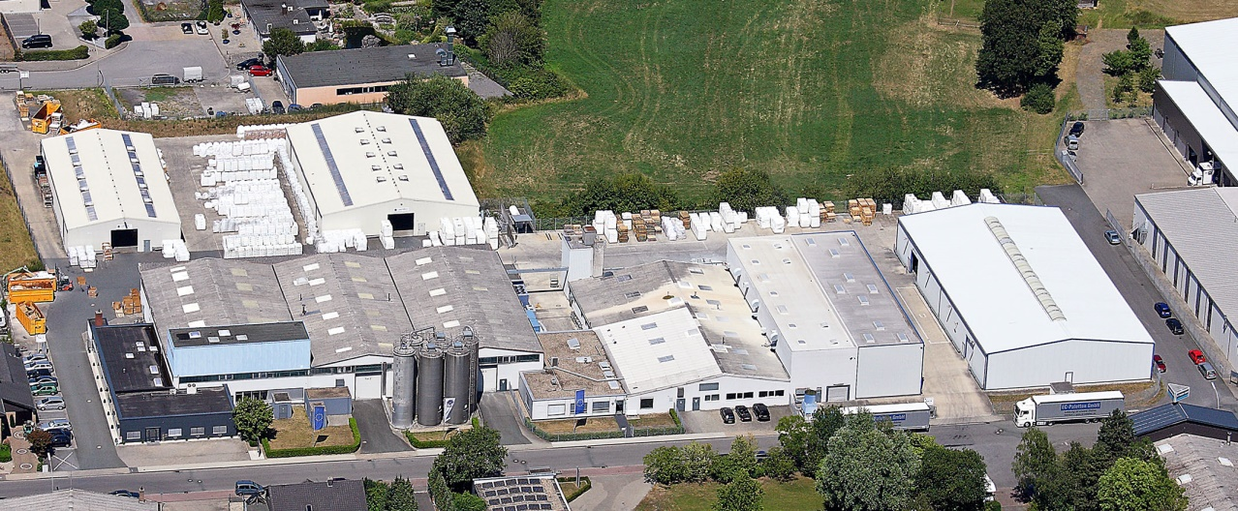
RAVAGO Manufacturing’s production site in Steinfurt/Germany
Augsburg/Germany, November 2020. Since July this year, RAVAGO Manufacturing's Steinfurt production site has been certified to international medical devices quality management standard DIN EN ISO 13485. The site produces compounds based on amorphous and semi-crystalline thermoplastics for applications in medical and pharmaceutical technology and in in vitro diagnostics. This standard focuses on compliance with regulatory requirements and product safety including risk management. Its requirements may also be extended to manufacturers of the raw materials used in medical devices.
Ultrapolymers, a member of the RAVAGO Group as well, distributes these Medical Compounds throughout Europe and provides customers with seamless support from initial concept to market introduction of their products. The compounds produced in Steinfurt complement the wide range of Ultrapolymers' thermoplastics for this sector which also include polyolefins, styrenics, polymethyl methacrylates, polycarbonates and TPE-S produced by leading polymer manufacturers.
As Pierre Fischer, European Technical Manager Healthcare at Ultrapolymers, explains: “Answering to an increased demand from our customers, the Medical Compounds complete Ultrapolymers Group NV’s portfolio in the health care sector, and expand our range of services. In cooperation with RAVAGO Manufacturing and its DIN EN ISO 13485 certified plant in Germany, we are able to offer suitable compounds which meet the most stringent quality requirements with optimum supply chain transparency. Our pan-European healthcare team with expertise in polymer processing, toolmaking, coloring and regulatory affairs can support our customers at every phase of their projects.”
Sandra Vontz, EMEA Healthcare Compliance Manager at Ultrapolymers Germany, adds: “The growing complexity of regulations and monitoring by the authorities requires maximum quality, care and responsibility right along the supply chain. Implementing a quality management system suitable for this market was our top priority. The system demonstrates compliance with all applicable regulations, legislation and guidelines and so creates market trust. Our compounds managed under a sustainable “medical strategy” covering characteristics such as traceability, formulation consistency, biocompatibility etc., meet the “medical grade plastics” requirements of VDI Guideline 2017.”
Ultrapolymers Deutschland GmbH, Augsburg, Germany, is part of the pan-European plastics distributor Ultrapolymers Group NV, Lommel, Belgium. In addition to the company headquarters in Augsburg, Ultrapolymers Deutschland has sales offices in Bielefeld, Kierspe, Nuremberg and Stuttgart. Ultrapolymers Austria GmbH, Werndorf, serves customers in Austria. Ultrapolymers Schweiz AG, Widnau, serves customers in Switzerland.
Ultrapolymers’ portfolio includes polyolefins from LyondellBasell and Chevron Phillips, styrenics from Ineos Styrolution, polyamides from DOMO and RAVAGO, polycarbonates from Samyang, PBT from Mitsubishi Engineering-Plastics, synthetic rubbers from Arlanxeo, long fiber reinforced thermoplastics, TPU and TPE from RAVAGO, PET from Dufor, biopolymers from FKuR, rotational molding plastics from LyondellBasell, standard plastics, masterbatch and additives as well as customer-specific compounds.
The RAVAGO Group, a multinational group with Belgian roots and its corporate headquarters located in Luxembourg, essentially focuses on distributing plastics and rubbers from renowned manufacturers and producing recycled plastics and rubbers and is one of the world's largest plastics compounders. RAVAGO Plastics Deutschland GmbH produces, distributes and reprocesses thermoplastics and additives and offers compounding services for masterbatches, colored or reinforced polymers and blends.
Editorial contact and please send voucher copies to:
Konsens PR GmbH & Co. KG, Dr. Jörg Wolters
Im Kühlen Grund 10, D-64823 Groß-Umstadt
Tel.: +49 (0) 60 78/93 63-13, Email: mail@konsens.de
Please find this press release in Word format and the image in jpg format
for download from: https://www.konsens.de/ultrapolymers

