New additions to Ultrapolymers' portfolio:
e-mobility and more – engineering thermoplastics from Mitsubishi for reliable electronics
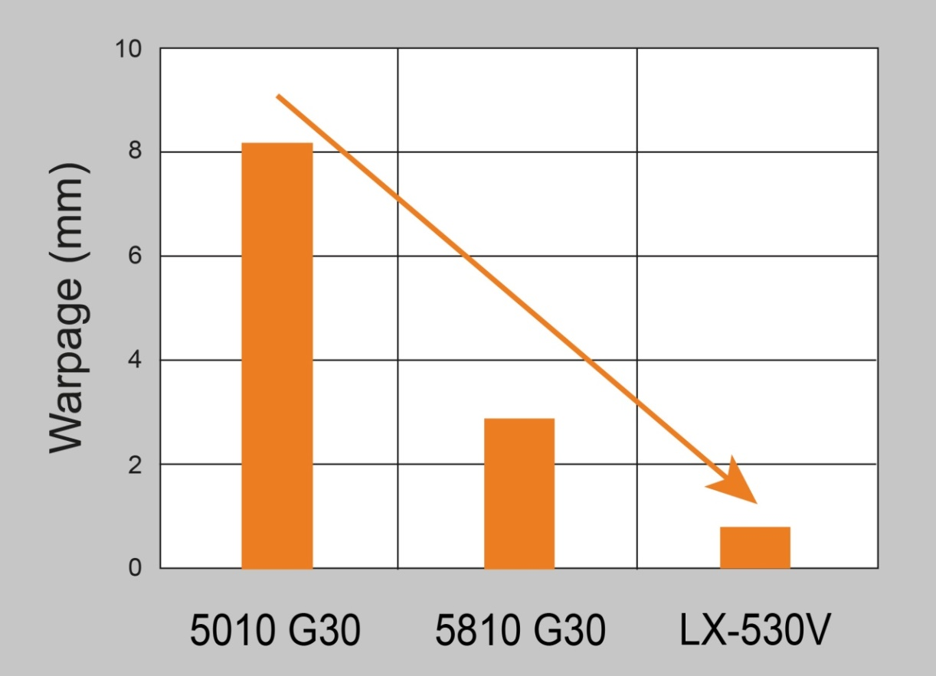
A comparison of the warpage of different NOVADURAN grades demonstrates the significant superiority of the new LX grades, here represented by NOVADURAN LX-530V. Source: Mitsubishi Engineering-Plastics
Augsburg/Germany, October 2020. Plastics distributor Ultrapolymers has added special NOVADURAN® PBT blends from Mitsubishi Engineering-Plastics (MEP) to its portfolio which outperform corresponding standard PBT grades in specific applications. The recently introduced NOVADURAN LX grades, for instance, set a benchmark in terms of low warpage. A new range of electrically insulating or electrically conductive grades offers thermal conductivity around 5 to 50 times higher than that of standard PBT. Applications for the new grades include enclosures and packages for sensitive sensors and other electronic components of the kind typically used for example in self-driving vehicles or automation and internet-of-things (IoT) settings.
Warpage minimized
The ultra-low-warpage NOVADURAN LX range currently comprises the UL-HB grade LX-530V with 30 wt.% glass fiber and the flame-retardant grades LX-515N (15 wt.% GF, V-0 at 1.6 mm), LX-530N (30 wt.% GF, V-0 at 1.6 mm) and LX-530N2 (30 wt.% GF, V-0 at 0.8 mm). All share PBT's typical combination of excellent flow properties and surface characteristics, low outgassing and high heat, oil and chemical resistance. Testing of round specimens 100 mm in diameter and 1.6 mm in thickness revealed that the warpage (maximum deflection at the edge of the test specimen) measured on LX-530V after cooling was only 0.8 mm and thus a factor of 3.6 lower than in the case of the previous benchmark NOVADURAN 5810G30 and only around one tenth of the value measured on the standard grade 5010G30. The new grades are also marked out by comparatively low density.
Greater heat dissipation
When it comes to temperature management, an important issue for sensors, the new electrically conductive NOVADURAN TCV grades 515T2, 517H and 521H meet very stringent thermal conductivity requirements with values of around 20 W/mK (ISO 22007-2). When used to make sensor enclosures, they enable heat dissipation which is higher by a factor of 50 than standard PBT and so provide particularly good protection from overheating. Also new are the electrically insulating grades NOVADURAN TGN515U, TGN525T and TGV525T which, with a thermal conductivity of around 2 W/mK, achieve values a factor of 5 higher than the corresponding standard PBT grades.
As Sebastian Thomsen, MEP's PBT business development manager in Europe, explains: “The electrical and electronics segment and in particular packages for high quality sensor systems are a target market for MEP.” And Marc Swatosch, product manager for engineering polymers at Ultrapolymers, adds: “These new NOVADURAN PBT blends expand our already extensive portfolio of engineering polymers which also includes DOMO's Technyl One, Technyl Orange und Technyl Red polyamides. This widens the range of problems we can solve and extends our offer of individual solutions to European customers in the E&E industry.”
Ultrapolymers Deutschland GmbH, Augsburg, Germany, is part of the pan-European plastics distributor Ultrapolymers Group NV, Lommel, Belgium. In addition to the company headquarters in Augsburg, Ultrapolymers Deutschland has sales offices in Bielefeld, Kierspe, Nuremberg and Stuttgart. Ultrapolymers Austria GmbH, Werndorf, serves customers in Austria. Ultrapolymers Schweiz AG, Widnau, serves customers in Switzerland.
Ultrapolymers’ portfolio includes polyolefins from LyondellBasell and Chevron Phillips, styrenics from Ineos Styrolution, polyamides from DOMO and Ravago, polycarbonates from Samyang, PBT from Mitsubishi Engineering-Plastics, synthetic rubbers from Arlanxeo, long fiber reinforced thermoplastics, TPU and TPE from Ravago, PET from Dufor, biopolymers from FKuR, rotational molding plastics from LyondellBasell, standard plastics, masterbatch and additives as well as customer-specific compounds.
Editorial contact and please send voucher copies to:
Konsens PR GmbH & Co. KG, Dr. Jörg Wolters
Im Kühlen Grund 10, D-64823 Groß-Umstadt
Tel.: +49 (0) 60 78/93 63-13, Email: mail@konsens.de
Please find this press release in Word format and the image in jpg format
for download from: https://www.konsens.de/ultrapolymers

