New in Ultrapolymers' portfolio:
Technyl® One polyamides with significantly reduced corrosiveness for E&E applications
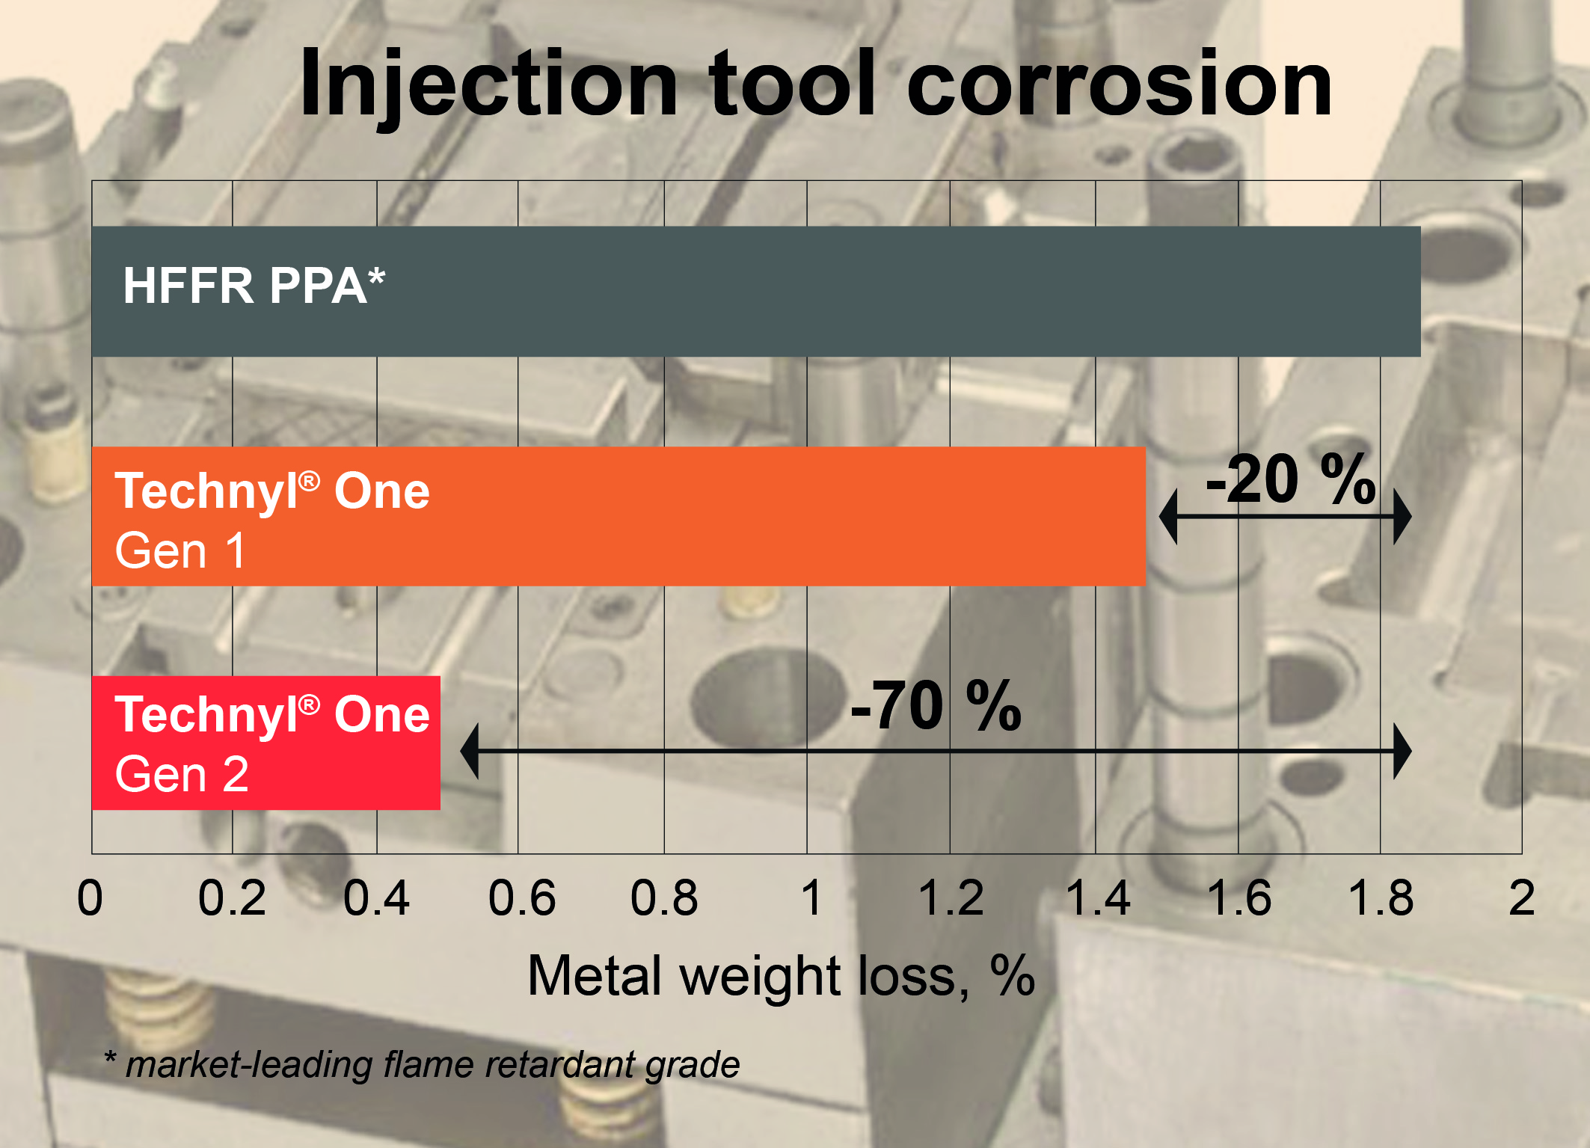
With their significantly reduced corrosiveness, the halogen free flame retardant (HFFR) Technyl® One polyamides of the second generation allow considerably longer tool lifetimes than comparable polymers with similar functionality.
Source: DOMO Chemicals
Augsburg/Germany, June 2020. A recent addition to the portfolio of the distributor Ultrapolymers is the second generation of the high-temperature resistant, halogen free flame retardant (HFFR) Technyl® One polyamides from Domo, developed specifically for the electrical and electronics industry. Thanks to their significantly reduced corrosiveness, which can be up to 70% lower compared to standard HFFR PPA grades of similar performance, they enable particularly long tool lifetimes. Their high fluidity enables low wall thicknesses and high degrees of miniaturization, even with glass fiber-reinforced grades. Typical applications include intelligent electricity meters, high-performance circuit breakers and other elements of power generation and distribution as well as components for diverse uses from e-mobility to high-voltage applications.
These second-generation Technyl® One grades offer a UL94 V0 rating at 0.4 mm, a Relative Temperature Index (RTI) of 150 °C, a high tracking resistance with a CTI value of 600 V and above, and they achieve a maximum Glow Wire Ignition Temperature (GWIT) of 800 °C. Other features of these PA66/6T copolymers include low moisture absorption, high mechanical strength, stiffness and dimensional stability of the glass fiber-reinforced grades, and very good surface finish of the injection molded parts produced with them.
Marc Swatosch, Product Manager Engineering Plastics at Ultrapolymers Deutschland GmbH, comments: "With the new generation of HFFR Technyl® One polyamides, we offer our customers in the E&E industry a product family that combines the highest levels of dielectric properties with unsurpassed economical processability, thus enabling higher added value without compromising performance.”
The Technyl® One product range, which also includes grades with enhanced heat stabilization and heat aging properties, is part of Domo's extensive polyamide portfolio recently made available by Ultrapolymers for customers in technologically demanding industries. This also includes Technyl® 4earth® based on technical textiles, Sinterline® Technyl® powder for selective laser sintering (SLS), Technyl® RED with its long-term resistance to the high temperatures around modern engines, the heat-stabilized Technyl® BLUE grades with high heat aging resistance in aggressive cooling media, the particularly easy-flowing Technyl STAR® grades, the partially bio-based Technyl eXten®, the new range of flame-retardant Technyl® ORANGE grades for high-voltage vehicle electrical systems and wiring in motor vehicles, and the highly filled Technyl® MAX lightweight grades for metal substitution.
Ultrapolymers Deutschland GmbH, Augsburg, Germany, is part of the pan-European plastics distributor Ultrapolymers Group NV, Lommel, Belgium. In addition to the company headquarters in Augsburg, Ultrapolymers Deutschland has sales offices in Bielefeld, Kierspe, Nuremberg and Stuttgart. Ultrapolymers Austria GmbH, Werndorf, serves customers in Austria. Ultrapolymers Schweiz AG, Widnau, serves customers in Switzerland.
Ultrapolymers’ portfolio includes polyolefins from LyondellBasell and Chevron Phillips, styrenics from Ineos Styrolution, polyamides from DOMO and Ravago, polycarbonates from Samyang, PBT from Mitsubishi Engineering-Plastics, Synthetic rubbers from Arlanxeo, long fiber reinforced thermoplastics, TPU from Ravago, biopolymers from FKuR, rotational molding plastics from LyondellBasell, standard plastics, masterbatch and additives as well as customer-specific compounds.
Editorial contact and please send voucher copies to:
Konsens PR GmbH & Co. KG, Dr. Jörg Wolters
Im Kühlen Grund 10, D-64823 Groß-Umstadt
Tel.: +49 (0) 60 78/93 63-13, E-Mail: mail@konsens.de
Please find this press release in Word format and the image in jpg format
for download at: https://www.konsens.de/ultrapolymers

