Expanded portfolio of sustainable plastics:
High-quality PCR compounds for demanding applications
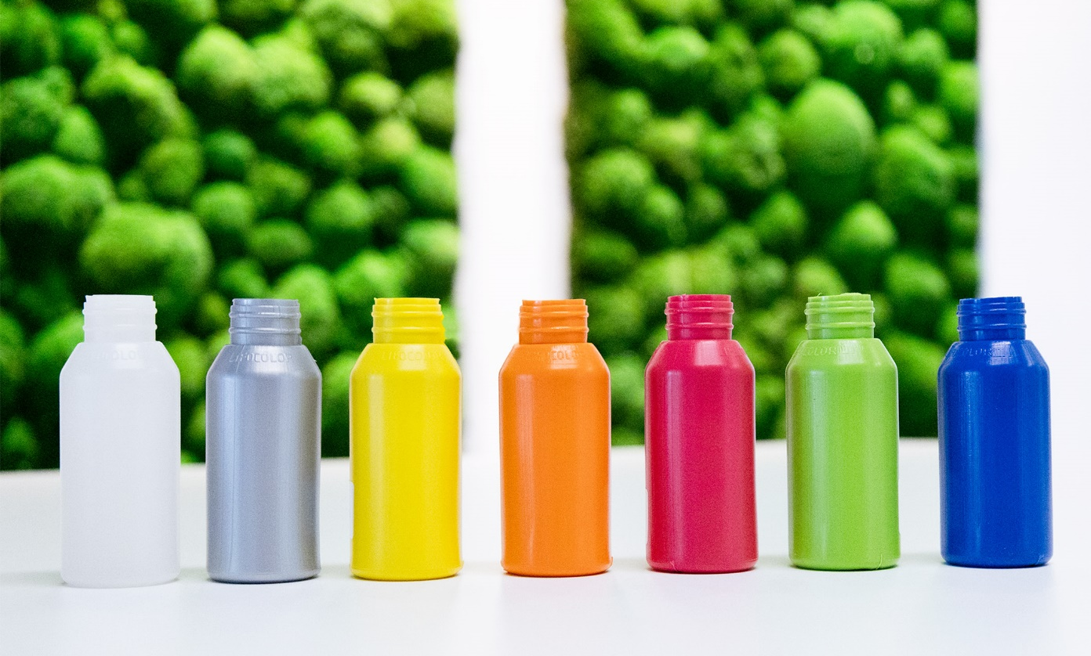
Ravago’s Ravapura PCR polyolefins: Certified recycled content, consistent quality, easy to process and suitable for in-house colouring. © Ravago
Augsburg/Germany, October 2026. –– With the addition of Ravapura®, the distributor Ultrapolymers has expanded its portfolio to include a new family of sustainable polyolefin compounds with a certified PCR content (post-use and post-consumer recycled material). They offer a wide range of applications, from packaging and consumer goods to technical components. Thanks to the consistently high quality of the grades in this range, users can achieve their sustainability goals without compromising on processability, appearance, mechanical properties, or final product specifications.
The Ravapura PE grades in Ultrapolymers’ portfolio are based on either LDPE or LLDPE. These compounds are characterised by their excellent processability and consistent mechanical properties. They are available in a variety of colours and can be coloured in-house. They also comply with RoHS/REACH and ISO 14021:2016 requirements. Typical applications include flexible primary packaging for the non-food sector and secondary or tertiary packaging, such as shrink films, stand-up pouches and foams. Furthermore, PP-based Ravapura grades are suitable for household and white goods, ABS grades are suitable for electrical appliances and furniture components, and PS (HIPS) grades for household goods and electrical applications. If standard grades do not meet specific requirements, Ultrapolymers will develop bespoke grades in close collaboration with Ravago.
Ultrapolymers will be showcasing these and other sustainable plastics, along with their applications, at Fakuma in Hall A5, Stand 5211.
Ravapura® is a trademark of Ravago.
Ultrapolymers offers a wide range of both commodity and speciality polymers. Through its partnerships with leading manufacturers in the plastics industry, the company provides its customers with a diverse product portfolio and access to the best possible solutions for their projects and applications. Founded in Belgium in October 2002, Ultrapolymers has quickly established itself as a leading plastics distributor within the Ravago Group. Further information is available on the Ultrapolymers website: https://www.ultrapolymers.com
For further information please contact:
Magdalena Marten, Ultrapolymers Deutschland GmbH
Unterer Talweg 46, 86179 Augsburg
Tel.: +49 (0) 821 27233-0, magdalena.marten@ultrapolymers.com
Editorial contact, and please send voucher copies to:
Konsens PR GmbH & Co. KG, Dr. Jörg Wolters
Hans-Böckler-Straße 20, D-63811 Stockstadt am Main
Tel.: +49 (0) 6027 99 00 5-13, mail@konsens.de
Please download this press release (text and image) from https://www.konsens.de/ultrapolymers.

