Tosaf launches new additive for halogen-free flame retardancy (HFFR) of PE foams
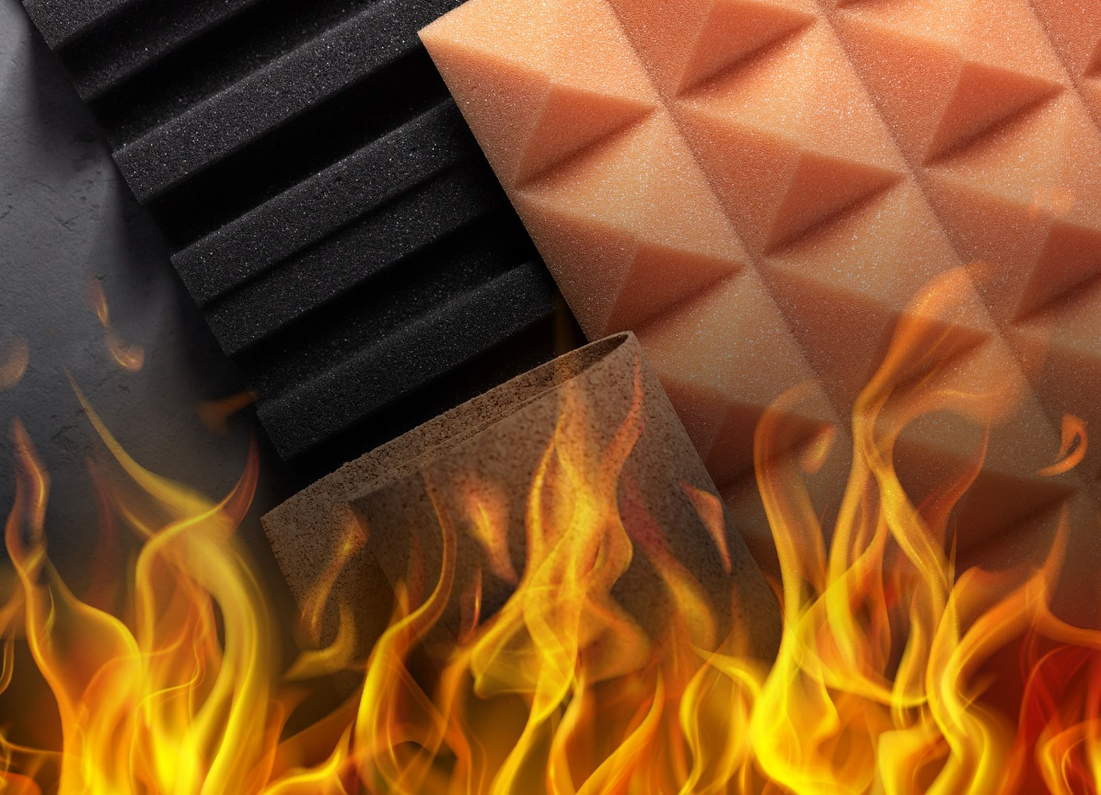
Tosaf’s FR9185PE is an innovative, halogen-free flame retardant (HFFR) for crosslinked and non-crosslinked polyethylene foams. ©Tosaf
May 2023 - FR9185PE is a halogen-free flame retardant (HFFR) additive newly developed by Tosaf for crosslinked and non-crosslinked polyethylene foams, to enlarge its extensive portfolio of market-proven products. Even at low concentrations, it helps prevent the spread and acceleration of fire. It thus facilitates compliance with demanding fire protection standards in industries such as construction, pipe insulation, automotive and shipment packaging.
Their high corrosion resistance, dimensional stability and thermal insulation effect a steadily growing use of PE foams in a wide range of applications including acoustic and mechanical dampers as well as flooring, pipe insulation, and decorative elements. However, their low fire resistance requires the addition of flame retardants. Here, the trend is toward halogen-free formulations for environmental and safety reasons, especially in Europe and the US. Tosaf has expanded its range of flame-retardant masterbatches to include appropriate solutions that do not impair the properties of the foam, but at the same time enable compliance with international fire protection standards.
High efficiency at low concentrations
As the latest representative of these HFFR masterbatches, the new FR9185PE is suitable not only for non-crosslinked but also for crosslinked PE foams. In the event of fire, its phosphorus-based active ingredient initiates a gaseous mechanism that stops combustion by reacting with the resulting free radicals. For achieving a similar performance as with halogen-based mechanisms, 10% to 15% of this product is required. By comparison, other halogen-free systems, which either rely on the formation of a protective layer that suffocates the fire or of water vapor to cool the combustion, require 30% to 60% of addition dosage.
FR9185PE ensures effective dispersion in the foam and does not negatively affect foam nucleation or crosslinking levels, resulting in a consistent cell structure and a high-quality foam product with preserved mechanical properties and thermal stability.
Expanding the portfolio of conventional flame-retardant additives
Halogen free flame retardants are relatively new in the market. Their development is complex, and it is quite difficult to find the diversity which halogen-based products are offering. Thus, FR9185PE EU is considered innovative.
For applications that are still demanding halogen-based products, Tosaf's portfolio covers a wide variety of products.
- Chlorine-based flame retardants such as FR9327PE offer good performance, they are cost-effective and can be used for non-crosslinked PE foams. However, they are not suitable for crosslinked PE and they have limited thermal stability.
- Brominated flame retardants such as FR1653PE are suitable for all types of PE foams. They provide high thermal stability, excellent performance meeting stringent fire standards and do not affect the properties of the foamed product.
New production plant for flame retardant materials
To meet the growing demand for flame retardants, Tosaf has invested in a new, state-of-the-art production facility. A laboratory with state-of-the-art equipment is available for testing in accordance with a wide range of fire standards, including a cone calorimeter for full combustion analysis. In addition, the company has established pilot lines that simulate real production conditions and allow flame retardant additives to be tailored for specific applications.
For over three decades, Tosaf (https://www.tosaf.com/) has been developing and manufacturing high quality additives, compounds and color masterbatches for the plastics industry. With the aim of providing for its customers’ every need, it has continuously grown and developed its offering, production capacity, and global reach, becoming a truly close to the market, global organization. Servicing customers in over 50 countries in Europe, North America, South America, Asia and the Middle East, Tosaf has over 1400 employees spread throughout its production sites, warehouses, sales and distribution offices around the world.
Tosaf CEO Amos Megides established the company in Israel in 1986, and still stands at its head, leading and inspiring his team to always uphold the following three pillars: Exceptional service, the highest quality and continuous innovation. Tosaf’s major shareholders include: Megides Holdings Ltd. and the Ravago Group.
Further information about Tosaf:  Mrs. Rotem Spiegel  Global Marketing Manager  Tosaf Compounds Ltd.  Phone: +972 9 8984610  Email: rotemsp@tosaf.com | Editorial contact and voucher copies:  Dr.-Ing. Jörg Wolters  KONSENS PR GmbH & Co. KG  NEW: Hans-Böckler-Str. 20, D-63811 Stockstadt,  Phone: +49 6027 99005-13  Email: mail@konsens.de
Please find image and text for download at https://www.konsens.de/tosaf

