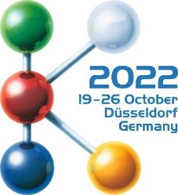  Hall 8a / D01 | Tosaf develops new white masterbatch without TiO₂
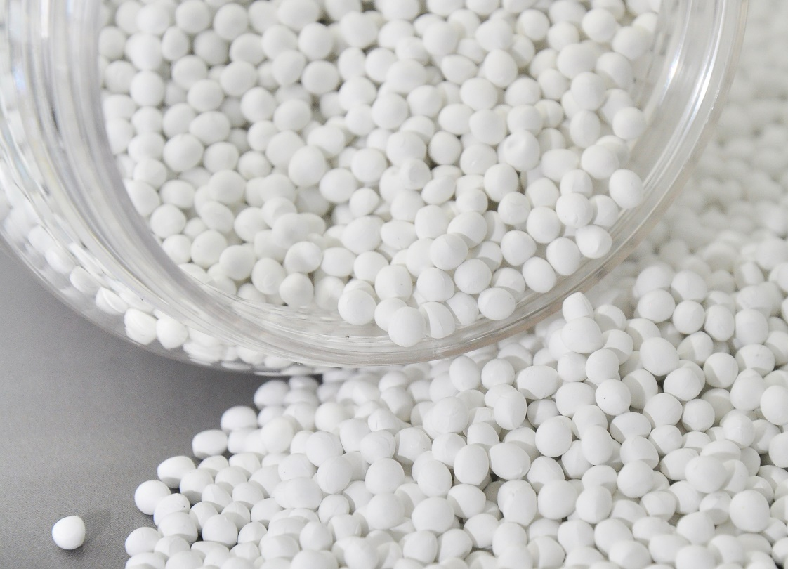
Tosaf has developed white masterbatches as an alternative to conventional types containing TiO₂, which are suitable to produce hard and soft packaging for the food industry, as well as parts for the toys and cosmetics industries. © Tosaf
September 2022 –– At K2022 in Düsseldorf, Tosaf will present a series of new white masterbatches with excellent properties in terms of whiteness, colour strength and opacity, which do not contain titanium dioxide (TiO₂). The company is thus responding to an increasing number of customers inquiries, since regular white pigment is suspected of being carcinogenic when inhaled in powder form, and because the EU has banned it as a food colourant (E171). Although this decision by the EU does not yet ban the use of titanium dioxide as a pigment in polymers that come into contact with food, there is a growing demand among manufacturers of hard and soft packaging for the food industry, as well as parts of the toys and cosmetics industries, to move to TiO₂-free masterbatches in the future.
Such masterbatches have now been developed by Tosaf as cylindrical as well as spherical granules. They are the result of a study initiated by Tosaf Benelux R&D on ways to find alternatives for the white colouring of plastics. Although their formulation does not contain unbound titanium dioxide, their opacity as well as their colour strength is on the same high level as that of standard TiO₂ masterbatches at equal let down rate. The colour shade itself can be adjusted from yellowish to neutral to bluish. As this applies regardless of the carrier system, Tosaf's new patent-pending white masterbatches are compatible with any host polymer. The low abrasiveness allows for long tool life, and no plate-out occurs when processed on two-roll systems.
Michel Theunisz, General Manager of Tosaf Benelux, says: “With the development and launch of our new Non-TiO₂ white masterbatches, available in a wide range of polymer carrier systems, we are giving plastics processors and brand owners the answer to the dilemma they have when it comes to white coloration of plastics for food packaging, cosmetics packaging, medical packaging and toys, regardless the process and regardless the end application. Tosaf’s new white masterbatches allow the plastics market to proactively take action on reducing the use of TiO₂ in Plastics”.
For over three decades, Tosaf has been developing and manufacturing high quality additives, compounds and color masterbatches for the plastics industry. With the aim of providing for its customers’ every need, it has continuously grown and developed its offering, production capacity, and global reach, becoming a truly close to the market, global organization. Servicing customers in over 50 countries in Europe, North America, South America, Asia and the Middle East, Tosaf has over 1400 employees spread throughout its production sites, warehouses, sales and distribution offices around the world.
Tosaf CEO Amos Megides established the company in Israel in 1986, and still stands at its head, leading and inspiring his team to always uphold the following three pillars: Exceptional service, the highest quality and continuous innovation. Tosaf’s major shareholders include: Megides Holdings Ltd. and the Ravago Group.
Tosaf assume no liability, nor take any responsibility of any kind for any outcomes to you or to your business that you believe may have been influenced by reading this information. We provide no warranty, nor representation of any kind, expressed or implied, as to the nature, standard, accuracy, completeness or otherwise of the information, neither to the suitability or otherwise of the products, to any use, application, or specific purpose, etc. It is your sole responsibility to make your own business judgement and to seek professional and/or legal advice relevant to your circumstances and business activities, as well as to match your particular needs and restrictions. Furthermore, it is your sole responsibility as to whether you choose to use or not to use any information provided herein.
Further information about Tosaf:  Mrs. Rotem Spiegel  Global Marketing Manager  Tosaf Compounds Ltd.  Phone: +972 9 8984610  Email: rotemsp@tosaf.com | Editorial contact and voucher copies:  Dr.-Ing. Jörg Wolters  KONSENS PR GmbH & Co. KG  Im Kühlen Grund 10  D-64823 Groß-Umstadt,  Phone: +49 6078 9363-13  Email: mail@konsens.de
Dear editors, please download the image and text of this press release from: https://www.konsens.de/tosaf

