Tosaf's ZD compounds for pearlized BoPP films ensure quality, production efficiency and flexibility in meeting customer requirements.
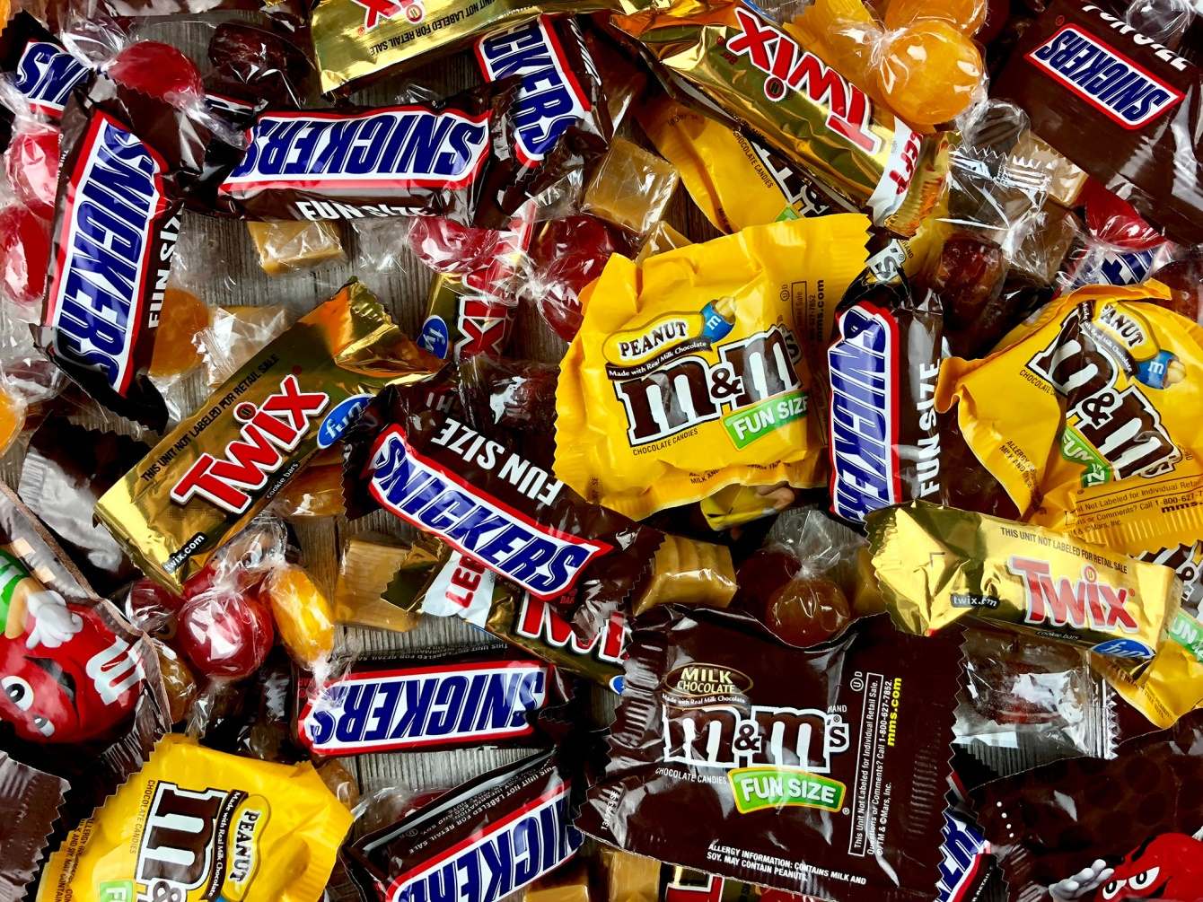
Typical applications of Tosaf’s pearlized Masterbatches include packaging films for chocolate bars or lentils. © JLMcAnally / Shutterstock.com
Alon Tavor, Israel, March 2021 ––The pearlized and white-pearlized masterbatches of Tosaf's ZD family enable manufacturers of BoPP films to flexibly address specific requirements of their customers in the packaging and label industries. When added during processing they ensure uniform film properties as opacity, gloss, and thickness, across the entire width, even when producing films with reduced density or high yield. At the same time, they contribute to stable production lines and thus high productivity.
ZD masterbatches from Tosaf are suitable for the production of pearlized and white-pearlized films in a wide density range from 0.55 to 0.80 g/cm³, with ZD1738HP being optimized for up to 0.65 g/cm³ and ZD2446HP for medium to higher densities. Typical applications include packaging for soap, confectionery, ice cream, baked goods, candy, and snacks. In the label sector for Wrap Around (WAL), In-Mold (IML), Cut & Stack and Pressure Sensitive Labels (PSL).
In parallel with standard grades, Tosaf commercializes white-pearlized compounds based on different ratios of calcium carbonate and titanium dioxide to match density, opacity, and whiteness to specific customer requirements. Films produced with ZD products can be metallized.
Says Saeed Agha, Product Manager for white & compounds at Tosaf: "The high quality of the films and the high production efficiency that can be achieved with the ZD masterbatches are the result of the expertise we have gained over many years of research and development work. We know the market needs of our customers and the common problems encountered in the production of pearlized and white-pearlized films. On this basis, and using the strictest quality control measures, we offer products with real added value that enable manufacturers to combine meeting tight specifications with high yields."
About Tosaf:
For over three decades, Tosaf has been developing and manufacturing high quality additives, compounds and color masterbatches for the plastics industry. With the aim of providing for its customers’ every need, it has continuously grown and developed its offering, production capacity, and global reach, becoming a truly close to the market, global organization.
Servicing customers in over 50 countries in Europe, North America, South America, Asia and the Middle East, Tosaf has over 1000 employees spread throughout its production sites, warehouses, sales and distribution offices around the world.
Tosaf CEO Amos Megides established the company in Israel in 1986, and still stands at its head, leading and inspiring his team to always uphold the following three pillars: Exceptional service, the highest quality and continuous innovation.
Tosaf’s major shareholders include: Megides Holdings Ltd. and the Ravago Group.
For further information about Tosaf please contact:  Ms. Ronit Segal Hayoon  Global Marketing Communication Manager  Tosaf Compounds Ltd.  Phone: +972 9 8984790  Email: ronith@tosaf.com | Editorial contact, and please send voucher copies to:  Dr.-Ing. Jörg Wolters  KONSENS PR GmbH & Co. KG  Im Kühlen Grund 10  D-64823 Groß-Umstadt,  Phone: +49 6078 9363-13  Email: mail@konsens.de

