TechnoCompound at Fakuma 2026:
Sustainable compounds for electrical and electronic and automotive applications
Bad Sobernheim/Germany, October 2026. TechnoCompound, a leading European supplier of bespoke thermoplastic compounds, will be highlighting its ongoing commitment to developing sustainable plastics at Fakuma 2026. At stand A4-4217 in hall A4, the company will focus on recently available material developments for electrical and electronic components, including those for electric mobility. The three main areas of focus are electromagnetic shielding, electrical insulation, and flame retardancy.
Electromagnetic shielding
TechnoCompound's new AbsorbXX products are electromagnetic shielding plastic compounds that provide a lightweight, easy-to-process alternative to metals. Primarily based on polyamide 6 and recycled polypropylene, they are carbon-fibre-reinforced and filled with carbon black. Consequently, they meet the stringent shielding requirements applicable to a wide range of components in the automotive and e-mobility sectors. Depending on the grade, they can achieve EMC shielding of up to 55 dB at frequencies ranging from 30 MHz to 1.5 GHz and beyond.
Tracking resistance
The newly developed TechnoMid GF 30 2 MH H (product code K052500059) is an advanced electrically insulating compound designed specifically for use in electromobility, containing 75% recycled content in the PA matrix. With a CTI rating of 600 V, it offers one of the highest tracking resistances (Group 1) of any electrically insulating thermoplastic. Reinforcement with 30% by weight of short glass fibres also ensures high dimensional stability and excellent mechanical properties. Heat stabilisation provides high resistance to thermal ageing, enabling continuous operating temperatures of up to 150 °C. In addition, it has good resistance to oils, greases and solvents, which is typical of PA6.
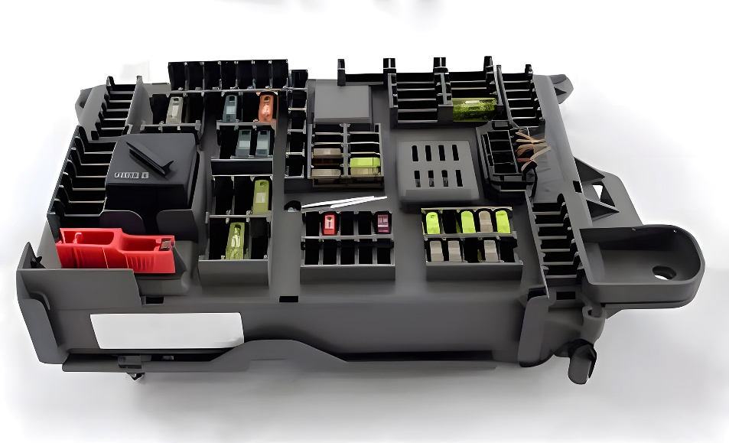
Relay box with a casing made of electrically insulating TechnoMid © TechnoCompound
Flame retardancy
TechnoDur PBT GF 7 1 HFFR V0 (product code 502339) is a new polybutylene terephthalate compound containing 7% by weight of short glass fibres and halogen-free flame retardants. It meets the stringent Class V-0 flammability requirements according to UL94 at 0.4 mm. Thanks to its very low fibre content, it offers high melt flowability and is therefore ideal for producing thin-walled moulded parts with long flow paths.
TechnoDur PBT GF 7 1 HFFR V0 (product code 502339) is a new polybutylene terephthalate (PBT) compound containing 7% by weight of short glass fibres and halogen-free flame retardants. It meets the stringent Class V-0 flammability requirements according to UL94 at 0.4 mm. Thanks to its very low fibre content, it also has a low melt viscosity, making it suitable for thin-walled moulded parts with long flow paths.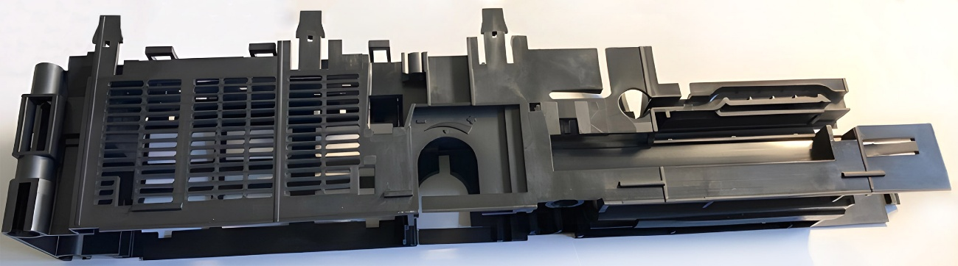
Despite long flow paths, TechnoDur PBT GF 7 1 HFFR V0 meets the mould-filling requirements for this support structure for automatic sliding doors, as well as the specifications for flame retardancy and rigidity. © TechnoCompound
Further new developments and enhancements
In addition to the aforementioned highlights, TechnoCompound will present a wide range of further material innovations at Fakuma 2026, with a focus on sustainability and the use of recycled materials. This will include closed-loop solutions for the plastics cycle in accordance with the End-of-Life Vehicles Regulation (ELV-R) and sustainable packaging solutions designed to comply with the EU Packaging Waste Regulation (PPWR). Other topics will include free-flowing PA6 Easy-Flow grades for injection moulding front-end modules; laser-markable, dimensionally stable PP grades with good creep properties; sustainable PP-LGF grades for automotive interiors; and electrically conductive or electrostatically dissipative PS-ESD compounds for extrusion and injection moulding. These compounds have been specially developed to protect sensitive electronic components from electrostatic discharge (ESD).
TechnoCompound GmbH (www.technocompound.com) in Bad Sobernheim, Germany, which is part of the Polymer-Group (www.polymer-gruppe.de) is a leading supplier of tailored polymer compounds in Europe and has a staff 90. It has state-of-the-art production facilities, and compounds, finishes and modifies polymers with a production capacity of 60,000 metric tons per year for customer-specific applications. The functionally modified polymer range extends from commodities via technical compounds to thermoplastic elastomers.
These polymers are primarily used by the automotive industry and its suppliers. However, applications in logistics, packaging and construction are also served. Its lean organization and modern facilities optimized for efficiency mean TechnoCompound GmbH is able to offer its products at competitive prices. Its full-service offering includes on-site technical application support and the development of compounds individually tailored to a specific application.
The Polymer-Group, with its registered office in Bad Sobernheim, emerged from Polymer-Chemie GmbH, an independent family business founded in 1973 to compound, finish and modify plastics. Combining flexibility and performance, it is increasingly supporting its global customers with innovative and customized products of the highest quality. Today, the Polymer-Group comprises the compounders Polymer-Chemie, Polymer-Chemie Rus, Sun Alloys Europe, TechnoCompound, PolyMIM and SoBiCo and has over 500 staff.
Further information:
Rifat Erden, Leiter Vertrieb und Marketing, TechnoCompound GmbH,
Am Gefach, D-55566 Bad Sobernheim
Tel.: +49 (0) 67 51/8 56 05-472, rifat.erden@technocompound.com
Editorial contact and voucher copies:
Dr.-Ing. Jörg Wolters, KONSENS Public Relations GmbH & Co. KG,
Hans-Böckler-Straße 20, D-63811 Stockstadt am Main
Tel.: +49 (0) 60 27/99 00 5-13, mail@konsens.de
The text and image of this press release can be downloaded from: https://www.konsens.de/pressemitteilungen/technocompound-gmbh

