Investment in growth, efficiency and sustainability:
TechnoCompound to expand its LGF production capacity by 4,800 tonnes per year
Bad Sobernheim, Germany, September 2026. In response to the growing demand for high-performance, long-glass-fibre-reinforced compounds, TechnoCompound is strengthening its sustainable product portfolio. The capacity expansion at the Bad Sobernheim site is being carried out without making significant changes to the processes or altering the technical concept of the existing production facilities. The new production line is scheduled to be operational by the second quarter of 2027.
The company already offers sustainable LGF compounds containing between 25 and 60 per cent post-consumer recycled (PCR) material. These compounds meet or exceed the future requirements of the EU End-of-Life Vehicles Regulation (ELV-R), offering optimal solutions for structural components in vehicle interiors.
Sales Manager Rifat Erden comments: 'By further expanding our production capacity in the LGF sector, we are making a targeted investment in TechnoCompound’s future. The expansion, which will add a further 4,800 tonnes per year, is our response to the steadily growing demand for high-performance, long-glass-fibre-reinforced compounds.”
'With this increase in capacity, TechnoCompound is placing particular emphasis on efficiency and sustainability,' adds Managing Director Dirk Breitbach. ‘The new plant will be operated in an energy-optimised manner and will meet the latest environmental and technological standards. This expansion underlines our commitment to providing innovative material solutions for demanding applications, and to growing as a reliable long-term partner for our customers.”
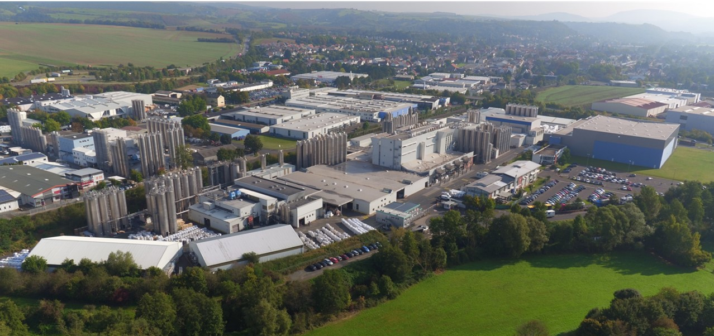
TechnoCompound, production site in Bad Sobernheim/Germany © TechnoCompound
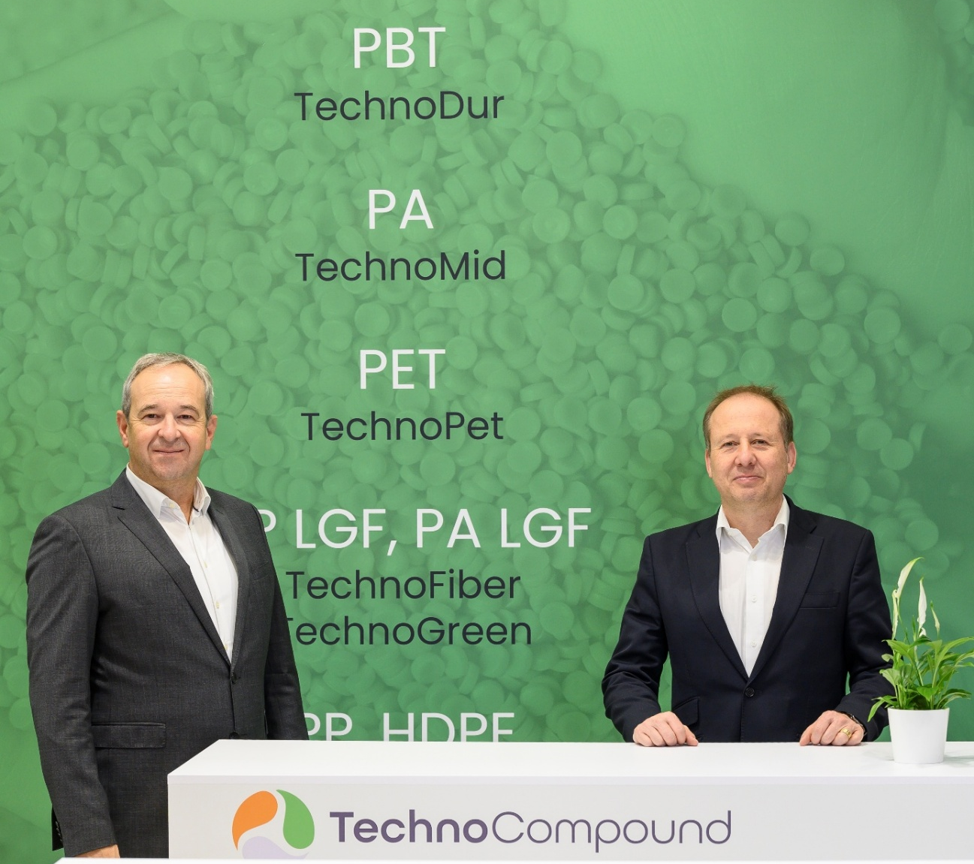
From left to right: Sales Manager Rifat Erden and TechnoCompound’s Managing Director Dirk Breitbach. © TechnoCompound
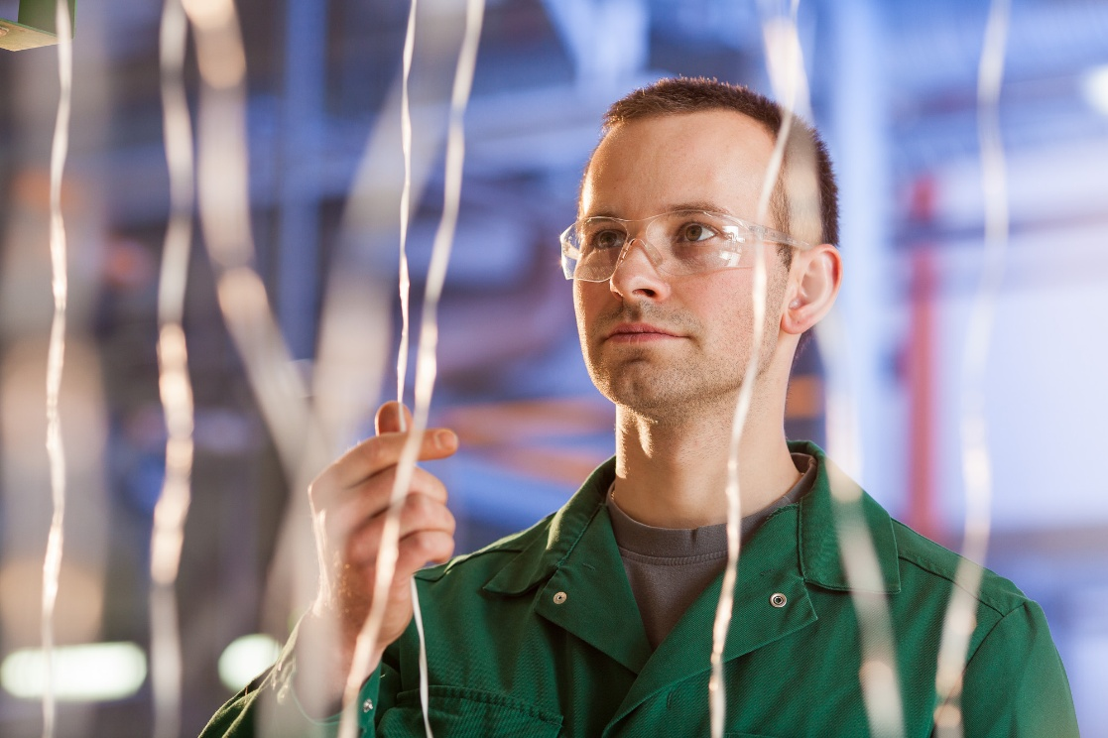
Continuous glass fibre strands are used as a precursor in the production of long-fibre-reinforced thermoplastics. © TechnoCompound
TechnoCompound GmbH (www.technocompound.com) in Bad Sobernheim, Germany, which is part of the Polymer-Group (www.polymer-gruppe.de) is a leading supplier of tailored polymer compounds in Europe and has a staff 90. It has state-of-the-art production facilities, and compounds, finishes and modifies polymers with a production capacity of 60,000 metric tons per year for customer-specific applications. The functionally modified polymer range extends from commodities via technical compounds to thermoplastic elastomers.
These polymers are primarily used by the automotive industry and its suppliers. However, applications in logistics, packaging and construction are also served. Its lean organization and modern facilities optimized for efficiency mean TechnoCompound GmbH is able to offer its products at competitive prices. Its full-service offering includes on-site technical application support and the development of compounds individually tailored to a specific application.
The Polymer-Group, with its registered office in Bad Sobernheim, emerged from Polymer-Chemie GmbH, an independent family business founded in 1973 to compound, finish and modify plastics. Combining flexibility and performance, it is increasingly supporting its global customers with innovative and customized products of the highest quality. Today, the Polymer-Group comprises the compounders Polymer-Chemie, Polymer-Chemie Rus, Sun Alloys Europe, TechnoCompound, PolyMIM and SoBiCo and has over 500 staff.
Further information:
Rifat Erden, Leiter Vertrieb und Marketing, TechnoCompound GmbH,
Am Gefach, D-55566 Bad Sobernheim
Tel.: +49 (0) 67 51/8 56 05-472, rifat.erden@technocompound.com
Editorial contact and voucher copies:
Dr.-Ing. Jörg Wolters, KONSENS Public Relations GmbH & Co. KG,
Hans-Böckler-Straße 20, D-63811 Stockstadt am Main
Tel.: +49 (0) 60 27/99 00 5-13, mail@konsens.de
The text and image of this press release can be downloaded from: https://www.konsens.de/pressemitteilungen/technocompound-gmbh

