Leading the way in sustainability:
TechnoCompound receives Silver certification from EcoVadis
Award recognises holistic approach to sustainability – TechnoCompound ranks among the top 3 per cent in its sector.
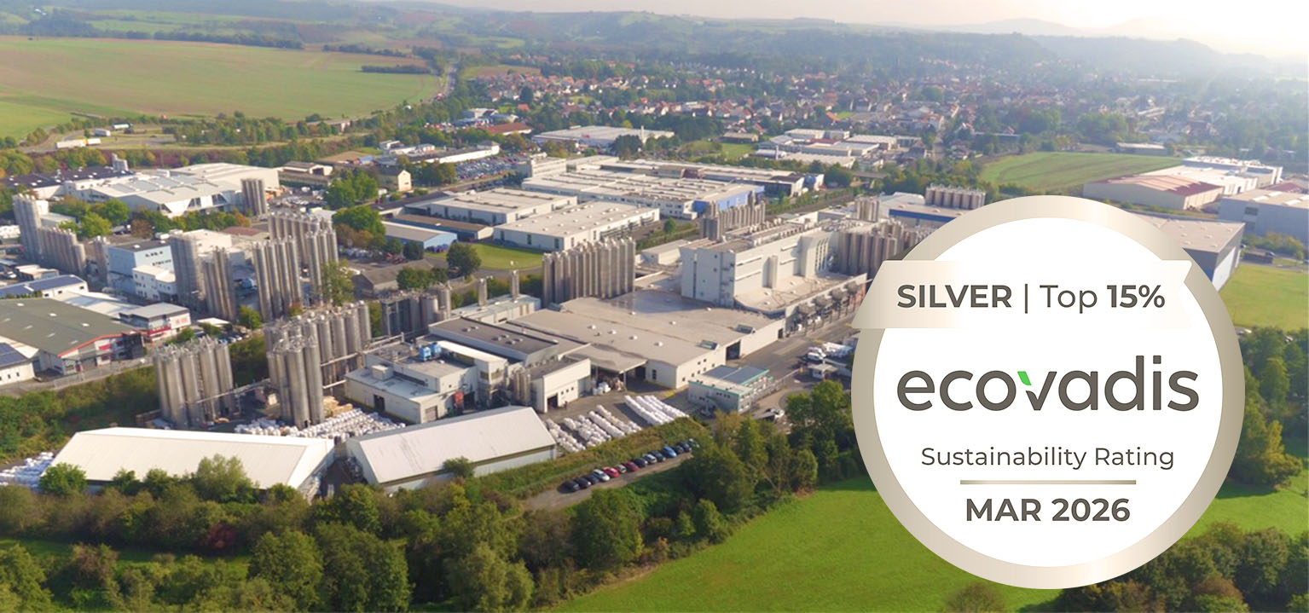
TechnoCompound, Production facility in Bad Sobernheim © TechnoCompound
Bad Sobernheim/Germany, July 2026. On its first certification, TechnoCompound was immediately awarded the Silver medal by EcoVadis and only narrowly missed out on the Gold award. In the EcoVadis overall ranking of around 8,000 companies in the sector, TechnoCompound ranks among the top 3 per cent and is in the top 6 per cent of the 130,000 companies assessed across all sectors. As early as 2025, TechnoCompound received OCS (Operation Clean Sweep) certification, a global voluntary initiative aimed at preventing the loss of plastic pellets, flakes, and powders into the environment.
EcoVadis is one of the world’s leading providers of sustainability ratings for companies. The areas assessed include the environment, labour and human rights, ethics and sustainable procurement. With its Silver rating, TechnoCompound ranks among the top-performing companies within the sector assessed.
Dr Gerald Aengenheyster, Authorised Signatory for R&D and Corporate Sustainability, said: “This award recognises TechnoCompound’s extensive achievements in the field of sustainability and underlines our ongoing commitment to responsible business practices.”
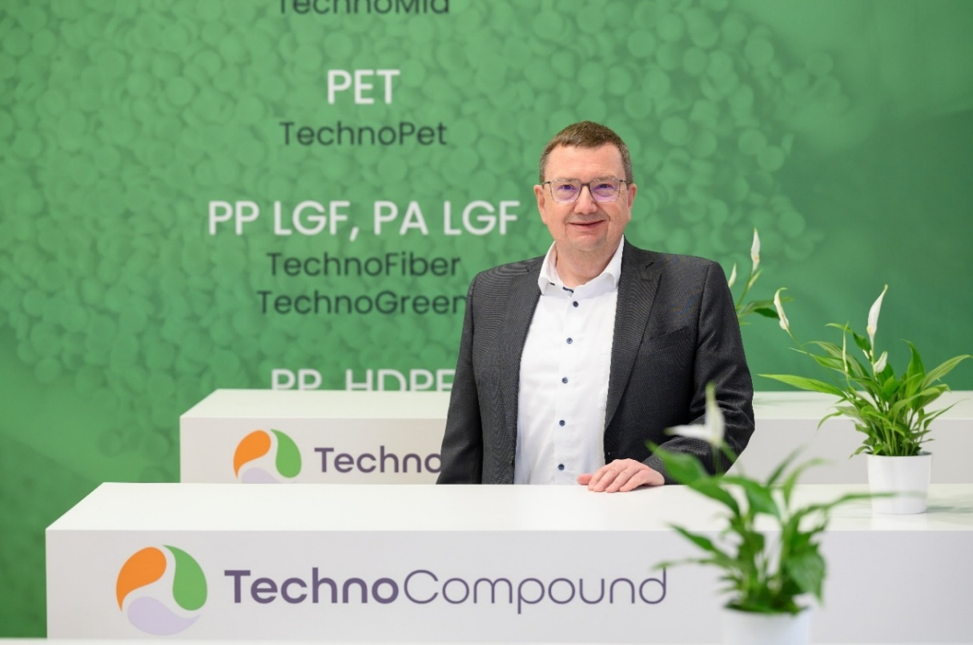
Dr Gerald Aengenheyster, Authorised Signatory for R&D and Corporate Sustainability at TechnoCompound © TechnoCompound
TechnoCompound takes a holistic approach to sustainability – from resource-efficient production processes, which have long made extensive use of recycled raw materials, through to the responsible management of supply chains and social standards within the company The award reflects the progress made in these areas and strengthens the trust of customers, partners and other stakeholders.
Managing Director Dirk Breitbach comments: “Sustainability is a key component of TechnoCompound’s long-term corporate strategy. The company will continue to invest specifically in relevant measures and innovations in the future.”
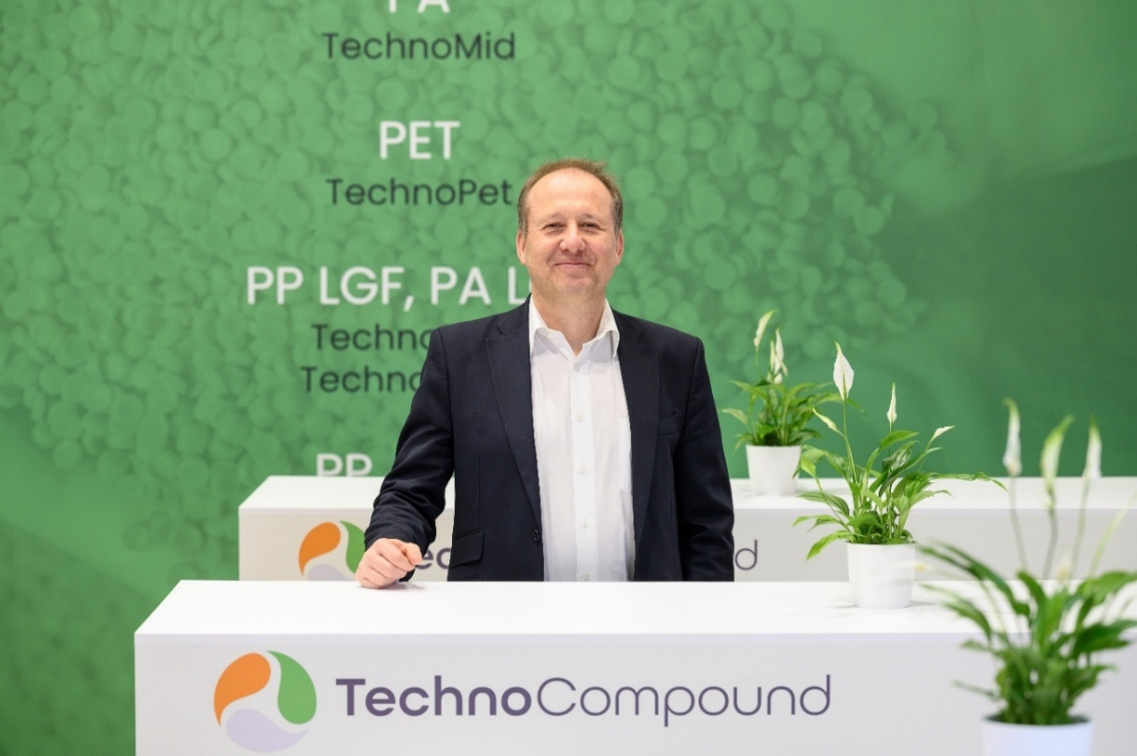
Dirk Breitbach, Managing Director of TechnoCompound © TechnoCompound
TechnoCompound GmbH (www.technocompound.com) in Bad Sobernheim, Germany, which is part of the Polymer-Group (www.polymer-gruppe.de) is a leading supplier of tailored polymer compounds in Europe and has a staff 90. It has state-of-the-art production facilities, and compounds, finishes and modifies polymers with a production capacity of 60,000 metric tons per year for customer-specific applications. The functionally modified polymer range extends from commodities via technical compounds to thermoplastic elastomers.
These polymers are primarily used by the automotive industry and its suppliers. However, applications in logistics, packaging and construction are also served. Its lean organization and modern facilities optimized for efficiency mean TechnoCompound GmbH is able to offer its products at competitive prices. Its full-service offering includes on-site technical application support and the development of compounds individually tailored to a specific application.
The Polymer-Group, with its registered office in Bad Sobernheim, emerged from Polymer-Chemie GmbH, an independent family business founded in 1973 to compound, finish and modify plastics. Combining flexibility and performance, it is increasingly supporting its global customers with innovative and customized products of the highest quality. Today, the Polymer-Group comprises the compounders Polymer-Chemie, Polymer-Chemie Rus, Sun Alloys Europe, TechnoCompound, PolyMIM and SoBiCo and has over 500 staff.
Further information:
Rifat Erden, Leiter Vertrieb und Marketing, TechnoCompound GmbH,
Am Gefach, D-55566 Bad Sobernheim
Tel.: +49 (0) 67 51/8 56 05-472, rifat.erden@technocompound.com
Editorial contact and voucher copies:
Dr.-Ing. Jörg Wolters, KONSENS Public Relations GmbH & Co. KG,
Hans-Böckler-Straße 20, D-63811 Stockstadt am Main
Tel.: +49 (0) 60 27/99 00 5-13, mail@konsens.de
The text and image of this press release can be downloaded from: https://www.konsens.de/pressemitteilungen/technocompound-gmbh

