TOPAS® cyclic olefin copolymers (COC) receive further certifications as reusable materials in the recycling stream
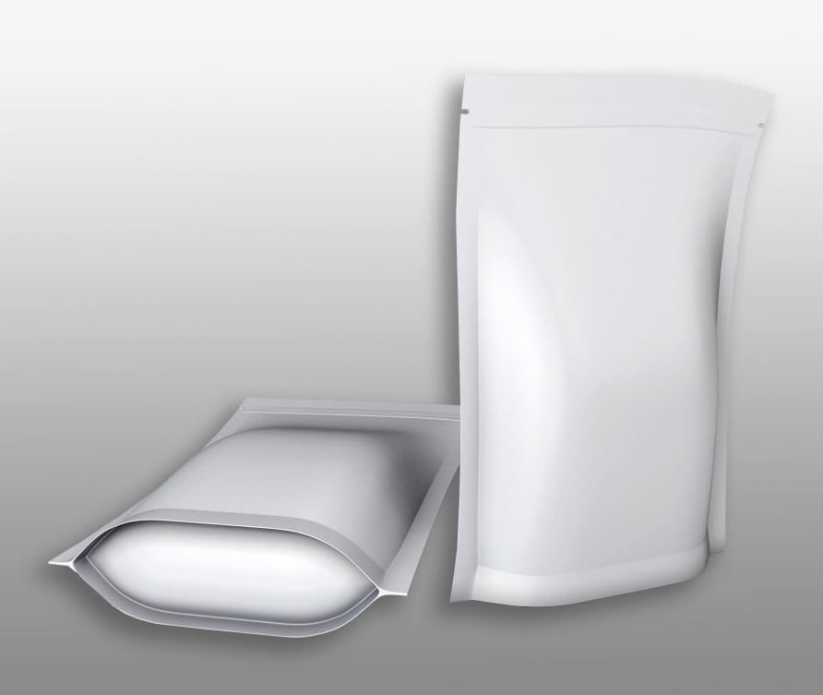 | Multi-layer films for stand-up pouches containing 15.5 % TOPAS® cyclic olefin copolymer (COC) are suitable for recycling in PE waste streams, confirms the APR.  © PantherMedia/3DMAVR
Raunheim/Germany, September 2021 – As a constituent of flexible multi-layer films for stand-up pouches, TOPAS® cyclic olefin copolymers (COC) from TOPAS Advanced Polymers are compatible with polyethylene film recycling streams. This has now been confirmed by the Association of Plastic Recyclers (APR) in the form of a Critical Guidance Recognition. The tests were carried out on stand-up pouch film containing the grades TOPAS® 9506F-500, 8007F-600, 7010F-600 und 6013F-04 with a content of 15.5 %. They comply with or exceed the Critical Guidance Protocol of the APR for PE film and flexible packaging, path 1 (FPE-CG-01).
In 2020, the APR had already tested high-gloss HDPE containers with an outer layer of 20 % TOPAS® 8007F-600 and issued a confirmation of compliance. Apart from that, TOPAS® COC was certified as a reusable polyolefin within the framework of the EU initiative for a circular economy for the recycling paths 1, 3 and 7.
TOPAS Advanced Polymers and the parent company Polyplastics are working together with leading global film manufacturers and brands on the development of recyclable packaging applications. Dr. Dirk Heukelbach, Market Development EMEA at Topas Advanced Polymers: "These certifications in Europe and the US are an important step for brand owners, producers and converters who are on the lookout for recyclable packaging solutions. COC thus proves to be a highly effective material option that can be used as a strategic component to comply with today’s comprehensive sustainability requirements."
The Association of Plastic Recyclers (APR) is an international trade association representing the plastics recycling industry. APR member companies are committed to the success of plastics recycling. Membership spans the entire industry and through their participation APR member companies are shaping the future of the industry. www.plasticsrecycling.org
TOPAS Advanced Polymers GmbH is the world’s leading maker of COC (cyclic olefin copolymer), a glass-clear and extremely pure plastic for healthcare, optics, packaging, and electronics applications. From insulin delivery, to food contact films, to tablet and smartphone components, TOPAS® COC is a high-performance material of choice. The broad global regulatory compliance of TOPAS COC can make developments a simpler task.
TOPAS Advanced Polymers is a business of Polyplastics Co., Ltd., a global leader in the development and production of engineering thermoplastic solutions. Along with COC, the company’s broad product portfolio includes POM, PPS, PBT, and LCP plastics. The company has the largest global market share of POM, LCP and COC. With more than 50 years of experience, the company is backed by a strong global network of R&D, production, and sales resources capable of creating advanced solutions for an ever-changing global marketplace.
TOPAS® is a registered trademark of TOPAS Advanced Polymers GmbH in Germany, the United States, and other countries for its family of cyclic olefin copolymer resins.
Editorial contact and please send voucher copies to:
Dr.-Ing. Jörg Wolters, Konsens PR GmbH & Co. KG,
Im Kühlen Grund 10, D-64823 Groß-Umstadt – www.konsens.de
Tel.: +49 (0) 60 78 / 93 63 - 13, E-Mail: mail@konsens.de

