Press release
For closure caps from Röchling Medical:
Reliable high productivity with servo motor controlled unscrewing units from Servomold
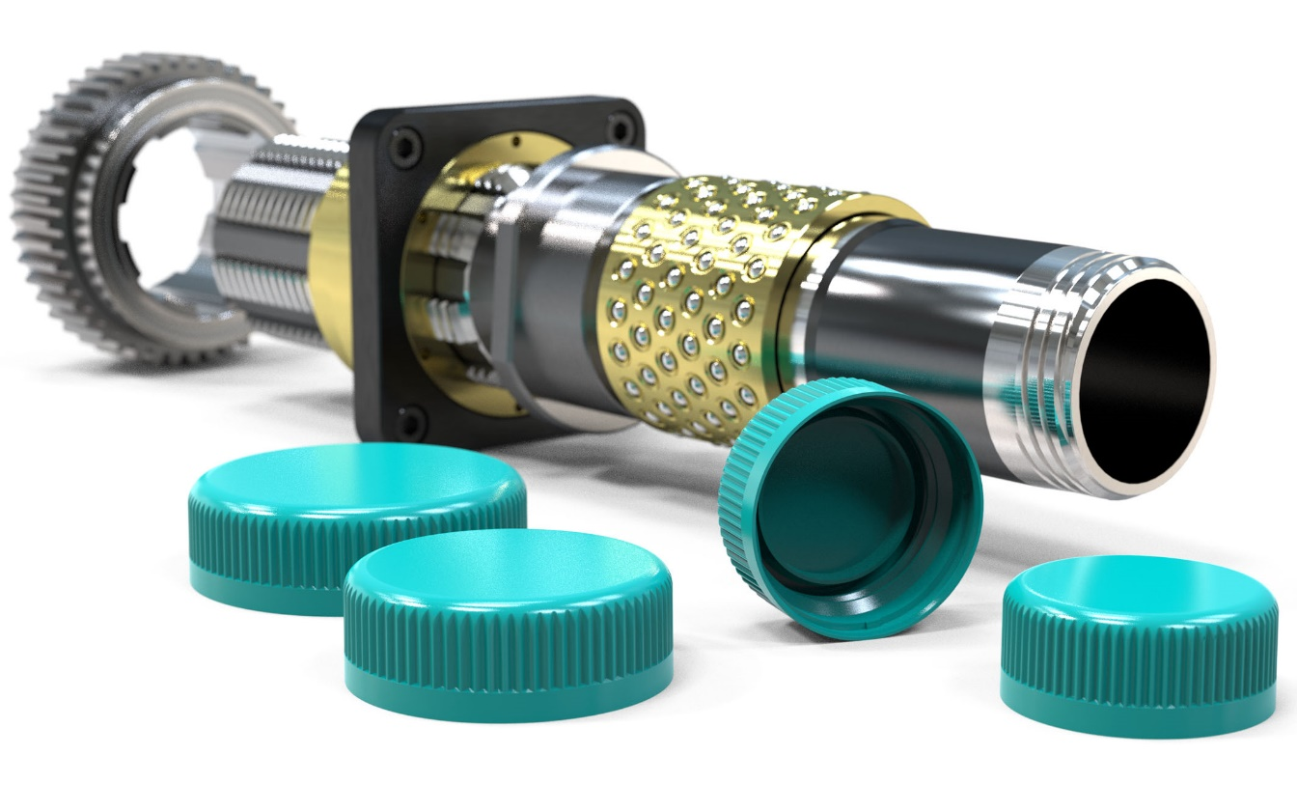
Röchling Medical uses Servomold servo motor controlled unscrewing units in 8- and 16-cavity injection molds for pharmaceutical closure caps. © Servomold
Erbach, Germany, September 2022 – Servomold supplies the servo motor controlled unscrewing units that Röchling Medical uses in one 16-cavity and two 8-cavity injection molds for the production of pharmaceutical closure caps made of polypropylene (PP). Due to the long-standing cooperation, the medical technology manufacturer had involved the Erbach-based expert for servo-electric automation concepts in the development at an early stage. This enabled the entire project to be started and implemented quickly.
Lucas Meister, project manager at Servomold, explains: "The starting point for this successful cooperation were simple hand sketches with the desired dimensions. We had also already supplied the unscrewing unit for an one-cavity prototype mold. This was similar in design to the later series tools and was suitable for three different screw cap sizes thanks to interchangeable thread core sleeves and stand cores."
Mold concept, gear layout and the right servo drive
From the experience gained, the possible system sizes and the basic design of the unscrewing units could be derived directly. For the preparation of a quotation, Servomold calculated on this basis the breakaway torques to be expected at the start of unscrewing. Lucas Meister continues: "We took into account influencing parameters such as the mechanical, tribological and processing characteristics of the PP to be processed, as well as the geometry of the cavities. These and the selected mold concept were then our basis for determining the required torques as the basis for the gear layout. Only then did we select the appropriate servo drive, consisting of a servo motor and planetary gearbox, which could meet the customer's requirements in terms of functional and process reliability. The final step in preparing the quotation was to coordinate the matching servo controller and servo amplifier."
The placement of the order shortly thereafter was the starting signal for the intensive cooperation between the design teams of Servomold and Röchling. This ensured that the three projected injection molds could be completed almost simultaneously. After Röchling had approved the design, the components were manufactured only two months after the initial contact. In parallel, the parties involved coordinated the interface between the control system and the injection molding machine. Thanks to the universal applicability of the Servomold control units already available at Röchling, this essentially focused on the creation of the sequence program. Thanks to their many years of experience with these control units, Röchling's employees were ultimately able to carry out the commissioning themselves.
Thomas Meister, Managing Director of Servomold, comments: "Again and again, our customers are amazed at how much preliminary work we invest in preparing a quotation. This thorough approach takes time, but more than pays off as the project progresses. Our experience and that of our customers shows that it saves from surprises during startup and continuous operation."
And Christopher Heyd, Manager Tool Shop at Röchling Medical, confirms, "This operational and functional reliability has been evident at our company since the first use of a Servomold unscrewing unit nine years ago. Because of this, we already have a total of 15 such units in operation today. In addition to unscrewing caps, they are also used to carry out slide movements or to rotate indexing plates. In no case did the projected performance deviate from the actual performance."
Patented system free from radial forces
Servomold unscrewing units are based on a patented system in which the drive train is separated from the thread core. This avoids drive influences on the thread core and simplifies assembly and maintenance. Radial forces of the drive train are absorbed by thin ring bearings. Thus, they have no influence on the threaded core, which - driven via a splined shaft profile and optimally concentrically guided by preloaded ball cages - moves back and forth through a brass guide nut. "Thanks to this patented design of the unscrewing system," says Thomas Meister, "we achieve very long service lives, minimize wear, and thus ensure high reliability and efficiency."
Other design refinements contribute to this, such as high-precision gear components manufactured with very tight tooth width tolerances and optimized profile correction. Meister continues, "The result of this multitude of design measures is a very high system efficiency by avoiding friction which, in addition to torque losses, could in the worst case lead to damage to the thread core surfaces. In addition, the tool life as well as the consistency and reproducibility of the process sequence are increased."
The Röchling Group has been developing and producing plastic products for various industries for around 200 years. In addition to Industrial and Automotive, this also includes the Medical division. Here, high-quality, customized components and assemblies are produced, up to and including complete OEM products for the market segments Diagnostics, Fluid Management, Surgery & Interventional, and Pharma.
Servomold GmbH & Co. KG, based in Erbach, Germany, is an experienced partner to the moldmaking industry for plastic injection molding. The company name stands for a growing number of standardized and individual solutions for servo-electric and thus clean, space-saving realization of rotational and linear movements in injection mold tools. Applications range from single threads in technical plastic parts to linear slide and core pull movements to multi-cavity closure cap molds.
Further information:
Thomas Meister, Servomold GmbH & Co. KG
Gewerbepark Gräsig 72, D-64711 Erbach
Tel.: +49(0) 60 62/80 933-0
info@servomold.com, www.servomold.com
Editorial contact and specimen copies:
Dr.-Ing. Jörg Wolters, KONSENS Public Relations GmbH & Co. KG
Im Kühlen Grund 10, D-64823 Groß-Umstadt
Tel.: +49(0) 60 78/93 63-13,
mail@konsens.de
You can find this press release as a Word file in German and in English as well as the image in printable quality for download at: http://www.konsens.de/servomold.html

