  Press release |  |   Hall A2, Stand A2-2111
Servomold at Fakuma 2026:
Demoulding of internal threads: rotation and linear motion perfectly synchronised
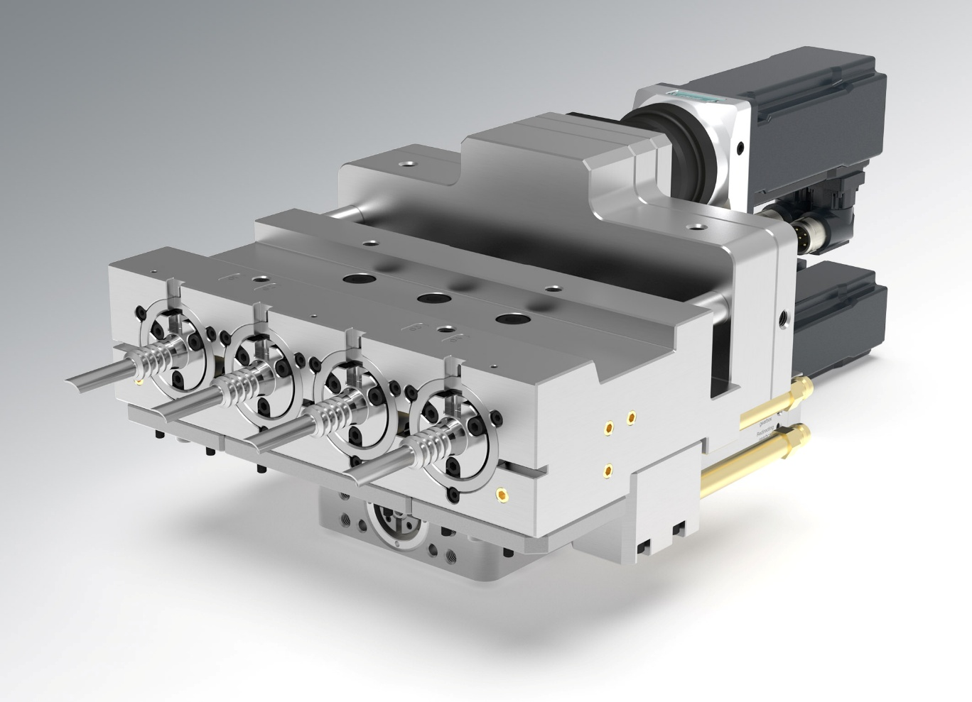
The new servo-electric linear unscrewing unit (SLU) from Servomold. © Servomold
Erbach/Germany, September 2026 – Servomold, a pioneer in the electrification of injection moulding tools, is showcasing its newly developed servo-electric linear unscrewing unit (SLU) for the first time at Fakuma 2026. When demoulding helical internal contours, this unit moves the core both rotationally and linearly in the axial direction with micrometre-level synchronised precision. It thus demoulds threads quickly and with repeatable accuracy, such as those found in plastic components of auto-injectors, pens and similar drug-delivery systems. Two sizes, with minimum core spacings of 40 mm and 60 mm respectively, enable compact mould designs. A single SLU unit can drive up to eight threaded cores. With four units, moulds with a maximum of 32 cavities can therefore be created.
Standardised core holders with customised mould contour attachments enable rapid changes between different contours and pitches. The integrated linear guide simultaneously guides the slide body and enables the demoulding of additional, non-rotating contours. In the closed mould, a mechanical locking mechanism ensures micrometre-precise axial positioning of the threaded core, even at high injection pressures. Cooling of the slider and core is integrated directly into the system, enabling short cycle times.
Software-controlled synchronisation
In conventional unscrewing systems, a lead screw nut generates the axial stroke simultaneously from the rotational movement of the threaded core. Thread pitch, rotation and linear movement are thus mechanically coupled. The SLU separates these functions: one servo drive generates the rotational movement, whilst a second generates the linear stroke. The MoldControl system synchronises both axes electronically. The movement ratio is specified in the control system to match the thread pitch. Furthermore, rotational and linear movements can also be used independently – for example, when, after unscrewing a thread, a long sleeve section is demoulded using purely linear movement. There is no need for a lead screw nut or the associated lead screw, nor for the associated lubrication and adjustment work. As the SLU operates on a servo-electric basis, no hydraulic oil is used. This facilitates clean, low-maintenance operation and use in cleanrooms.
Live at the trade fair
At the exhibition stand (Hall A2, Stand A2-2111), visitors can follow the motion sequence of the new SLU live using a working model. The system is controlled by Servomold’s SMC (Servo MoldControl), which was launched in 2025 and has won awards for its design. Key features include intuitive operation and automatic switching between different position-sensing systems. Alternatively, a video demonstrating the SLU’s functionality is available at https://bit.ly/4zQ3iuW.
In addition, Richard Gane, Sales Director at Servomold, will explain the operation of the SLU and other servo-electric linear actuators in his presentation entitled ‘Servo-electric movements in injection moulding tools’ on Wednesday 14 October at 11.00 am in the Fakuma Forum.
In addition to the new linear unscrewing unit, Servomold will be presenting a comprehensive range of standardised – and therefore cost-effective – servo system components at Fakuma 2026. These include servo-electric single to quadruple unscrewing units, screw extractors for unscrewing threads, ready-to-use unscrewing halves, high-performance servo drive units, space-saving index plate rotators, threaded core sets and rotating threaded core cooling systems for unscrewing units.
Servomold, based in Erbach in the Odenwald, has been developing and manufacturing innovative servo-electric drive solutions for injection moulding tools since 1998, for the production of tubular plastic parts with and without internal threads. Even for complex tasks, these solutions ensure maximum process control and micrometre-precise positioning of the cores. A network of international distribution partners ensures local service and technical support on every continent.
Further information:
Daniel Blömers, Head of Marketing, Servomold GmbH & Co. KG
Gewerbepark Gräsig 72, D-64711 Erbach
Tel.: +49(0) 60 62/80 933-45; dbloemers@servomold.com, www.servomold.com
Press enquiries and review copies:
Dr Jörg Wolters, Konsens Public Relations GmbH & Co. KG
Hans-Böckler-Straße 20, D-63811 Stockstadt am Main
Tel.: +49(0) 60 27/99005-13, mail@konsens.de
You can find this press release in German and English, as well as the image in print-ready quality, at: https://www.konsens.de/pressemitteilungen/servomold-gmbh-co-kg

