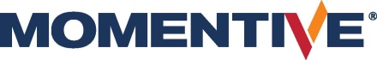 | Press Release
Please find this press release at  https://www.konsens.de/en/press-releases/momentive | 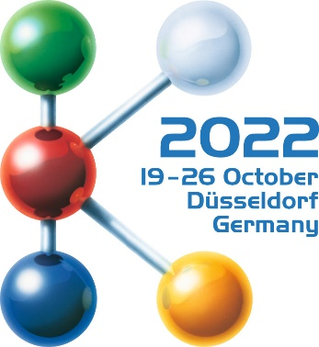  Hall 6  Stand B15
Momentive at K 2022:
Advanced hardcoat technologies for the automotive industry
Leverkusen and Düsseldorf / Germany, 19 October 2022 – At K 2022 Momentive Performance Materials will be presenting the latest developments in SilFORT hardcoat technology for use in demanding automotive exterior applications. Among other things, the precise and material-saving digital coating of three-dimensional moulded parts with the optimised inkjet technology can be experienced live at the trade fair. Other topics include easy-to-clean paint surfaces for sensor elements and protective coatings with improved sustainability.
Highly transparent SilFORT Hardcoats from Momentive are high-performance siloxane resin-based scratch-resistant coatings that expand the range of uses for plastics in exterior and interior applications. Applied to surfaces in ultra-thin layers, they reliably protect against damage caused by UV radiation as well as mechanical and chemical stresses. As a result, their colour, gloss, light transmission and other physical properties are preserved over long periods of time. In many cases, plastic parts which are protected in this way, can replace conventional, heavier materials such as metals and glass and thus contribute to reduced CO₂ emissions.
Three-dimensional inkjet printing saves material
Together with FPT Robotik, Momentive has further developed the use of digital inkjet printing for such applications in a way that these requirements can be met and also combine ecological with economic advantages. With the correspondingly optimised process, only the single drop which is actually needed leaves the nozzle. This free-form digital printing process can be used over large areas and delivers high-quality results on component edges and on parts with complex shapes. At stand B15 in hall 6 visitors can experience live how the digital coating process is used. There, the print head is guided robotically over the component in a pilot booth and simulates how the scratch-resistant coating is applied to the contours of a three-dimensional polycarbonate component using drop-on-demand inkjet technology.
Momentive will also provide information on other new technologies, including easy-to-clean paint surfaces for sensor elements such as LiDAR or cameras, as well as protective coatings with improved sustainability benefits. On the one hand, the focus is on shortening the application process for curing the coating systems to save energy and time. On the other hand, products with reduced solvent content will be presented.
Application-optimised portfolio
Momentive's hardcoats are approved by and in use with the world's leading automotive manufacturers.
SilFORT AS4700-SP1 is a protective clearcoat that gives automotive exteriors in clear and black polycarbonate high scratch, abrasion and weather resistance. This special coating was developed for the use of bell spraying on large parts with complex shapes and facilitates long-term cleaning of the surfaces.
SilFORT UVHC5000K1 is the latest generation of UV-curable, highly weather-resistant protective clearcoats for automotive exteriors and meets the most important global regulations for automotive headlamp applications.
The SilFORT TAC2000 anti-fog coating, applied to the inside of headlamps and sensor covers, prevents condensation.
SilFORT UVHC7400 is a highly scratch and chemical resistant UV-curable clearcoat for automotive interiors and displays. It is suitable for application with the new digital inkjet printing.
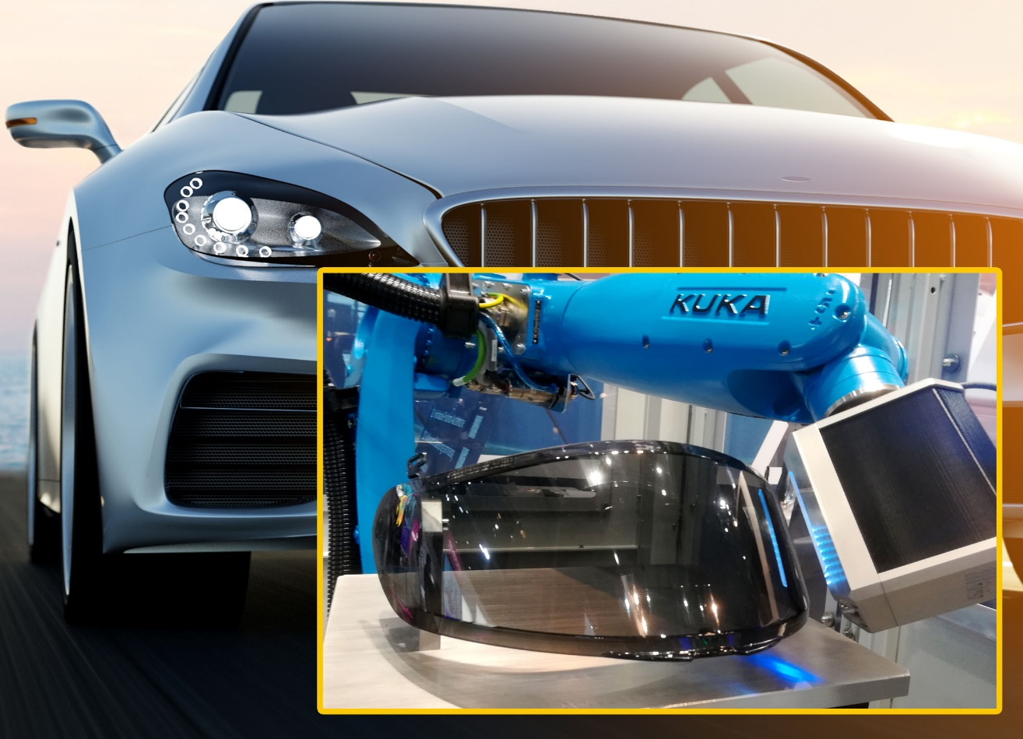
In a digital printing pilot plant, Momentive is developing drop-on-demand inkjet technology for the contour-sharp application of scratch-resistant coatings to three-dimensional components.
© Momentive
About the Company
Momentive is a premier global advanced materials company with a cutting-edge focus on silicones and specialty products. We deliver solutions designed to help propel our customers’ products forward – products that have a profound impact on all aspects of life, around the clock, from living rooms to outer space. With every innovation, Momentive creates a more sustainable future. Our vast product portfolio is made up of advanced silicones and specialty solutions that play an essential role in driving performance across a multitude of industries, including agriculture, automotive, aerospace, electronics, energy, healthcare, personal care, consumer products, construction, and more. Momentive Performance Materials Inc. is an indirect wholly-owned subsidiary of MOM Holding Company. Additional information about Momentive and its products is available at www.momentive.com.
The use of the “™” symbol designates registered or unregistered trademarks of Momentive Performance Materials Inc. or its affiliated companies. Momentive is a registered trademark of Momentive Performance Materials Inc. All third-party trademarks referenced in this this material are the trademarks or registered trademarks of their respective owners.
Further information:  Philipp Tönnemann  Momentive Performance Materials Inc.  Chempark, Gebäude V7  51368 Leverkusen  Phone: +49 (0) 214 30 46503  philipp.toennemann@momentive.com  www.momentive.com | Editorial contact, and please send voucher copies to:  Konsens PR GmbH & Co. KG  Dr.-Ing. Jörg Wolters  Im Kühlen Grund 10  D-64823 Groß-Umstadt  Phone: +49 (0) 60 78/93 63-13  mail@konsens.de, www.konsens.de

