 | Press Release
Please find this press release at  https://www.konsens.de/en/press-releases/momentive | 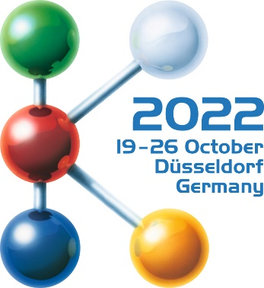  Hall 6  Stand B15
Momentive at K 2022:
New LSR grades for alternative drive concepts
and low curing temperatures
Leverkusen and Düsseldorf, 19 October 2022 - At K 2022 Momentive Performance Materials will present the newly developed product family of NEVSil LSR and HCR silicone rubbers, which is geared towards the requirements of modern mobility concepts, i. e. New Energy Vehicles. The new generation of LTC-LSRs from Momentive, which cure at particularly low temperatures, is especially suitable for thick-walled parts and combinations with temperature-sensitive materials.
NEVSil for alternative vehicle drive systems
Momentive's new LSR and HCR-based NEVSil product family is suitable for a wide range of sealing applications in vehicles powered by alternative energies, including e-mobility, hybrid concepts and fuel cell technology. In addition to a generally low compression set, their wide range of grades includes high temperature resistance as well as flame retardancy, self-lubricating, low viscosity, low stiffness, fast curing, increased crack and ageing resistance, good colourability, and thermal conductivity.
The flame retardant NEVSil FR LSR and HCR grades with Shore A hardnesses ranging from 35 to 70 meet the requirements according to UL94 V-0 for 1 mm thickness with balanced mechanical properties and very good heat resistance. Typical applications include connectors and heat ageing resistant moulded components such as gaskets, O-rings, etc.
Included in the NEVSIL FR portfolio are two NEVSIL SLFR grades, offering both UL94 V-0 flame retardant properties (1mm) coupled with self-lubricating functionality. Both grades are peroxide cured HCR grades offering balanced physical properties in addition to high heat and temperature resistant characteristics.
Resistance to high heat is the outstanding property of the NEVSil HTHR HCR compounds, with Shore A hardnesses ranging from 30 to 80. Properly catalysed, these products qualified to the demanding SAE/USCAR-2 temperature classification T5 (-40 °C to +175 °C at 1008 h) are suitable for demanding environments with long-term exposure to temperatures up to 300 °C. They combine very good mechanical properties with good miscibility, creating a series which is easily blendable to achieve varied hardness levels. Typical applications are O-rings, seals, gaskets, and other moulded parts for high temperature applications.
In addition, the NEVSil portfolio offers thermally conductive silicone technologies in both LSR and HCR offerings. NEVSil TC LSR grades provide hardnesses in both 30 and 60 Shore A, while the HCR version provides a thermally conductive solution in a 60 Shore A durometer. Additional capabilities include Momentive’s ability to custom tailor the thermal conductivity to meet demanding application needs while optimizing the thermal management properties. All grades are easy to process with high reactivity and exhibit low compression set even at low temperatures. Typical applications here are heat dissipating pads and gaskets as well as battery seals.
Dedicated to sealing bipolar plates (BPP) and membrane electrode assemblies (MEA) in fuel cells is Momentive’s new translucent LSR grade NEVSil FC140. Its low viscosity enables a lower injection pressure, critical when overmolding sensitive substrates. In combination with the company’s XP81-A6361 primer technology, the material offers good adhesion properties to both stainless steel and graphite. With its fast cure and low compression set properties without post curing, NEVSil FC140 offers significant advantages over RTV products used in similar applications.
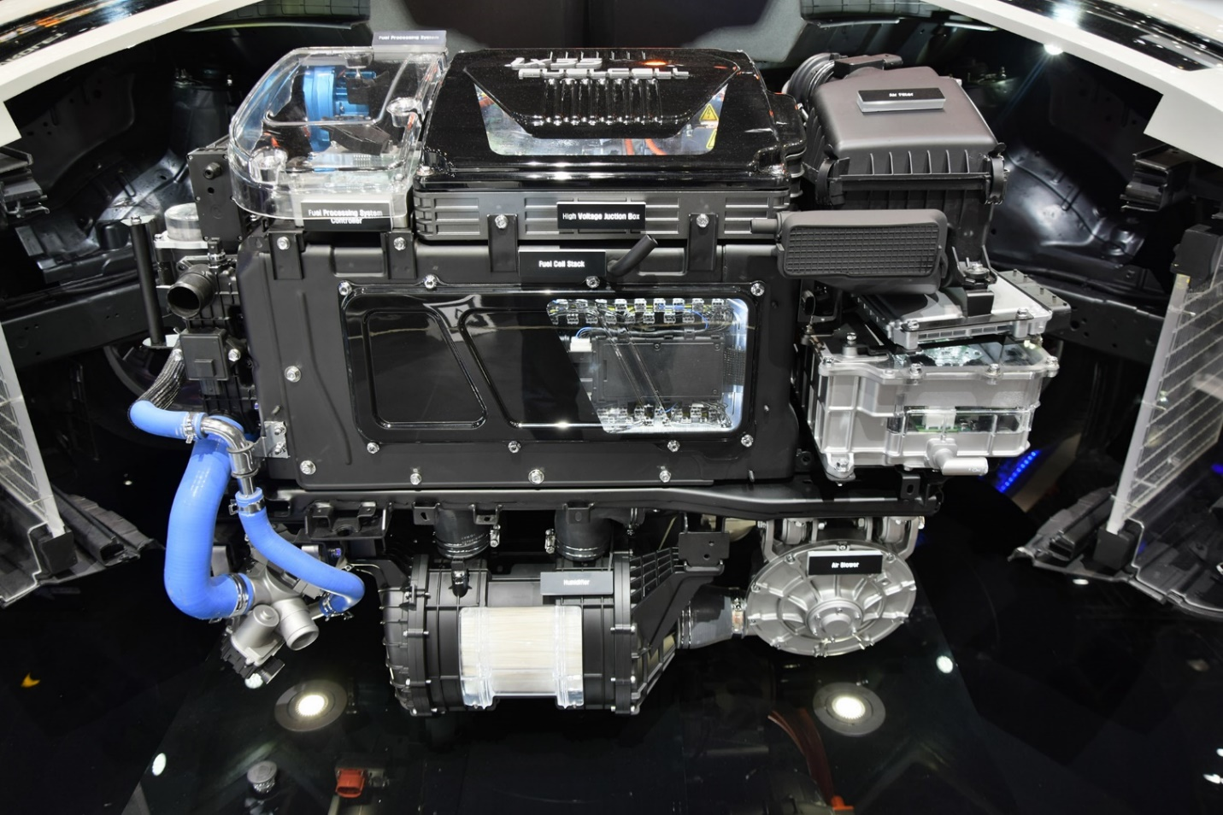
Sealing of bipolar plates in fuel cells is the typical application of the new LSR NEVSil FC140. © Stock photo/Tramino
LTC-LSR: Halved curing time at low curing temperature
Momentive's LTC-LSR (Low Temperature Cure) grades cure at particularly low temperatures, enabling shorter curing times for thicker-walled articles, for example for applications in e-mobility and general high-voltage technology. At the same time, the lower processing temperature allows energy savings in mould heating. For two-component parts, LTC-LSR can also be used to produce material combinations that would not be economical to manufacture with conventional curing LSR due to the low temperature resistance of the material to be overmoulded.
By optimising the reactivity, Momentive was able to realise these diverse advantages with curing times that are acceptable in practice and was already able to demonstrate this at Fakuma 2021 with the LTC type LSR 5650. An even further, productivity-increasing reduction in curing times at low curing temperatures has now been achieved with the development of the LTC generation LSR-K2022. Thanks to further increased reactivity at temperatures between 90 °C and 130 °C, this cures 30% to 50% faster than the previous version. The pot life is more than a week, whereas for conventional curing systems with similarly high reactivity it is less than 24 hours. This means that the efficiency of processing into high-quality moulded parts is significantly higher, not only due to the higher reactivity, but also due to a lower curing in the conveyor system.
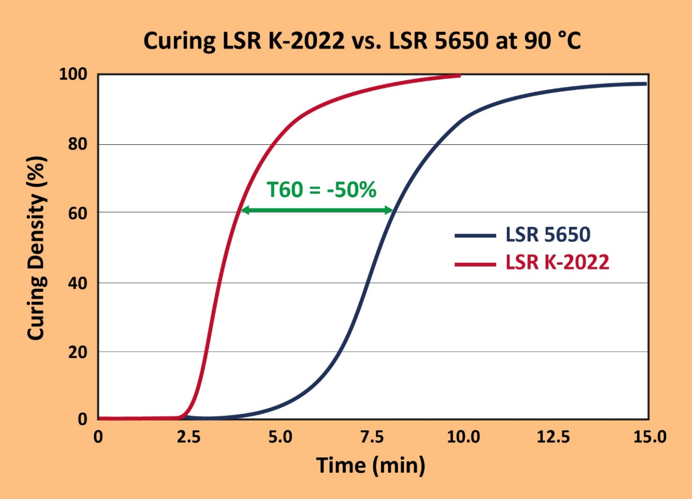
At a cross-linking temperature of 90 °C, the LTC-LSR grade from Momentive presented at K 2022 achieves a curing density of 60 % after only half the time required by the predecessor LTC grade LSR 5650. © Momentive
About the Company
Momentive is a premier global advanced materials company with a cutting-edge focus on silicones and specialty products. We deliver solutions designed to help propel our customers’ products forward – products that have a profound impact on all aspects of life, around the clock, from living rooms to outer space. With every innovation, Momentive creates a more sustainable future. Our vast product portfolio is made up of advanced silicones and specialty solutions that play an essential role in driving performance across a multitude of industries, including agriculture, automotive, aerospace, electronics, energy, healthcare, personal care, consumer products, construction, and more. Momentive Performance Materials Inc. is an indirect wholly-owned subsidiary of MOM Holding Company. Additional information about Momentive and its products is available at www.momentive.com.
The use of the “™” symbol designates registered or unregistered trademarks of Momentive Performance Materials Inc. or its affiliated companies. Momentive is a registered trademark of Momentive Performance Materials Inc. All third-party trademarks referenced in this this material are the trademarks or registered trademarks of their respective owners.

Further information:  Philipp Tönnemann  Momentive Performance Materials Inc.  Chempark, Gebäude V7  51368 Leverkusen  Phone: +49 (0) 214 30 46503  philipp.toennemann@momentive.com  www.momentive.com | Editorial contact, and please send voucher copies to:  Konsens PR GmbH & Co. KG  Dr.-Ing. Jörg Wolters  Im Kühlen Grund 10  D-64823 Groß-Umstadt  Phone: +49 (0) 60 78/93 63-13  mail@konsens.de, www.konsens.de

