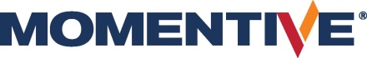 | Press Release
Please find this press release for download at https://www.konsens.de/pressemitteilungen/momentive | 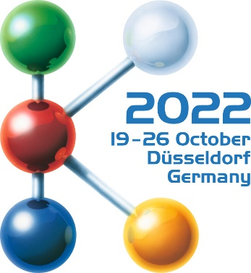  Hall 6  Stand B15
Momentive at K 2022:
LSR and Hardcoats for the mobility of today and tomorrow
Leverkusen, July 2022 – At K 2022, Momentive Performance Materials will focus on the requirements of modern mobility concepts and will present corresponding developments from the areas of Liquid Silicone Rubbers (LSR) and Hardcoats at Booth B15 in Hall 6. These include flame-retardant LSRs grades for the cost-efficient production of hard-soft composites, and grades that crosslink at low temperature, thus facilitating the production of thick-walled parts. In the Hardcoats area, the focus is on innovative scratch and weather-resistant coatings that can be applied with high accuracy and cost-effectiveness to virtually any shaped plastic part for automotive interior and exterior applications.
Temperature resistance with increased flame retardancy
The new LSR grades NL6830FR and NL6850FR, both in dark gray, meet the UL94-V0 requirements at 1 mm thickness. With Shore A hardnesses of 35 and 45, respectively, they combine balanced yet very good mechanical properties with low compression set. Possible applications therefore include seals in the intake area of combustion engines, collective seals and O-rings, for example for use in sensor technology and in the drive area of electric vehicles requiring flame resistance.
Self-lubricating for hard-soft composites
Silopren™ LSR 2725/40 is a further developed, self-lubricating grade. It enables the cost-efficient production of rigid-soft composites in which engineering plastics including PBT are overmolded, for example molded parts with integrated sealing or damping. Because Silopren LSR 2725/40 forms good initial adhesion to the substrate very quickly, short cycle times are possible. Full adhesion is achieved during subsequent storage at room temperature. At the same time, a migration process takes place, which gives the LSR surface its self-lubricating property that facilitates assembly processes. The material is resistant to high temperatures and flexible at low temperatures, combines good dielectric and mechanical properties and can be easily colored.
Even lower curing temperatures
Momentive will present the third generation of its LTC-LSR (Low Temperature Cure Liquid Silicone Rubber) at K 2022. This new liquid silicone rubber cures at even lower temperatures than the development grade presented at Fakuma 2021. This allows the mold temperature to be lowered even further while maintaining the same short heating time, thus saving energy. This can contribute to more sustainability through reduced energy consumption and enables combinations with compounds containing temperature-sensitive formulation components. Alternatively, it is now possible to almost halve the crosslinking time compared with a standard LSR, such as Silopren LSR 2050. Subsequent annealing is not necessary.
Momentive will be demonstrating the processing of the new LTC-LSR at its booth on a Victory 100-120 injection molding machine from Engel Austria GmbH. In this process, a fully automated mold with cold runner and valve gate system from ACH Solution GmbH is used to produce thick-walled, translucent tea light holders as giveaways that resemble cut glass in appearance.
Sustainable Hardcoat solutions for the protection of automotive exterior parts
Also at Booth B15 in Hall 6, the Hardcoats division of Momentive will present sustainable material- and energy-saving solutions in the field of crystal-clear, scratch and weather-resistant protective coatings for automotive exterior parts. Applied as an ultra-thin layer to the surface of plastic parts, Hardcoats reliably protect against damage caused by UV-radiation and mechanical and chemical stresses.
Applications in automotive exteriors include forward lighting, decorative trim and sensor covers. Increasingly, the focus is on plastic front modules that are replacing classic radiator grilles on electric vehicles. Long-lasting Hardcoat solutions can be applied evenly to such large, three-dimensional surfaces, saving time, materials, and costs.
Momentive will be demonstrating what is possible with a live digital printing demonstration installed at the trade show booth together with the company FPT Robotik. This enables the scratch-resistant coatings to be printed with sharp contours onto a three-dimensional polycarbonate component using drop-on-demand inkjet technology. In an improved process, only the drop that is actually needed leaves the nozzle. This free-form digital printing process, which can be used on a large scale, also delivers high-quality results on component edges and for complex shapes. The demonstration will take place in a pilot booth where the print head is guided robotically over the component.
Momentive will also provide information on research topics, including easy-to-clean coated surfaces for sensor elements, such as LiDAR or cameras, and will show current examples of front modules from serial production.
About the Company
Momentive is a premier global advanced materials company with a cutting-edge focus on silicones and specialty products. We deliver solutions designed to help propel our customers’ products forward – products that have a profound impact on all aspects of life, around the clock, from living rooms to outer space. With every innovation, Momentive creates a more sustainable future. Our vast product portfolio is made up of advanced silicones and specialty solutions that play an essential role in driving performance across a multitude of industries, including agriculture, automotive, aerospace, electronics, energy, healthcare, personal care, consumer products, construction, and more. Momentive Performance Materials Inc. is an indirect wholly-owned subsidiary of MOM Holding Company. Additional information about Momentive and its products is available at www.momentive.com.
The use of the “™” symbol designates registered or unregistered trademarks of Momentive Performance Materials Inc. or its affiliated companies. Momentive is a registered trademark of Momentive Performance Materials Inc. All third-party trademarks referenced in this this material are the trademarks or registered trademarks of their respective owners.
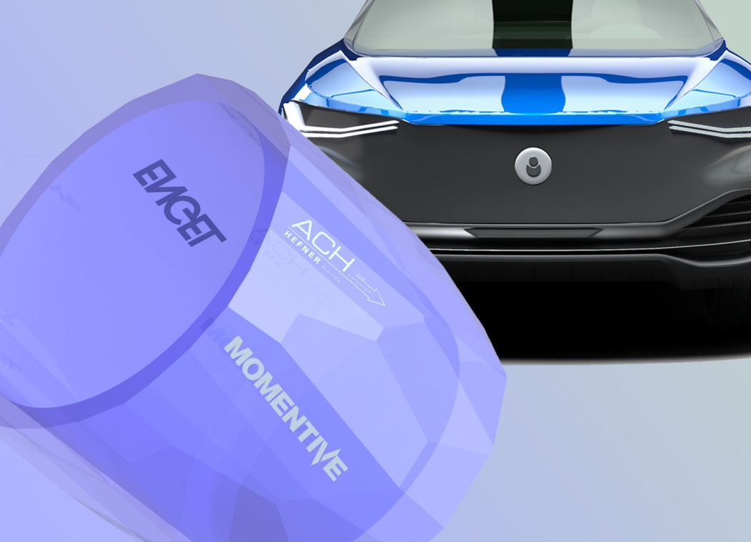
At its booth B15 in Hall 6, Momentive is processing the new LTC-LSR, which now crosslinks at an even lower temperature, into thick-walled tea light holders as a giveaway for visitors, while the Hardcoats division is demonstrating the fully automated coating of a three-dimensional component using free-form digital printing.
Further information:
Philipp Tönnemann
Momentive Performance Materials Inc.
Chempark, Gebäude V7
51368 Leverkusen
Phone: +49 214 30 46503
philipp.toennemann@momentive.com
www.momentive.com
Editorial contact, and please send voucher copies to:
Konsens PR GmbH & Co. KG
Dr.-Ing. Jörg Wolters
Im Kühlen Grund 10
D-64823 Groß-Umstadt
Phone: +49 60 78/93 63-13
mail@konsens.de
www.konsens.de

