 | Press Release
Please download text and image from https://www.konsens.de/en/press-releases/momentive | Hall A4  Stand A4-4307
Momentive at Fakuma 2021:
LSR for e-mobility and more flexibility in processing
New developments from Momentive Performance Materials include thermally conductive liquid silicone rubber grades that are designed for use at high temperatures. In addition, the silicone specialist from Leverkusen has developed a new cross-linking technology that is already effective at low temperatures and at the same time brings more flexibility for processors due to its long pot life.
Leverkusen und Friedrichshafen/Germany, October 12th, 2021 – Momentive Performance Materials is expanding its materials portfolio. Due to their thermal conductivity, the new liquid silicone rubbers (LSR) NL9360 and NL9330 are particularly suitable for dissipating high temperatures from sensitive components, for example in electronics applications. They are therefore predestined for the production of parts in the drive sector or charging management of electric vehicles. Momentive’s equally new LTC-LSR already cross-links at low temperatures while remaining processable at room temperature for a very long time, enabling new materials combination options as well as a flexible production.
NL9360 and NL 9330 – New applications for LSR in the engine compartment
The thermally conductive grade NL9360 with a hardness of 60 Shore A is optimised for injection molding and combines short processing times with high stability and flexibility. In addition, it has a low compression set of only 10%. The thermal conductivity is 1.5 W/mK, which is around five times higher than conventional LSR. NL9330 is an equally thermally conductive LSR-grade with a hardness of 30 Shore A and a compression set of only 9%, also developed for injection molding.
Both, NL9360 and NL9330 have been specified for the production of heat conducting pads and seals as well as cooling units in the engine compartment of vehicles. They are resource-saving and maintenance-friendly due to their low weight and long durability compared to alternative materials.
Faster, more flexible and safer production with Low Temperature Cure
With LTC-LSR, the material experts at Momentive have developed a Low Temperature Cure Liquid Silicone Rubber which already cures at 110 °C, i.e. at a considerably lower temperature than previously available grades. Tests show that the mold temperature can be reduced by 30 °C in comparison without having to extend the heating time. Instead of reducing the processing temperature, the cross-linking time can alternatively be reduced by up to 45% compared to a standard LSR, such as Silopren™ LSR 2050.
This opens up new material combinations for LSR, for example with temperature-sensitive thermoplastics. Subsequent tempering is not required. The production time of the parts is shortened and the risk of burns during demolding is reduced. Once the A and B components of LTC-LSR are mixed, they can be stored and processed at room temperature for over a week, giving high design flexibility for processing procedures.
At its Fakuma exhibition stand A4-4307 in Hall A4, Momentive is demonstrating the processing of the new material on an electric Allrounder 470 A injection molding machine from Arburg. Thick-walled mini frisbee discs are produced there using a mold from ACH Solution. Sigmasoft supports the demonstration with a simulation that calculates and visualises the advantages of the new material.
Momentive Performance Materials Inc. is a global leader in silicones and other advanced materials. For 75 years, the company has brought to market high-performance applications for major industries that make everyday life easier and better. Momentive develops science-based solutions by aligning its extensive technology portfolio with customer needs. The company is an indirect wholly owned subsidiary of MOM Holding Company. For more information about Momentive and its products, visit www.momentive.com.
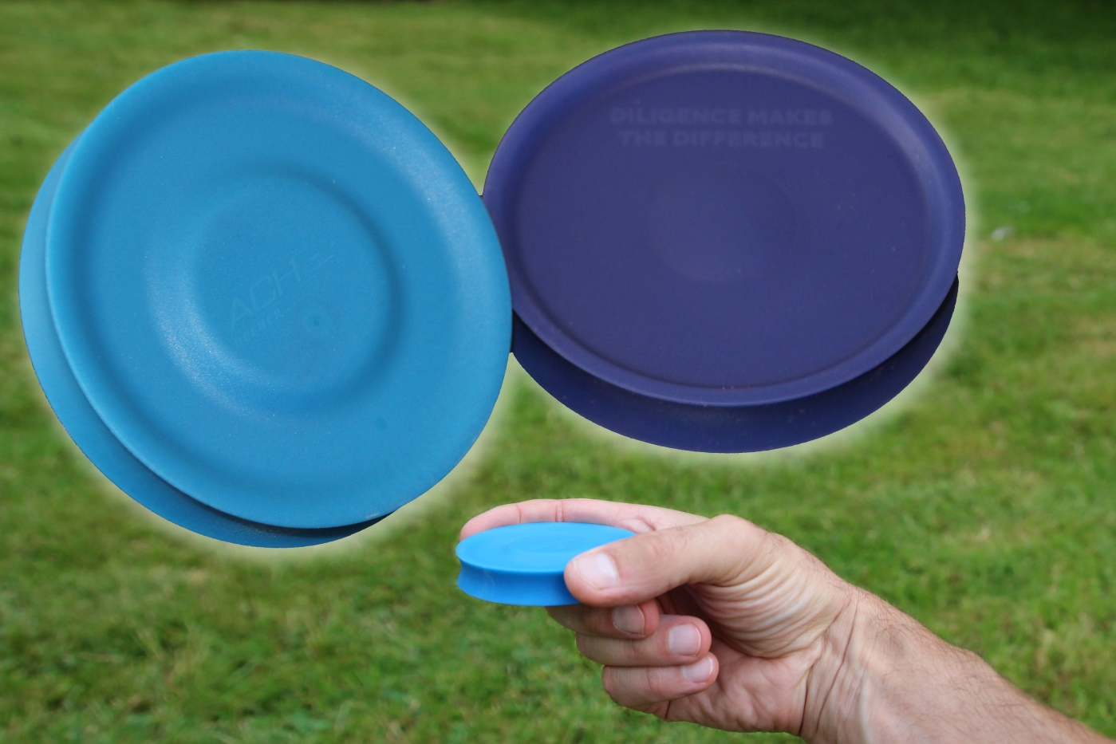
At its stand A4-4307 in Hall A4, Momentive demonstrates live processing of the new, low-temperature crosslinking LTC-LSR into thick-walled mini frisbee discs.
X X X
Further Information:  Philipp Tönnemann  Momentive Performance Materials Inc.  Chempark, Gebäude V7  51368 Leverkusen  Tel: +49 (0) 214 30 46503  philipp.toennemann@momentive.com  www.momentive.com | Editorial Contact and please send voucher copies to:  Konsens PR GmbH & Co. KG  Dr.-Ing. Jörg Wolters  Im Kühlen Grund 10  D-64823 Groß-Umstadt  Tel.: +49 (0) 60 78/93 63-0  mail@konsens.de  www.konsens.de

