Regrind from Engineering Plastic Residues:
New Workshop Creates Space for Further Expansion
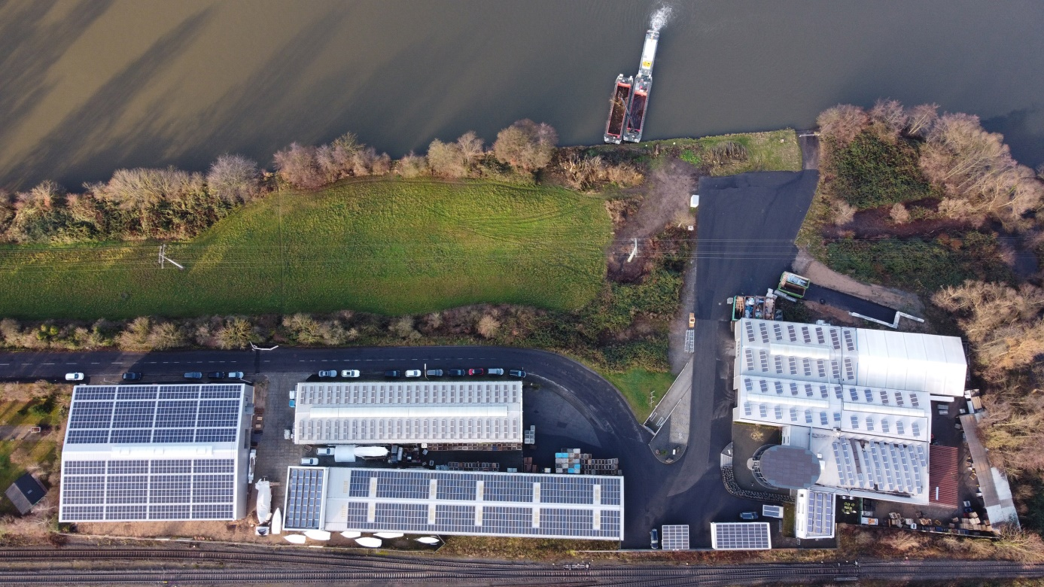
Including the new workshop 6 (on the left in the photo), Krall Kunststoff-Recycling has a total floor area of 6800 square meters available for sorting and grinding production residues from the plastics industry as well as for recycling CDs.
© KRALL Kunststoff-Recycling
Elsenfeld, Germany, January 2022 ––Krall Kunststoff-Recycling GmbH has further increased its floor area at its headquarters in Elsenfeld am Main by commissioning another workshop in late 2021, so enabling this expanding business to bring its production and storage capacity into line with growing demand for secondary plastic materials for processing into sorted regrind. Including these additional 2100 square meters, Krall now has six workshops with a total floor area of 6800 square meters.
As executive director Markus Krall explains, “The enforced use of high-quality recycled materials by all industries is boosting demand for plastic regrind of highest purity and best quality. Our new workshop gives us the space we need to bring our processing capacity into line with market demand for engineering thermoplastics like PC, PMMA, and PET-G. At the same time, it gives us room for future growth. As a result, we can meet the constantly growing demand from our customers for engineering plastics, including not only PA, POM or PC/ABS, but also high-performance materials such as PEEK, PPSU, and fluoropolymers.”
Like all the buildings on the Krall Kunststoff-Recycling site, the new workshop 6 is designed for maximum energy efficiency. The entire roof is covered with state-of-the-art, high-efficiency solar panels with a generating capacity of 220 kW. As Markus Krall says, “With total solar generating capacity of 550 kW, we are now able to meet the majority of our power requirements for our systems and buildings with our own, environmentally friendly energy generation. Apart from making the greatest possible use of solar energy, we also consistently select our installed plant and equipment on the basis of the best possible balance of performance to energy consumption.”
Krall Kunststoff-Recycling GmbH is a family-owned, certified recycling company centrally located in the Rhine-Main area. Since the early 1990s, the company has been reusing nearly all types of plastic waste from production processes in sorted or mixed form. Another focus is CD recycling. Krall provides the complete infrastructure, including space-saving collection bins and logistics, for around 800 manufacturing, retail and commercial collection points across Europe. With 34 employees, two shredding machines, and 10 cutting mills, the company reprocesses some 8000 tonnes of plastic materials each year. The company’s custom-developed process technology means that even similar plastics can be clearly identified and sorted by type.
Further information:  Markus Krall, Managing Director  Krall Kunststoff-Recycling GmbH  Glanzstoffstr. 21  D-63820 Elsenfeld am Main  Tel.: +49.6022.7099-0  markus.krall@krall.de  https://kunststoff-recycling.de | Editorial contact and voucher copies:  Dr. Jörg Wolters  Konsens PR GmbH & Co. KG  Im Kühlen Grund 10  D-64823 Groß-Umstadt  Tel.: +49.6078.9363-13  joerg.wolters@konsens.de  www.konsens.de
This press release information as a docx-file and the photo in printable resolution
can be downloaded from
https://www.konsens.de/en/press-releases/krall-kunststoff-recycling-gmbh

