Excellent Ecological Footprint for Technical Plastic Regrinds
A Certified Pioneer in the Recycling Industry
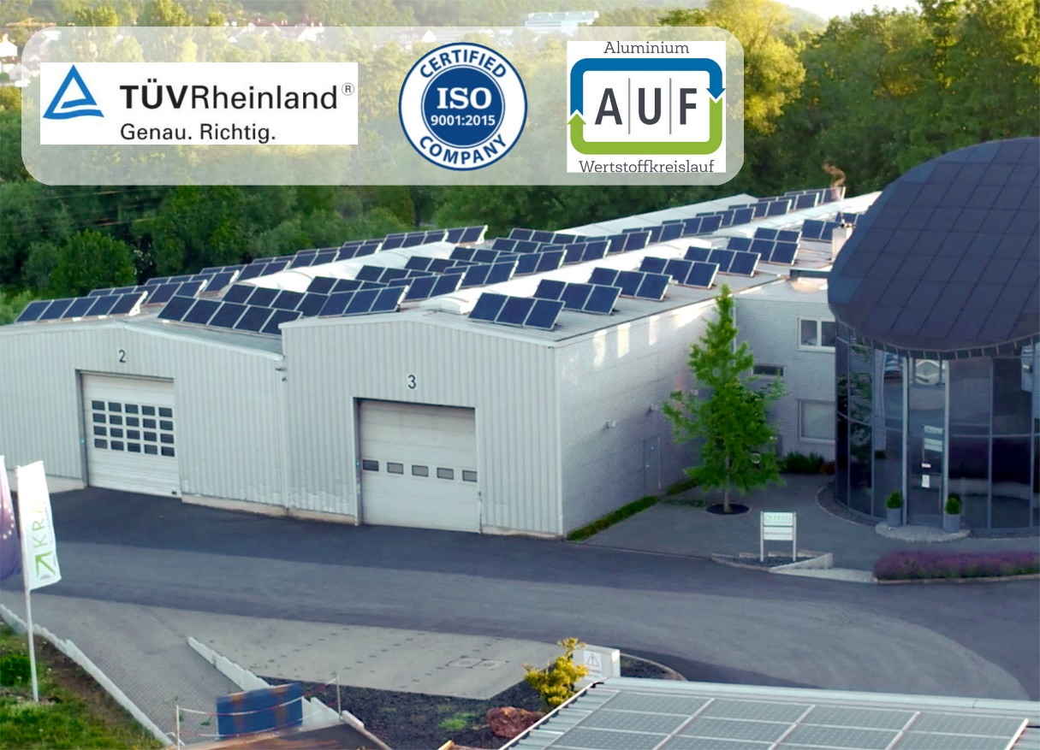
Thanks to self-generated solar energy, the technical regrinds from Krall Kunststoff-Recycling score with excellent carbon footprints. © Krall Kunststoff-Recycling
Elsenfeld/Germany, April 2023 –– As a pioneer in the recycling industry, Krall Kunststoff-Recycling can now prove that the CO₂ equivalents of the PMMA, PET and PC regrinds produced there from post-industrial plastic waste are up to 95% lower than those of corresponding virgin materials. One key to this particularly high contribution to sustainability is the extensive use of solar energy generated in-house. The calculation of the carbon footprints, which was carried out at a renowned institute, was based on the international standards DIN EN ISO 14040 / 14044 on "Life Cycle Assessment" and DIN EN ISO 14067 on "Carbon Footprint of Products".
Company founder and managing director Markus Krall comments: "The documentation of greenhouse gas savings gives our customers and partners a valuable aid for proving and evaluating their own environmental measures. The high values that apply specifically to our regrinds make a particularly positive contribution to this."
Variety of certifications strengthens trust among suppliers, customers, and partners
As a further confidence-building measure, Krall has already demonstrated in the course of an audit by TÜV Rheinland Cert in 2022 that the quality management system anchored in the company fulfils the extensive requirements of ISO 9001 in all areas, from purchasing to goods receipt, preparation and storage to distribution and dispatch of the goods.
TÜV Rheinland Cert also confirms that the company complies with the strict criteria of the Ordinance on Specialised Waste Management Companies. This certification is tailored to the specific conditions in the industry and at Krall covers the storage, treatment and recycling of waste from technical plastics, polyolefins and composite materials. It certifies the technical and expert knowledge as well as the reliability of the management and the responsible persons in the company.
This was consistently followed in January 2023 by the certification of AUF as an authorised collection partner, which is actively committed to aluminium and the environment in the window and façade construction sector, from which many of the processed residual materials originate.
Last but not least, the German Creditreform certifies Krall's excellent creditworthiness with the CrefoCert certificate, which only 2% of all German companies can boast.
Krall Kunststoff-Recycling GmbH is a family-owned, certified recycling company centrally located in the Rhine-Main area. Since the early 1990s, the company has been reusing nearly all types of plastic waste from production processes in sorted or mixed form. Another focus is CD recycling. Krall provides the complete infrastructure, including space-saving collection bins and logistics, for around 800 manufacturing, retail, and commercial collection points across Europe. With 34 employees, two shredding machines, and 10 chopping mills, the company reprocesses some 8000 tonnes of plastic materials each year. The company’s custom-developed process technology means that even similar plastics can be clearly identified and sorted by type.
Further information:  Markus Krall  Managing Director  Krall Kunststoff-Recycling GmbH  Glanzstoffstr. 21  D-63820 Elsenfeld am Main  Tel.: +49.6022.7099-0  markus.krall@krall.de  https://kunststoff-recycling.de | Editorial contact, and please send voucher copies to:  Dr. Jörg Wolters  Konsens PR GmbH & Co. KG  NEW: Hans-Böckler-Str. 20  D-63811 Stockstadt  Tel.: +49.6027.90055-13  joerg.wolters@konsens.de  www.konsens.de
This press release information as a docx-file and the photo in printable resolution can be downloaded from https://www.konsens.de/pressemitteilungen/krall-kunststoff-recycling-gmbh

