Turning Waste into Sought-after Raw Materials:
30 Years of Krall Kunststoff-Recycling
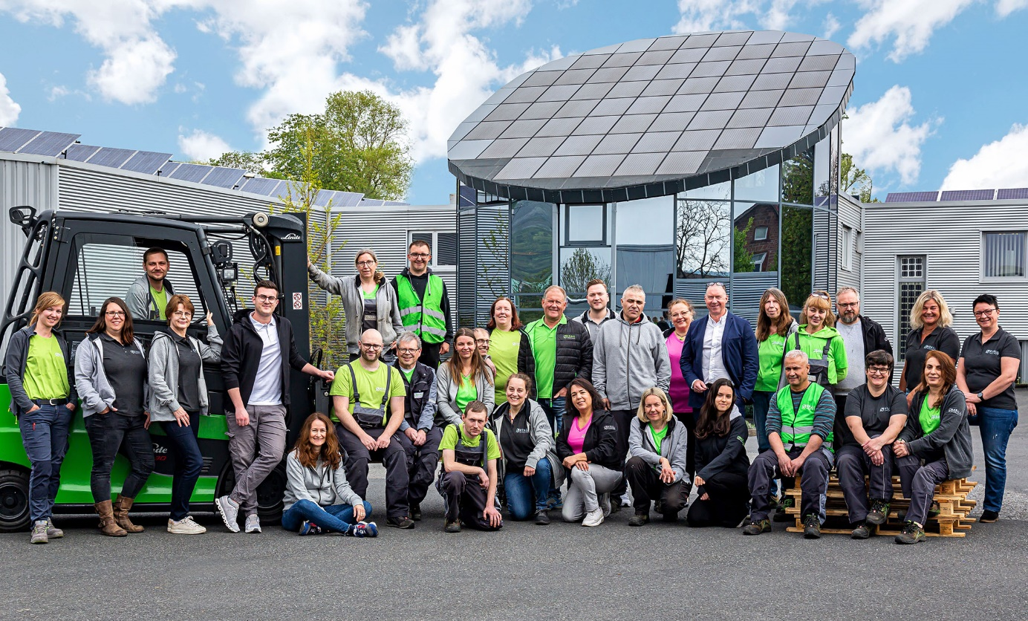
With about forty committed, well-trained employees and thirty years of experience, Krall Kunststoff-Recycling turns industrial and post-consumer waste into type-sorted regrinds: Sought-after raw materials for the manufacture of new, high-quality products. © Krall Kunststoff-Recycling
Elsenfeld, Germany, July 2022 – For three decades, sustainability has been the focus of the family-owned company Krall Kunststoff-Recycling in Elsenfeld am Main. Its history began with a small plant in early 1992, when “recycling” still was almost unheard of in public. Manufacturers and processors were offered the takeover of plastic residues for subsequent type-sorting and grinding. From the very beginning, executive director Markus Krall focussed on transparent plastic materials, mainly polycarbonate and PMMA, which constitute the core business still today. Further key aspects are engineering plastics and the recycling of CDs.
Today, the company comprises six workshops with a total floor area of 12,000 square meters. With about 40 employees, two shredding machines, and 10 chopping mills, the company will reprocess some 8,000 tonnes of plastic materials in the anniversary year, consequently working with environmentally friendly solar power. The type-sorted regrinds from Krall Kunststoff-Recycling are raw materials worldwide sought-for by processors who gladly return them into the materials cycle – for the direct manufacture of new products or as an ingredient of compounds.
Krall provides the complete infrastructure, including space-saving collection bins and logistics, for around 800 manufacturing, retail and commercial collection points across Europe. More than 15,000 load carriers from Krall are in circulation, including boxes in many different sizes and designs, ideally matched for the respective needs, ensuring a smooth collection procedure. Also, Krall accepts all common box systems up to large containers, and beyond that even offers the possibility to unload walking-floor trucks.
With Robot Technology and Artificial Intelligence to the Future
The continuous success is a motivation for Markus Krall and his son Louis, meanwhile management member with statutory authority, to make their company future-proof: “The market for high-quality recyclates is growing rapidly. Increasing amounts require manual sorting to be supplemented by powerful automation processes. The use of robots and artificial intelligence will be helpful. Our excellent international market position enables us to promote the development of state-of-the-art technologies up to practicability. In cooperation with institutes, we perform feasibility studies and invest in new systems to create the prerequisites to meet tomorrow's market requirements.”

Further information:  Markus Krall, Managing Director  Krall Kunststoff-Recycling GmbH  Glanzstoffstr. 21  D-63820 Elsenfeld am Main  Tel.: +49.6022.7099-0  markus.krall@krall.de  https://kunststoff-recycling.de | Editorial contact voucher copies:  Dr. Jörg Wolters  Konsens PR GmbH & Co. KG  Im Kühlen Grund 10  D-64823 Groß-Umstadt  Tel.: +49.6078.9363-13  joerg.wolters@konsens.de  www.konsens.de
This press release information as a docx-file and the photo in printable resolution can be downloaded from https://www.konsens.de/pressemitteilungen/krall-kunststoff-recycling-gmbh

