Succession settled:
Louis Krall appointed to the management board of Krall Kunststoff-Recycling
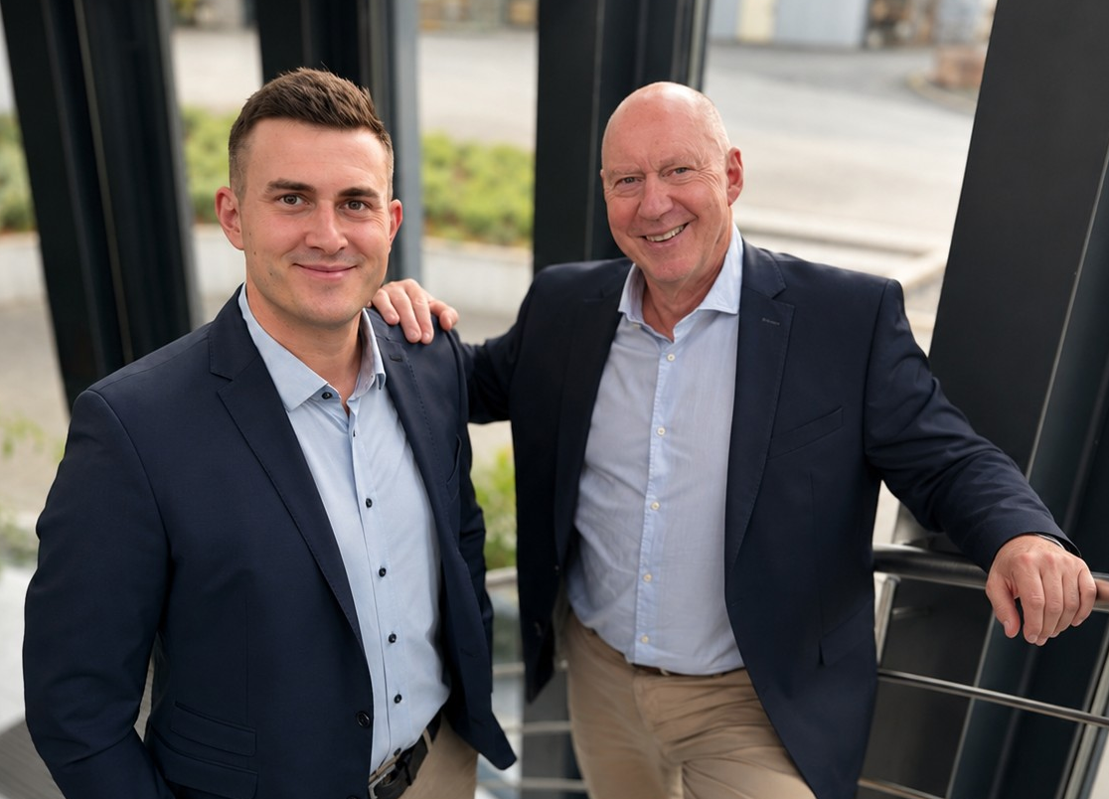
Louis Krall (left) and his father Markus Krall (right) now share the management of Krall Kunststoff-Recycling GmbH. © Krall
Elsenfeld am Main, Germany, September 2026 – Louis Krall has been appointed to the management board of Krall Kunststoff-Recycling GmbH with effect from 1 July. Alongside his father, company founder Markus Krall, he will now lead the family business.
Louis Krall will particularly be responsible for sales, procurement and customer development. Meanwhile, Markus Krall will continue to focus on automating operational processes and developing the company's strategy. This new management team is setting the company on a successful course for generational succession and sustainable growth.
Louis Krall, born in 1995, joined the company in 2018 after completing his commercial apprenticeship, initially gaining experience in the sales team. In 2020, he was appointed Sales Manager and was granted power of attorney in 2021. Since early 2025, he has also held the position of authorised signatory at the subsidiary Polymer Solutions GmbH.
Markus Krall commented: “My son Louis’s appointment to the management board of Krall Kunststoff-Recycling marks an important milestone in the company’s successful history. He has been involved in its development for eight years now, five of which as an authorised signatory. I am delighted that this step has been possible, as it secures the succession. His experience, his commitment and his in-depth knowledge of our processes provide the best possible foundation for leading the group of companies into a promising future.”
Louis Krall adds: “My dual role as Managing Director of Krall Kunststoff-Recycling and authorised signatory of our subsidiary Polymer Solutions opens up excellent opportunities for me. I intend to seize these opportunities to foster collaboration within the group, establish forward-looking synergies, and introduce innovative recycling solutions that deliver tangible value to our customers.”
Krall Kunststoff-Recycling is a family-run business founded in early 1992 and has been a reliable partner to the industry ever since. State-of-the-art technology enables the company to process plastics by type and produce high-quality secondary raw materials, which are then fed back into industrial production processes. The focus is on transparent plastics such as polycarbonate and PMMA. Other key areas include engineering plastics and the recycling of CDs. Relying entirely on solar power, the company currently operates across six halls with a usable floor area of 12,000 square metres. With a workforce of around 40 people, two shredders and 10 granulators, the company achieves an annual throughput of approximately 8,000 tonnes of plastic.
Polymer Solutions is a leading company in the plastics recycling sector. Also based in Elsenfeld am Main, it specialises in the production of regranulates and compounds. Combining many years of experience with state-of-the-art technology, the company delivers bespoke solutions for customers across a range of industries.
Further Informationen:  Markus Krall, Managing Director  Krall Kunststoff-Recycling GmbH  Glanzstoffstraße 21  D-63820 Elsenfeld am Main  Phone: +49.6022.70990  info@krall.de, https://krall.de | Editorial Contact and please send voucher copies to:  Dr. Jörg Wolters,  Konsens PR GmbH & Co. KG  Hans-Böckler-Str. 20, D-63811 Stockstadt  Phone: +49.6027.99005-13  joerg.wolters@konsens.de, ww.konsens.de
Please find this press release for download at https://www.konsens.de/pressemitteilungen/krall-kunststoff-recycling-gmbh

