PRESS RELEASE Contact: ITW Test & Measurement Italia S.r.l.
Instron CEAST Division
Erica Deserti
Marketing Communications
Via Airauda, I-10044 Pianezza (TO)
Tel.: +39 011 9685502 erica_deserti@instron.com
New melt index testers save time and increase repeatability
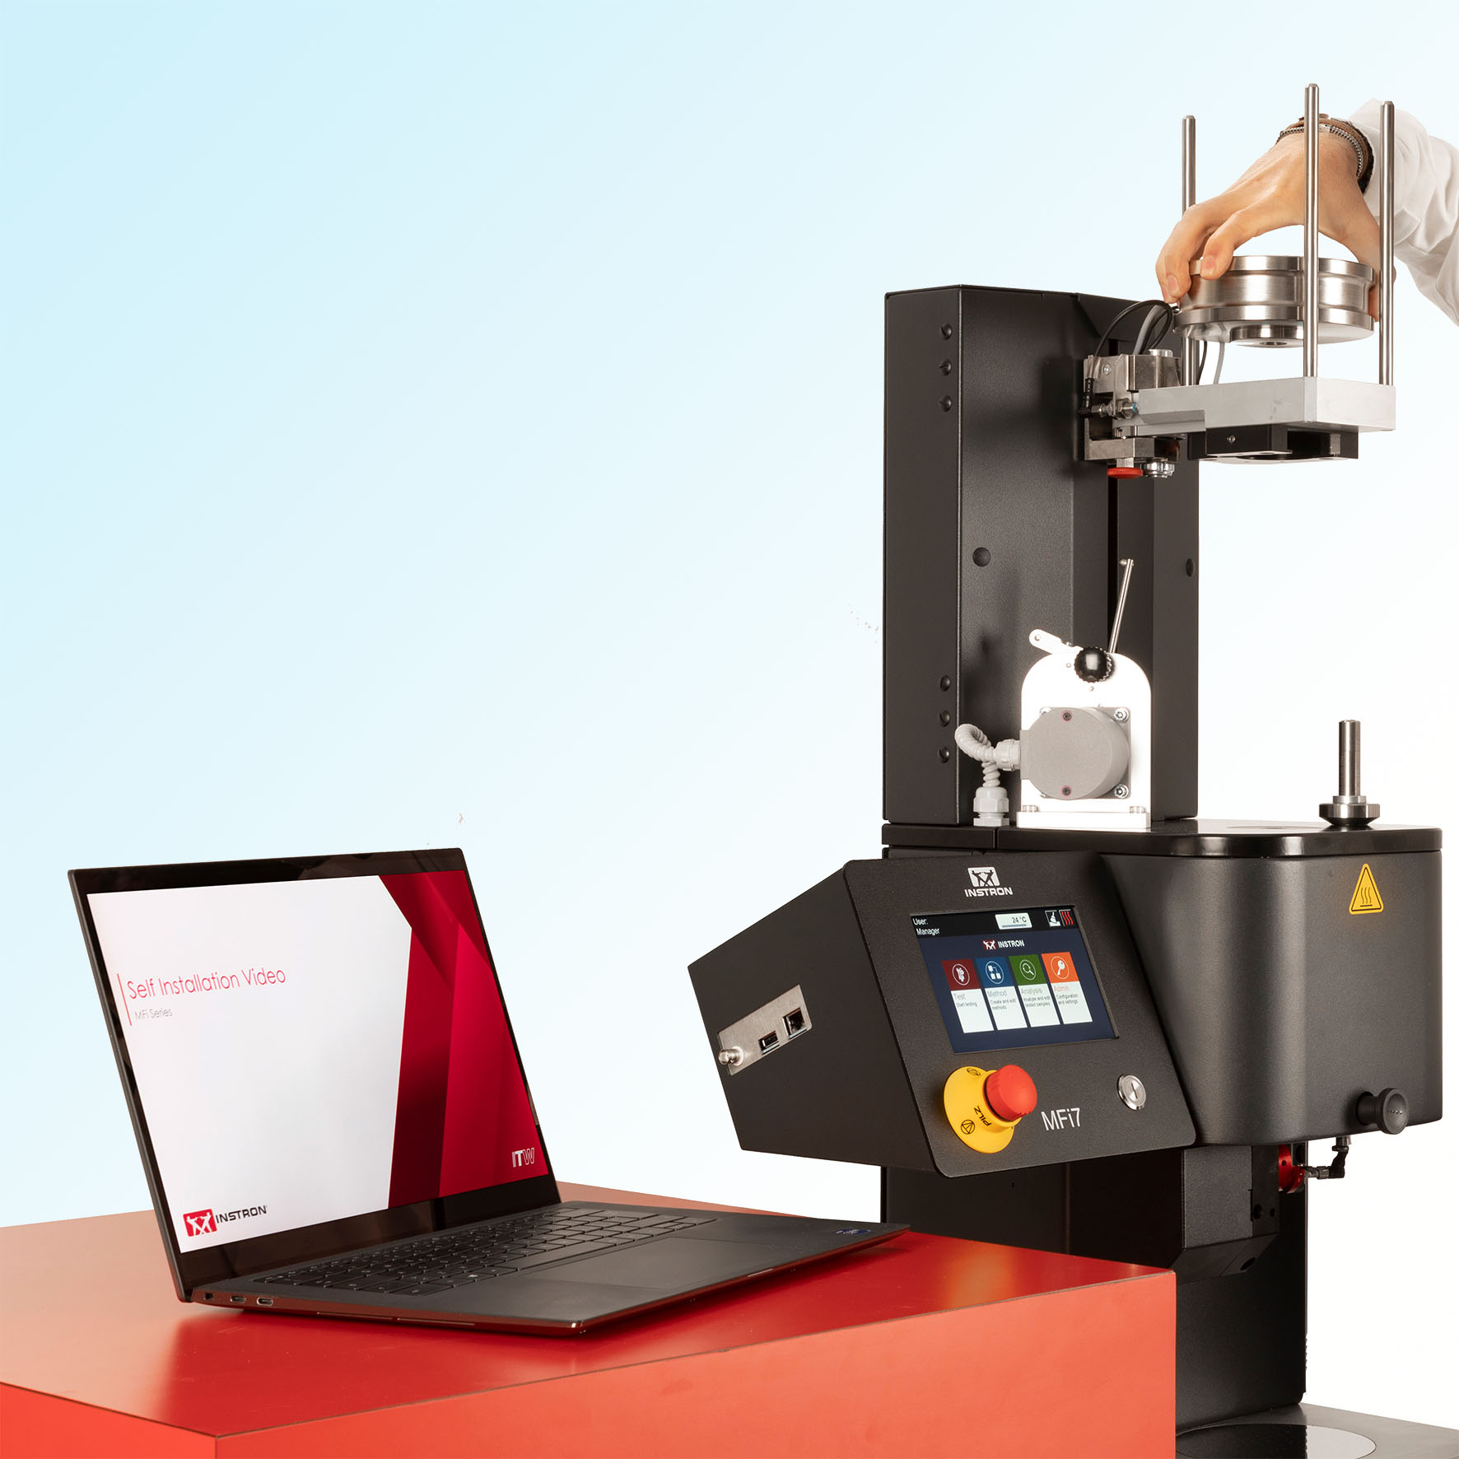
Instron's new MFi7 melt index tester during fast, software-assisted self-installation. © Instron
Pianezza (TO)/Italy, May 2023 – With the MFi5 and MFi7, Instron presents a new generation of melt index testers for a wide range of tasks, from monitoring incoming materials to product development and process control. The compact, manually operated MFi5 is ideal for fast and reliable measurements thanks to preset methods, while the modular MFi7 can be flexibly adapted to accommodate an increasing volume of testing. Both are suitable for test temperatures from 50 °C to 450 °C and are equipped with test weights from 0.1 to 21.6 kg. A piston travel transducer resolution of 0.005 mm and a piston displacement accuracy of up to 0.02 mm enable particularly accurate measurements. They thus cover the entire range of requirements for standard melt index tests in accordance with ISO 1133 and ASTM D1238, Methods A, B and C. Each System is operated via a 7" capacitive color touchscreen.
Optional equipment for MFi5 and MFi7 includes a motor-driven cutting device for precise, repeatable separation of the extrudate by time (with 0.01 s accuracy) or position. Also optional are automatic automatic die plug opening, special pistons for high flow materials with very high MFR (1600 g/10 min and more), and the use of particularly corrosion- and wear-resistant steels for cylinders, pistons, and dies.
Shortened test cycles with high operational reliability
As an additional standard feature of the MFi7, a motorized lifting device handles the automatic, operator-independent application of test masses for more accurate, repeatable and reliable test results. An easily removable die retainer facilitates cleaning so that testing can be quickly resumed. An automatic material compaction system operates at constant pressure, also providing added accuracy and repeatability. Automated purging and cylinder cleaning allow effortless, rapid emptying of materials remaining in the cylinder after testing is complete. Load-cell controlled compaction and emptying phases avoid operator influences and can thus further boost laboratory efficiency and the consistency of test results. Time-consuming cleaning operations are eliminated at the end of each test. Options for the MFi7 include a manual mass selector for added operator safety and a safety cover that prevents unintentional access to the machine's test areas.
Three inputs via the user interface of the control panel are sufficient to create test methods quickly and easily. User permissions can be set up individually. Test results are displayed in the form of real-time graphs. Live help offered on each screen reduces the amount of training required for new operators, and it helps avoid costly errors during testing.
Convenient with Bluehill® Melt software
The MFi series is supported by Instron's Bluehill® Melt software. Equipped with easy-to-understand icons and workflows, it simplifies user training and test setup. Test methods can be deployed to any number of recipients, multiple measurement systems can be managed over a wired network, and reports can be generated, saved and exported automatically.
Fast from idea to commissioning, service 24/7
Application-specific optimal melt index measuring devices can be put together with the help of an online, interactive and intuitive configurator. Once the order is placed, Instron uses its smart inventory management and efficient production processes to realize short delivery times. In the test lab, videos then explain the measures for self-installation and immediate commissioning of the system.
To ensure productivity, reduce risk and minimize downtime, support teams are available around the clock to answer technical questions. A team of more than 300 service technicians helps Instron customers worldwide on-site to resolve issues. This is helped by the InSkill app as an AI-driven support tool that can be used, among other things, to submit support requests and view the calibration certificates and service history of the specific system.
METHOD A (ISO 1133-1/-2*, ASTM D1238), a procedure widely used for basic quality control, is a mass measurement method that requires the operator to weigh portions of the extruded material at precise time intervals. The Melt Mass-Flow Rate (MFR) result is obtained directly by dividing the extrudate mass by the corresponding extrusion time. The standards recommend this method for MFR in the range of 0.15 - 50 g/10 min.
METHOD B (ISO 1133-1/-2*, ASTM D1238), the most common procedure for melt index measurements, is a volumetric method where the instrument uses a piston displacement transducer (encoder) and a synchronized timing device to perform a semi-automatic test. The instrument calculates the melt volume flow rate (MVR) and multiplies it by the melt density, resulting in a MFR value. The melt density value can either be known in advance or calculated by the instrument based on the extrudate mass.
METHOD C (ASTM D1238) is a variation of Method B and applies to high-flow materials (e.g., MFR of 50 g/10 min or more). It requires a different die geometry ("half die") and a tamping device to prevent excessive leakage of the material before measurements begin. The use of half die is also provided by ISO as an option in procedures A and B.
Instron is a leading global manufacturer of materials and component testing systems used to test a wide variety of materials from soft body tissue to high strength materials to entire vehicles. Instron testing systems are used for tensile, compression & torsion testing, cyclic testing, fatigue testing, impact testing, multi-axial testing, rheological testing. Instron offers a wide range of solutions from a single source, complemented by local service and technical support. Instron's comprehensive service offering includes qualification support, calibration to international standards, machine relocation, employee training and preventive maintenance. Instron centers of excellence worldwide ensure that the highest standards of quality and customer satisfaction stand behind every Instron test system. Through participation in various ASTM and ISO committees, Instron gains insight into the latest developments and changes that are important to our customers.
– – – – –
Editorial contact and please send voucher copies to:
Dr.-Ing. Jörg Wolters, Konsens PR GmbH & Co. KG
New:
Hans-Böckler-Straße 20, D-63811 Stockstadt
Tel.: +49 (0) 6027 99005-13
mail@konsens.de, www.konsens.de
Dear colleagues, Instron press releases with text as well as images in printable resolution are available for download at: www.konsens.de/instron-CEAST.html

