Press release
Sustainable zipper sealing
At FachPack from 28 to 30 September in Nuremberg, Herrmann Ultraschall will be presenting the Zipper Seal Module ZSM, a modular system for continuously sealing zippers in plastic pouches, even those made from readily recyclable monomaterial. Innovative process control for longitudinal sealing processes will also be on show.
Resealable packaging, in particular made from sustainable packaging materials, is becoming increasingly popular. Herrmann Ultraschall has now developed a module that makes the advantages of ultrasonic sealing usable for monomaterials and paper-based materials for stand-up and tubular pouches with an integrated zipper. The Zipper Seal Module ZSM takes up little space, is hygienic and delivers consistent sealing results, even at varying processing speeds.
This is made possible by an optimized combination of an ultrasonic generator and the ZSM. The ULTRAPACK generator used is specifically designed for high-speed packaging applications and enables reproducible control of the weld process. This means that the system can be adjusted to new material properties in a matter of seconds.
Finally, the Zipper Seal Module ZSM enables a continuous sealing process with two sonotrodes arranged opposite each other. The material to be welded is passed between the two sonotrodes, which heat and fuse the material. Stopping and restarting is not necessary, but possible if required. The system can be run at variable speeds, so increasing manufacturing flexibility. Because the heat is generated only directly in the seam, the process is particularly gentle on the packaging material and allows continuous sealing of zippers in sustainable packaging made of monomaterial and paper composites.
No material adheres to the sonotrodes during the weld process, so, in contrast to other welding processes, there is usually no need for cleaning. Nevertheless, for highest hygienic standards the system allows easy access for cleaning. The ZSM is compact and can also be integrated into existing systems.
ThermoControl protects sensitive material
Another innovation that Herrmann Ultraschall is premiering at FachPack is the new ThermoControl process control system. ThermoControl very precisely monitors the temperature of the material during welding and adjusts the weld process to stay within the specified process window. Particularly the processing of sensitive monomaterials in longitudinal seam processes becomes even more controllable and thus easier with ThermoControl. As a result, recyclable monomaterials can be put to even more versatile use in continuous packaging applications.
Visitors to FachPack will be able to see ZSM and ThermoControl demonstrated live at Herrmann Ultraschall’s booth 1-211 in Hall 1.

Image material:
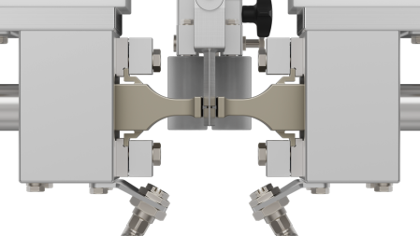
Image caption: The Zipper Seal Module ZSM continuously seals zippers into monomaterial pouch packaging. The film is passed between the two sonotrodes and gently welded. Photo: Herrmann Ultraschall
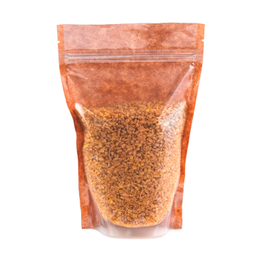
Image caption: ZSM means the advantages of ultrasonic welding can also be used for resealable monomaterial stand-up pouches. Photo: Herrmann Ultraschall

Further information:  Herrmann Ultraschalltechnik GmbH & Co. KG  Steffen Ullrich  Descostraße 3-11  D-76307 Karlsbad  Tel.: +49 (0) 7248 79-0  info@herrmannultraschall.com  www.herrmannultraschall.com | Editorial contact and voucher copies:  Konsens PR GmbH & Co. KG  Philipp Lubos  Im Kühlen Grund 10  D-64823 Groß-Umstadt  Tel.: +49 (0) 60 78/93 63-0, Fax: -20  mail@konsens.de  www.konsens.de
This press release (.doc file) and the images in print-ready resolution can be downloaded from:
https://www.konsens.de/en/press-releases/herrmann-ultraschalltechnik

About Herrmann Ultraschall
Herrmann Ultraschall is a world leader in ultrasonic welding with six decades’ expertise. Based in Karlsbad, Baden, Germany, the company was founded in 1961 and has become a performance leader by innovating and delivering expert solutions in all fields of ultrasonic welding technology for plastics, packaging, nonwovens and metals. Today, Herrmann Ultraschall has 600 employees worldwide and maintains Tech-Centers in 20 countries. Each year, Herrmann supplies solutions for around 2,000 different applications in key-industries such as automotive, medical, hygiene and foodstuffs. Its sophisticated machines and systems meet all the requirements of modern, digitalized production and can usually also be integrated into existing production environments.
Ultrasonic technology is one of the fastest ways of joining plastics and nonferrous metals, uses no consumables, needs little energy and enables a high level of process reliability. This makes the technology very resource-efficient. The technology requires knowledge of mechanics, acoustics, electronics, software and material behavior and is applied in a wide variety of industries.

