Press release

Hellweg expands production capacity
Shredding technology manufacturer builds new production shop in Roetgen
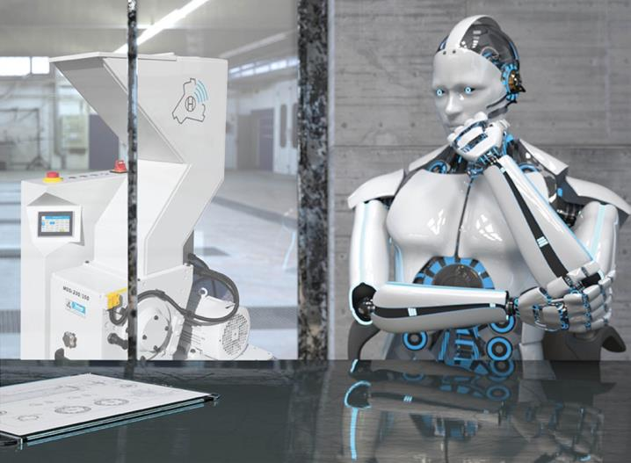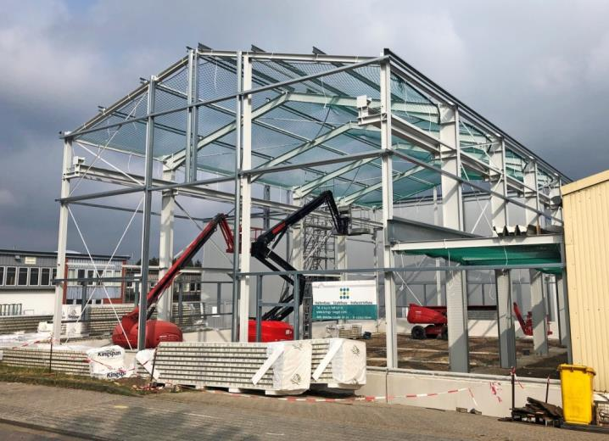
The new production shop boosts capacity and creates space for building large machinery which is completely assembled and tested in Roetgen.
© Hellweg Maschinenbau GmbH & Co. KG, Roetgen
Roetgen, June 2020 – Granulator specialist Hellweg Maschinenbau GmbH & Co. KG is building a new production shop at its Roetgen headquarters in the Eifel region of Germany. The investment will provide around 500 m² of additional manufacturing space by August 2020. With a height of some 11 m, there will be enough space for assembling even large systems. In addition to expanding its production facilities, Hellweg is also planning a substantial expansion of its administrative offices in the coming months.
As managing director Mark Hellweg says, "We urgently need the extra space to accelerate handling of the large volume of orders which we have won since K2019 where our Smart Control machine controller was a major hit. We have also been seeing a trend toward large and complex machines. In future, we will be able to assemble and test these in our own facilities and so ensure trouble-free commissioning on our customers' premises."
Despite the coronavirus crisis, Hellweg's economic future looks very rosy. "2019 saw us achieve the highest sales figures in the company's history", explains Hellweg. "So expansion had already been on the cards for some time. Of course, the pace of development has slackened off during lockdown, but if things continue at their present level we will be able to celebrate record results at the end of this year too."
Hellweg Maschinenbau GmbH & Co. KG manufactures machinery and systems, in particular also for custom applications, for customers in the plastics and recycling industry worldwide. Its product range includes beside-the-machine granulators, blade granulators, edge strip shredders, edge strip feeders, film cutters, and dust extraction and removal systems including accessories.
Further information
Hellweg Maschinenbau GmbH & Co. KG
Contact: Mark Hellweg, managing director
Vennstraße 10, 52159 Roetgen, Germany
Tel. +49 (0) 24 71 / 42 54, Fax +49 (0) 24 71 / 16 30
info@hellweg-maschinenbau.de, www.hellweg-maschinenbau.de
Editorial contact and voucher copies:
Philipp Lubos, Konsens PR GmbH & Co. KG,
Im Kühlen Grund 10, D-64823 Groß-Umstadt – www.konsens.de
Tel.: +49 (0) 60 78 / 93 63 - 0, Fax: - 20, Email: mail@konsens.de
Press releases from Hellweg including text and pictures in print-ready resolution can be downloaded from: https://www.konsens.de/hellweg

