Press Release
Hellweg at K2019:
Granulators with new digital control system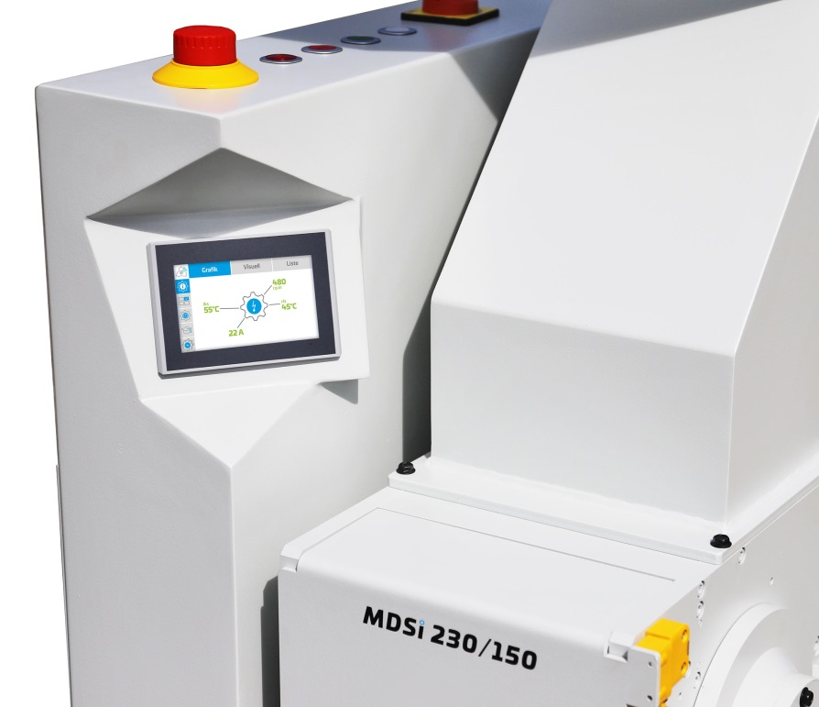
New MDSi digital Smart Control version of the established MDS 150.
© Hellweg Maschinenbau GmbH & Co. KG, Roetgen
Roetgen/Germany, October 2019. At K 2019, Hellweg will be showing its granulators with their new digital Smart Control system. This enables networked communication of the machines with upstream and downstream components, as well as with operators, in line with Industry 4.0 “Internet of the Things” (IoT) principles. The new system measures and stores power consumption as well as, for example, rotational speed and bearing temperatures and monitors the service life of bearings, blades, screens and the wedge-profile drive belts (V-belts). This new Smart Control system is available for all Hellweg granulators from the 150 series upwards.
Monitoring of mechanical mill components means conclusions can be drawn about expected maintenance dates in order to avoid unplanned production down-time, while possible faults and damage can be detected at an early stage. A visual alarm informs the operator of the need to replace a part due to wear. An active V-belt monitoring system automatically switches off the granulator in the event of a deviation from the nominal value. Smart Control also includes an automated enquiry system that issues requests for quotations for spare parts such as blades, screens and V-belts directly from the manufacturer.
The new “boost operation” option enables a short-term increase in grinding performance, in order to compensate for production-related fluctuations. In addition, certain rotational speed ranges have been defined for various plastics, thanks to which, for example, low melt-temperature granulation can be performed continuously without problems arising, so that water-cooling is not required.
Optimized energy efficiency
Power consumption recording allows conclusions to be drawn about the specific energy input when grinding certain plastics to defined grain sizes. Smart Control evaluates measured power consumption over extended periods of time. The operator can use a digital ammeter in real-time operation and access detailed statistics that have been compiled over long-term operation. Granulation process efficiency can be assessed by comparison with stored reference values, and, if necessary, optimized.
Standardized soft starting of the motor and a new motor brake make the granulators energy saving and safe. Power consumption can also be reduced with the new “eco” operating mode, as this adapts rotational speed to input quantity.
Detailed instructions
Detailed, user-friendly “step by step” instructions are available, for example for changing blades, maintaining V-belts and cleaning the granulator quickly and efficiently. The instructions also explain checking the V-belt pre-tensioning force, which can be carried out with a test device included within the scope of delivery. while further instructions are provided for carrying out the recommended visual inspection.
Hellweg Maschinenbau has specialized in the development and production of shredding machinery for the plastics industry – especially in granulators/cutting mills. The standard range of machines covers mobile machine-side mills, slow-running and central granulators/grinders in different sizes as well as complete fully automated recycling lines. Hellweg Maschinenbau also develops solutions according to specific customer requirements.
Further Information
Hellweg Maschinenbau GmbH & Co. KG
Contact: Mark Hellweg, Managing Director
Vennstraße 10, 52159 Roetgen/Germany
Phone +49 24 71 / 42 54, Fax +49 24 71 / 16 30
info@hellweg-maschinenbau.de, www.hellweg-maschinenbau.de
Editorial contact and please send voucher copies to:
Dr.-Ing. Jörg Wolters, Konsens PR GmbH & Co. KG,
Hans-Kudlich-Straße 25, D-64823 Groß-Umstadt – www.konsens.de
Phone +49 (0) 60 78 / 93 63 - 0, mail@konsens.de
Press releases from Hellweg including text and print-ready images are available for download from www.konsens.de/hellweg.html

