Smart Plastics Shredding
Hellweg Awarded Top Innovator 2023
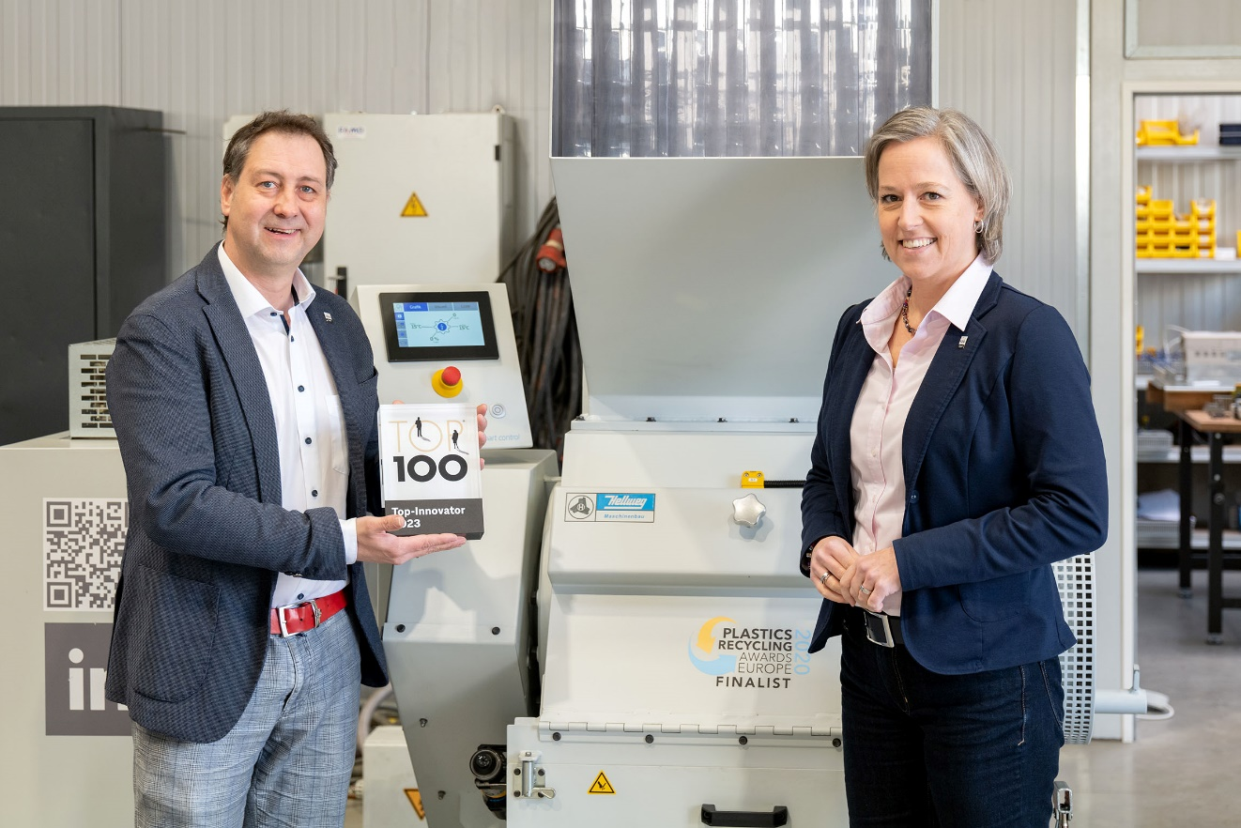
Hellweg’s culture of innovation has borne much fruit, including Smart Control, the digital control system for plastics shredders. The TOP 100 2023 seal of approval underscores the company’s future-oriented focus. left: Mark Hellweg, Managing Director, right: Susanne Hellweg © Hellweg Maschinenbau
Roetgen, Germany, February 2023. compamedia has awarded Hellweg Maschinenbau, the manufacturer of high-quality shredders digitally controlled by Smart Control for efficient plastics recycling, the TOP 100 2023 seal of approval as a particularly innovative medium-sized company. The award was made following a science-based selection procedure, in which innovation researcher Prof. Dr. Nikolaus Franke of the Vienna University of Economics and Business and his team compared the applicants’ innovative strengths. Particular attention was paid in this procedure to the systematic planning of realized projects as a criterion for future repeatability.
In the course of the selection procedure, Hellweg had to address the issues of how important innovation is as a corporate goal and whether it is capable of creatively questioning existing thinking and successfully implementing new ideas on the market. The assessment was made on the basis of more than 100 criteria in five categories. A comparison was made of the extent to which management encourages innovation in the company, whether employees have the freedom to develop their own ideas, for example, how workflows and innovation processes are organized, how collaboration with partners and customers works, and whether there are concrete market successes or increased numbers of patent applications.
As managing director Mark Hellweg says, “Our work in recent years has focused, and will continue to focus, on applying the possibilities of artificial intelligence to plastics recycling and, in particular, to granulating production waste. Our digital Smart Control system paves the way to greater energy efficiency in granulators, extended service life of all system components, and ultimately increased process sustainability. At the same time, regrinds and granules of higher, more uniform, quality are obtained. The fact that we, a comparatively small medium-sized company, are now numbered in the illustrious ranks of TOP 100 innovators with up to 50 employees is a great honor and a huge incentive to continue on our path.”
The digital Smart Control system is now available for all sizes of Hellweg granulators, starting from the 150 series machine-side granulators for small parts and sprues right up to the heavy-duty 600 series designed for the toughest applications. Parameters detected by the control system include not only power consumption, motor speed and bearing temperatures but also the state of blades, screens and V belts.
As Sven Kamerar, Head of Corporate Communications at compamedia explains, “TOP 100 companies are the pacesetters in their industries, achieving great things with sometimes inconspicuous innovations. Companies from the manufacturing sector are represented as well as service providers. Global market leaders can be found alongside companies that are on their way to the top, especially in future-oriented industries. Many of these ‘unknown masters’ as yet have no public profile.”
The award will be presented at the German SME Summit on June 23 in Augsburg by Ranga Yogeshwar, science journalist and TOP 100 mentor.
The Competition
Since 1993, compamedia has been awarding the TOP 100 seal of approval to medium-sized companies which have demonstrated particular innovative strength and above-average success in innovation. Since 2002, the scientific direction has been in the hands of Prof. Dr. Nikolaus Franke, who as founder and director of the Institute for Entrepreneurship & Innovation at the Vienna University of Economics and Business is a leading innovation researcher. Project partners are the Fraunhofer-Gesellschaft zur Förderung der angewandten Forschung e.V. and BVMW, the German association for small and medium-sized enterprises. manager magazine, impulse and ZEIT für Unternehmer back the company comparison as media partners. www.top100.de.
Hellweg Maschinenbau GmbH & Co. KG,
founded as a family business in 1985, is now managed by the second generation of the family. The company manufactures machinery and systems, including many custom designs, for the global plastics and recycling industry in its own production facilities. The product range includes laboratory granulators, machine-side granulators, toothed roll granulators, central granulators, lump granulators, punched skeleton granulators and film & edge strip granulators, edge strip feeders, film cutters as well as dust extraction and removal systems including accessories. Robustly constructed, Hellweg granulators are synonymous with advanced technology and meet the most stringent quality requirements – and all with a well-balanced price-performance ratio.
Further Information
Hellweg Maschinenbau GmbH & Co. KG
Contact: Mark Hellweg, managing director
Vennstraße 10, 52159 Roetgen, Germany
Tel. +49 (0) 24 71 / 42 54, Fax +49 (0) 24 71 / 16 30
info@hellweg-maschinenbau.de, www.hellweg-maschinenbau.de
Editorial Contact and Voucher Copies:
Dr.-Ing. Jörg Wolters, Konsens PR GmbH & Co. KG,
Im Kühlen Grund 10, D-64823 Groß-Umstadt – www.konsens.de
Tel.: +49 (0) 60 78 / 93 63 - 13, Fax: - 20, Email: mail@konsens.de
Press releases from Hellweg including text and pictures in printable resolution can be downloaded from: https://www.konsens.de/hellweg

