Press Release
Granulators deliver on their promises:
Challenging materials successfully tested
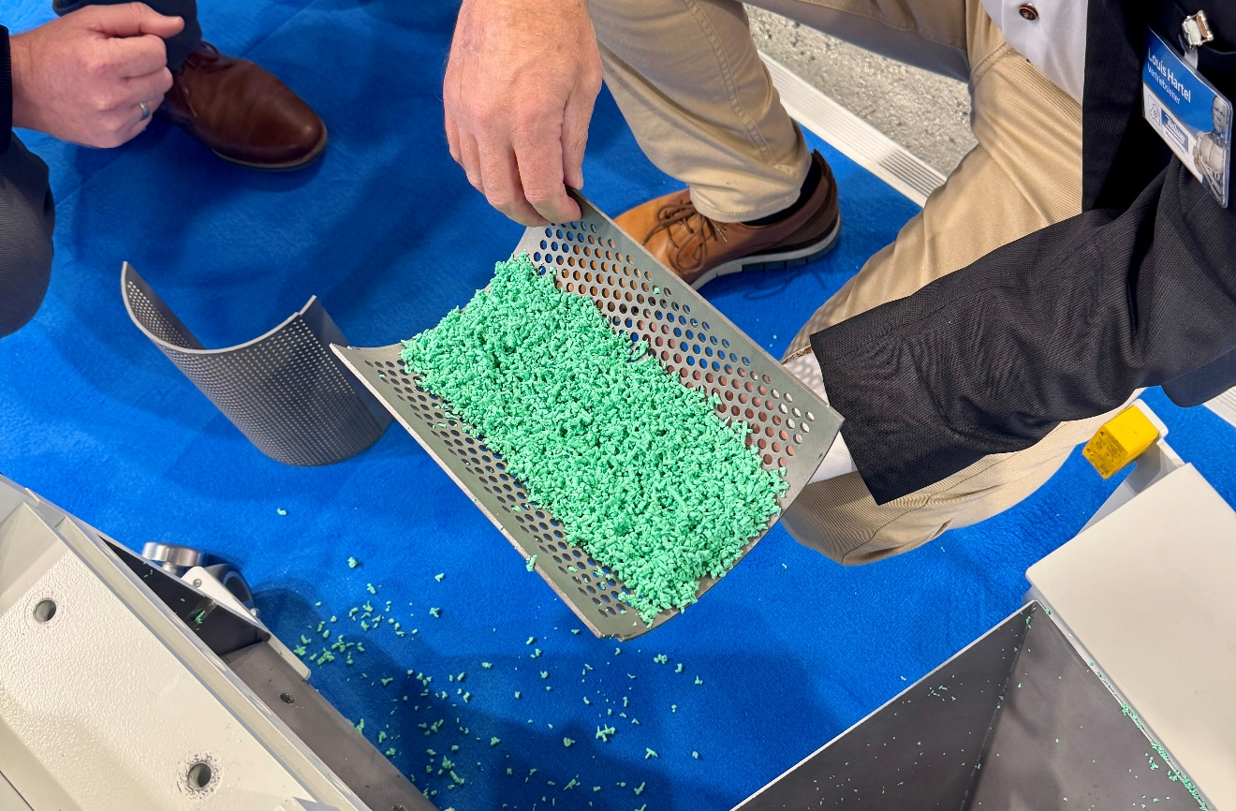
Sprues made from ultra-elastic TPE following a perfectly successful ad hoc grinding trial at Fakuma 2026. © Hellweg Maschinenbau
Roetgen/Germany, October 2026. At Fakuma 2026, Mark Hellweg, Managing Director of Hellweg Maschinenbau, had made an unusual offer to visitors at short notice: “From numerous trials in our technical centre and our experience with our customers’ materials, we know that our granulators can handle (almost) any challenge,” he said. “Anyone who would like to see this for themselves is invited to bring samples of their ‘problematic’ material to our stand to test them.”
The positive response, despite the very short lead time, highlights the importance of the topic. The result is indeed impressive. “By the end of the trade fair, the score was 8–0 in favour of our mills!” Hellweg summarises. Eight visitors to the stand had brought material that they considered difficult to granulate and were eager to see how it would fare in the milling process. On eight occasions, the material disappeared into the hopper of the fully operational MDSi 230/150 mill within seconds. Immediately afterwards, it collected in a tray, each time forming uniformly granulates with a particle size of 2 mm. This even worked with particularly elastic TPE. The team received a soft NBR rubber compound only after the trade fair had closed. This could also be shredded without any problems – no pre-treatment, no addition of release agents, no additional, energy-intensive cooling. Score: 9–0!
Hellweg knows why: “The key lies in our consistent use of genuine shear cutting to treat the feed material. All interested parties were able to take home an ideal, homogeneous ground material with a narrow particle size distribution, a minimal proportion of fine particles and a uniform, smooth-edged geometry, regardless of whether it was TPE, EPS, rubber, nylon or even foam. Our shear-cut granulators handled all tasks with ease.” For Hellweg, it goes without saying that such trials can also be offered at any time in Roetgen.
Prospects look brightening
Following a slow start to the current financial year – typical for this industry – Mark Hellweg is sensing an upturn following Fakuma. His takeaway from the trade fair: “After investment decisions were put on hold for months, companies are starting to invest again. We are seeing rising demand for energy-efficient granulators and smart monitoring systems that help reduce downtime and operating costs. And our order intake gives us reason to hope that, despite the weak start, we will at least be able to maintain 2025’s turnover.” For 2027, he anticipates that the combination of deferred investments and growing demand could support a recovery.
Hellweg Maschinenbau GmbH & Co. KG, founded as a family business in 1985, is now managed by the second generation of the family. The company manufactures machinery and systems, including many custom designs, for the global plastics and recycling industry in its own production facilities. The product range includes laboratory grinders, machine-side grinders, toothed roll grinders, central grinders, lump grinders, punched skeleton grinders and film & edge strip grinders, edge strip feeders, film cutters as well as dust extraction and removal systems including accessories. Robustly constructed, Hellweg grinders are synonymous with advanced technology and meet the most stringent quality requirements – and all with a well-balanced price-performance ratio.
Further information
Hellweg Maschinenbau GmbH & Co. KG
Contact: Mark Hellweg, Managing Director
Vennstraße 10, 52159 Roetgen, Germany
Tel. +49 (0) 24 71 / 42 54, Fax +49 (0) 24 71 / 16 30
info@hellweg-maschinenbau.de, www.hellweg-maschinenbau.de
Editorial contact and please send voucher copies to:
Dr.-Ing. Jörg Wolters, Konsens PR GmbH & Co. KG,
Hans-Böckler-Straße 20, D-63811 Stockstadt am Main – www.konsens.de
Tel.: +49 (0) 60 27 / 99 00 5-13, Email: mail@konsens.de
Press releases from Hellweg including text and pictures in print-ready resolution can be downloaded from: https://www.konsens.de/hellweg

