Press Release
Hellweg invites to try it out at the Fakuma stand:
A perfect cut, even with soft plastics
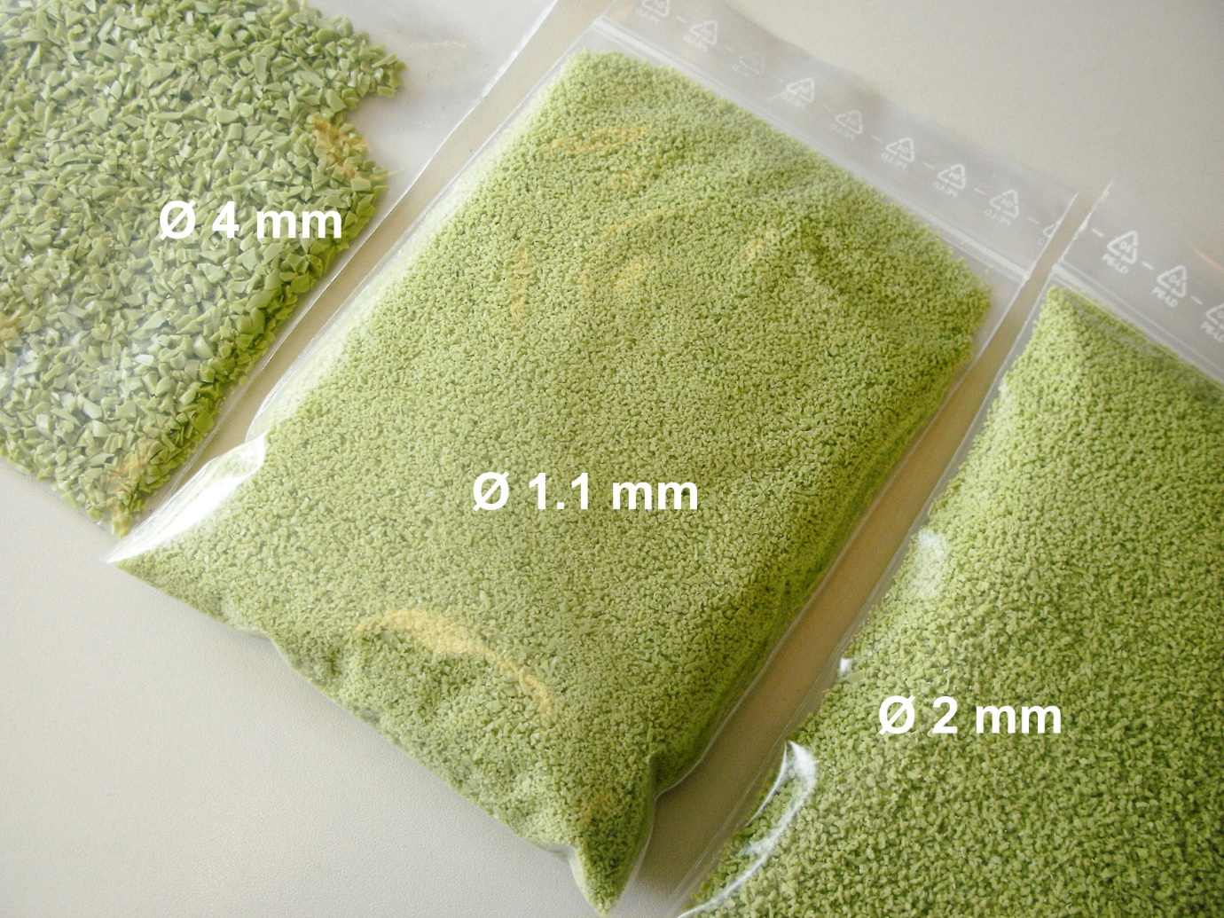
Visitors to the Hellweg Maschinenbau stand can trial their own challenging plastics on granulators with working widths of 230 mm and 600 mm, respectively.© Hellweg Maschinenbau
Roetgen/Germany, September 2026.
At Fakuma 2026, Hellweg Maschinenbau will give visitors the opportunity to experience grinding plastics that are generally considered particularly challenging in this respect, using their own samples. Two fully functional granulators with working widths of 230 mm and 600 mm respectively will be available at stand A1-1005 to demonstrate their performance even under difficult conditions. The expanded range of ground materials on display, including films, high-performance plastics and technical fibres, demonstrates the ganulators' virtually unlimited range of applications.
The key to this versatility lies in Hellweg's consistent use of the genuine scissor-cutting process to cleanly separate the feed material. The result is a perfect, homogeneous ground product with a minimal proportion of fine particles, a narrow particle size distribution ranging from 1 to 50 mm and a uniform, smooth-edged geometry, which is ideally suited to the subsequent recycling stages. This applies even to soft TPE grades, which do not require any additional, energy-consuming cooling of the material or the ganulator.
Managing Director Mark Hellweg comments: “Extensive testing in our in-house technical centre, coupled with practical experience with customers' materials, has shown us that we can rise to any challenge. Anyone who would like to see this for themselves is invited to bring samples of their 'problematic' material to our stand.” While registration is not required, it can be arranged via Louis Hartel (l.hartel@hellweg-maschinenbau.de).
Further expansion of digitalisation
All Hellweg ganulators can be fitted with the Smart Control system, which monitors parameters such as power consumption, motor speed and bearing temperatures. Operating hour counters are used to record and analyse the service life of blades, screens and V-belts. Furthermore, Smart Control can continuously optimise the ratio between motor load and throughput. Extensions to this modular system will be on display at Fakuma 2026. These include the online measurement of the flow rate using microwaves, which was first unveiled at K 2025, to determine grinding output performance over time. There will also be a vibration measurement feature, which provides information on the machine’s condition, making its debut at Fakuma 2026.
Hellweg Maschinenbau GmbH & Co. KG, founded as a family business in 1985, is now managed by the second generation of the family. The company manufactures machinery and systems, including many custom designs, for the global plastics and recycling industry in its own production facilities. The product range includes laboratory grinders, machine-side grinders, toothed roll grinders, central grinders, lump grinders, punched skeleton grinders and film & edge strip grinders, edge strip feeders, film cutters as well as dust extraction and removal systems including accessories. Robustly constructed, Hellweg grinders are synonymous with advanced technology and meet the most stringent quality requirements – and all with a well-balanced price-performance ratio.
Further information
Hellweg Maschinenbau GmbH & Co. KG
Contact: Mark Hellweg, Managing Director
Vennstraße 10, 52159 Roetgen, Germany
Tel. +49 (0) 24 71 / 42 54, Fax +49 (0) 24 71 / 16 30
info@hellweg-maschinenbau.de, www.hellweg-maschinenbau.de
Editorial contact and please send voucher copies to:
Dr.-Ing. Jörg Wolters, Konsens PR GmbH & Co. KG,
Hans-Böckler-Straße 20, D-63811 Stockstadt am Main – www.konsens.de
Tel.: +49 (0) 60 27 / 99 00 5-13, Email: mail@konsens.de
Press releases from Hellweg including text and pictures in print-ready resolution can be downloaded from: https://www.konsens.de/hellweg

