Press Release
The Smart Family continues to grow:
Vibrations provide information on the granulator’s condition
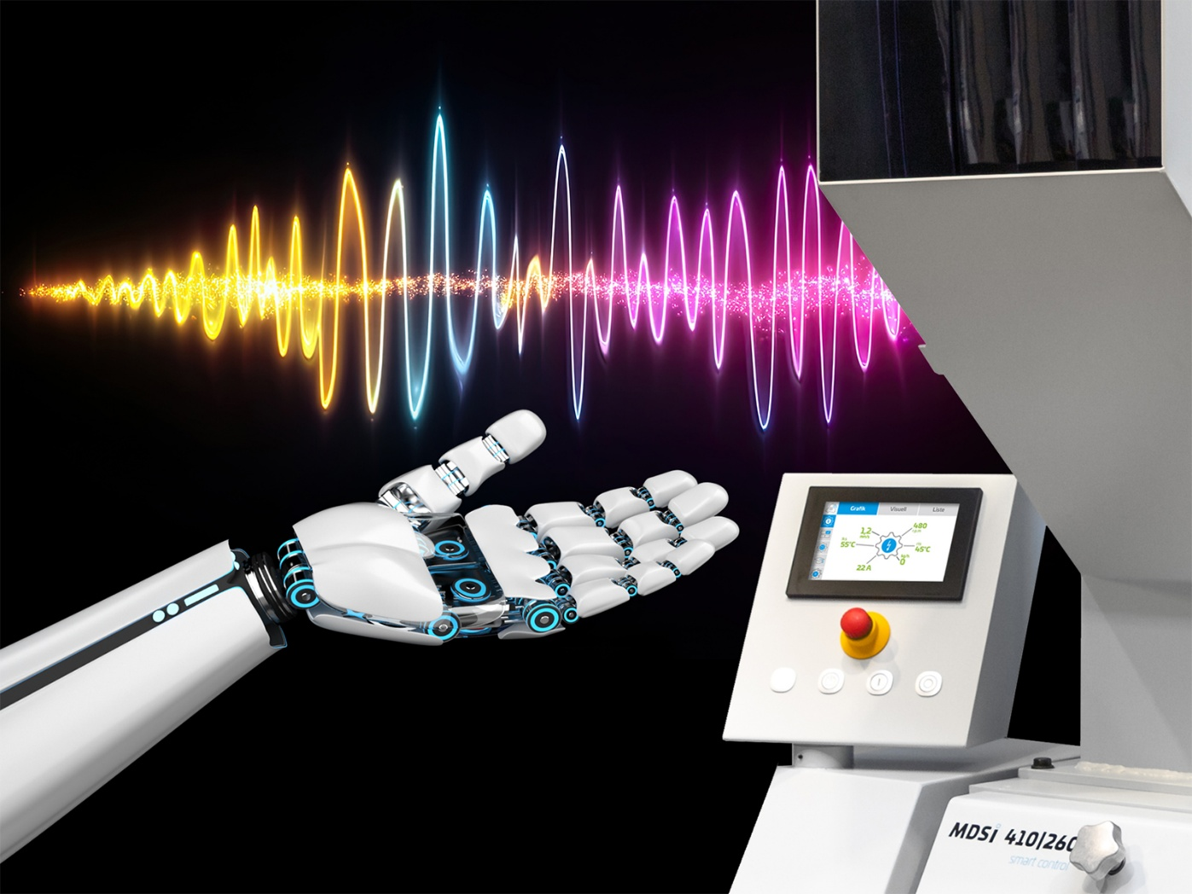
Vibrations, continuously recorded by Hellweg’s new Smart Cut Guard module, provide insights into the condition of the machine. © Hellweg Maschinenbau
Roetgen/Germany, October 2026.
At Fakuma 2026, Hellweg Maschinenbau will present the new Smart Cut Guard module as an optional add-on for the Smart Control system of its granulators at Stand A1-1005. Vibrations, emitted by the respective machine, are detected by a sensitive transducer and then processed. Analysis of the results provides an early warning of potential problems before they become apparent in any other way. For instance, users will receive alerts about faulty bearings or blunt blades long before they cause more serious damage. Depending on the results, maintenance intervals can be extended and necessary repairs scheduled in good time.
For local use, Smart Cut Guard can be integrated into the Smart Control system. Alternatively, an additional module can be used to automatically upload data to a cloud service to which Hellweg has exclusive access. In the event of an alarm, Hellweg can then contact its customers immediately. This option is particularly recommended for mills that need to process large quantities of material around the clock.
Managing Director Mark Hellweg comments: “Vibrations are detrimental to machines that operate with cutting tools or blades. Our mills are renowned for their virtually vibration-free operation, as they are heavily built and, for example, fitted with rotors machined from a single block of material. This increases the flywheel mass and reduces vibration to virtually zero, enabling us to detect irregularities caused by vibrations at an early stage. Thus, users can plan necessary maintenance for times when it will incur the least effort, long before any damage leads to additional costs.”
Four smart modules make granulating smarter, more efficient and easier to plan
The Smart Control system can be fitted to all Hellweg granulators. It monitors the entire process and intelligently regulates output according to actual demand. The latest addition is the Smart Cut Guard vibration measurement module, which detects defects at an early stage. At Fakuma 2026, Hellweg will also present the Smart Sonic module, which uses ultrasound to measure the material flow and enable feed rates to be tailored to actual requirements. Another highlight is the Smart Flow module, which was first unveiled at K 2025 and is installed in the riser pipe of the extraction system. There, it uses a microwave sensor to contactless measure the flow of bulk material, providing a clear picture of the actual output.
Mark Hellweg sums it up: 'With our Smart Control system and the three add-on modules — Smart Cut Guard, Smart Sonic and Smart Flow — the collection of individual measurement values gradually evolves into an intelligent, comprehensive system designed to boost energy efficiency and throughput, minimise maintenance, and maximise process reliability. Furthermore, the Hellweg Smart Family will continue to grow.”
Hellweg Maschinenbau GmbH & Co. KG, founded as a family business in 1985, is now managed by the second generation of the family. The company manufactures machinery and systems, including many custom designs, for the global plastics and recycling industry in its own production facilities. The product range includes laboratory grinders, machine-side grinders, toothed roll grinders, central grinders, lump grinders, punched skeleton grinders and film & edge strip grinders, edge strip feeders, film cutters as well as dust extraction and removal systems including accessories. Robustly constructed, Hellweg grinders are synonymous with advanced technology and meet the most stringent quality requirements – and all with a well-balanced price-performance ratio.
Further information
Hellweg Maschinenbau GmbH & Co. KG
Contact: Mark Hellweg, Managing Director
Vennstraße 10, 52159 Roetgen, Germany
Tel. +49 (0) 24 71 / 42 54, Fax +49 (0) 24 71 / 16 30
info@hellweg-maschinenbau.de, www.hellweg-maschinenbau.de
Editorial contact and please send voucher copies to:
Dr.-Ing. Jörg Wolters, Konsens PR GmbH & Co. KG,
Hans-Böckler-Straße 20, D-63811 Stockstadt am Main – www.konsens.de
Tel.: +49 (0) 60 27 / 99 00 5-13, Email: mail@konsens.de
Press releases from Hellweg including text and pictures in print-ready resolution can be downloaded from: https://www.konsens.de/hellweg

