Press Release
Hot runner technology for the automotive industry:
Minimizing secondary operations in injection molding
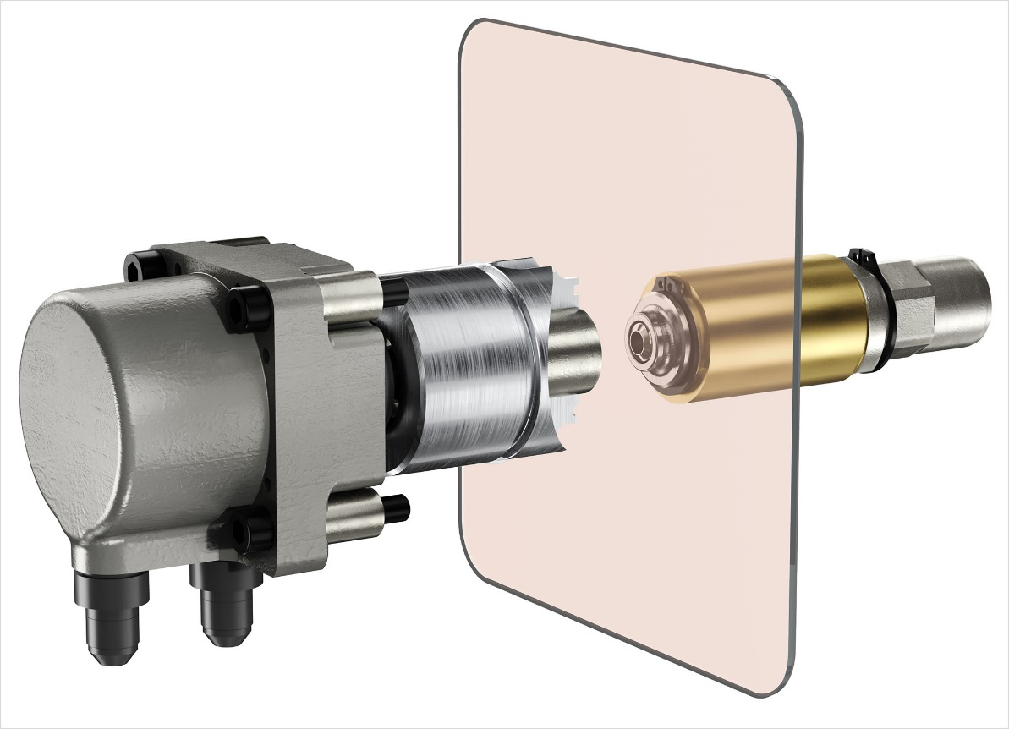
GLOW HRS technology: a compact solution for high-quality parts with direct injection, eliminating halos. © Oerlikon HRSflow
San Polo di Piave/Italy, November 2025 – At K 2025 Oerlikon HRSflow presented two innovative developments from its range of solutions for the automotive industry: the new GLOW HRS technology and advanced solutions for the low-stress back-injection of films in the production of large parts with high-quality surfaces, significantly reducing costly post-processing.
No halos. Even with direct injection.
Oerlikon HRSflow's new GLOW HRS technology is a compact solution for direct injection molding of high-quality parts that prevents halos and enables superior surface aesthetics. Precise control of the surface temperature minimizes the need for post-molding rework and reduces energy consumption, contributing to a more sustainable process. Easy to install and with no impact on cycle time, GLOW HRS technology ensures consistently high productivity. From hoods and tailgates to roofs and smart panels, the system adapts seamlessly to a wide range of automotive applications. To further support customers, Oerlikon HRSflow opens its R&D Test Lab, offering the opportunity to test the technology even with the most challenging polymers.
Achieving premium automotive parts directly from the mold
Using an automotive wheel arch as an example, Oerlikon HRSflow demonstrated the production of paint-free automotive parts using servo-controlled FLEXflow HRS® needle valve technology at Haitian International Germany's K 2025 booth. The electrical system features three drops from the Ma nozzle series and is integrated into an Inevo reverse mold with a vacuum insert. FLEXflow HRS® thus enabled precise, low-stress back-injection of recyclable PP onto a decorative PP film insert from DNP Group, which was placed directly in the mold.
The result is a flawless, fully decorated surface that eliminates the need for downstream operations such as transfer, painting, or trimming. The parts leave the mold ready for installation, while their mono-material structure ensures easy recycling without additional reworking. The automotive wheel arch also offers high scratch resistance for long-lasting durability. Moreover, the simple exchange of decorative films allows quick, flexible, and resource-efficient color changes, minimizing waste.
About Oerlikon HRSflow
Oerlikon HRSflow, part of the listed Swiss Oerlikon Group, operates worldwide with over 1,000 employees and develops, produces and distributes innovative hot runner and control systems for plastic injection molding.
Thanks to its many years of experience, Oerlikon HRSflow implements sophisticated and advanced injection molding solutions. The company has been growing for years in a wide range of sectors, from automotive, logistics and environmental, domestic appliances, mobility, houseware and gardening, technical applications, medical, beverage and home, thin wall packaging, beauty and personal care markets. The product range of the group's sister company, Oerlikon Balzers, has been expanded to include special coatings.
A global network of three identically structured and networked plants (Italy-HQ/San Polo di Piave; China/Hangzhou and USA/Byron Center) and over 50 subsidiaries with expert teams that support our customers at the highest technical level enable us to respond quickly to high-demand markets. Thanks to the plants, targeted, customer-specific products can be manufactured with short lead times.
For further information: www.hrsflow.com
For further information, please contact:
Chiara Montagner  Marketing & Communication Manager  Oerlikon HRSflow  Tel: +39 0422 750 127  chiara.montagner@oerlikon.com  www.oerlikon.com/hrsflow | Erica Gaggiato  Marketing & Communication Specialist  Oerlikon HRSflow  Tel: +39 0422 750 120  erica.gaggiato@oerlikon.com  www.oerlikon.com/hrsflow
Editorial contact and please send voucher copies to:
Dr.-Ing. Jörg Wolters
Konsens PR GmbH & Co. KG
Hans-Böckler-Str. 20, D-63811 Stockstadt, Germany
Tel: +49 6027 99005 13
mail@konsens.de www.konsens.de
Please find text and image for download at https://www.konsens.de/hrsflow

