Media Release
Hall A2
Stand A2-2217
Oerlikon HRSflow at Fakuma 2021:
New S Series for small applications and reduced pitch
San Polo di Piave/Italy and Friedrichshafen/Germany, 12 October 2021 – At Fakuma 2021 the hot runner manufacturer Oerlikon HRSflow will present the S-series, a new cylinder and nozzle range for small applications.
In early 2021, Oerlikon HRSflow has launched a new patent-pending hot runner system series for small applications. This S-Series is mainly suitable for engineering plastics and offers a compact solution for a reduced pitch.
Depending on the application, the new S-series can be equipped with Sa, Tp and Sp nozzles from Oerlikon HRSflow. The Sa series is a screwed-in hot runner system, while the Tp and Sp series are face-to-face products with different inner bore sizes.
Designed for injection moulding of technical and electronic components, the Sa Series offers a compact solution for the production of automotive parts such as exterior emblems, small interior switches, sound system knobs or tiny components in air-conditioning systems.
At the other end of the scale, the TP and SP series are ideal solutions for multi-cavity applications (up to 30 g). Beyond injection moulded parts for engineering and electronics, they are also suitable for houseware and consumer goods as well as packaging applications. The minimum nozzle spacing is 29 mm and 22 mm respectively.
Based on extensive laboratory research into heat distribution, the new S series ensures optimum sealing with an optimal temperature profile along the entire nozzle. In addition, the optimisation of the channel geometry enables fast colour changes.
In the valve gate version, the S series is equipped with a compact cylinder. Thanks to its compactness, the plate thickness can be reduced and its downsized width allows a minimum nozzle pitch of 37 mm. In its basic version the cylinder has a height of 62 mm, the adjustable version, which allows for optimal positioning of the pin, is 70 mm high.
At Fakuma 2021, Oerlikon HRSflow will showcase various applications of its S Series for reduced pitch. These include the "Hydration Reminder" made of PP for drinking vessels. Attached to bottles, glasses or cups, the system simply and easily registers every sip. The new S-series allows two of the main requirements for the production of the tracing device to be met: a low part weight with a thickness of only 1 mm as well as a fast colour change.
About Oerlikon HRSflow
Oerlikon HRSflow (www.hrsflow.com), part of the Swiss technology group Oerlikon and its Polymer Processing Solutions Division, is based in San Polo di Piave/Italy and specializes in the development and production of advanced and innovative hot runner systems for the injection molding industry. The business unit employs about 1,000 people and is present in all major global markets. Oerlikon HRSflow manufactures hot runner systems at its European headquarters in San Polo di Piave, Italy, its Asian headquarters in Hangzhou, China, and its Byron Center facility near Grand Rapids, MI, USA.
Your contact at Fakuma
Grit Reifer
Marketing Manager Oerlikon HRSflow D-A-CH
HRSflow GmbH, Frankfurt/M.
Mobile: +49 160 7407058
Grit.reifer@oerlikon.com
www.oerlikon.com/hrsflow
For further information, please contact:
Chiara Montagner  Marketing & Communication Manager  Oerlikon HRSflow  Tel: +39 0422 750 127  Fax: +39 0422 750 303  chiara.montagner@oerlikon.com  www.oerlikon.com/hrsflow | Erica Gaggiato  Marketing & Communication Specialist  Oerlikon HRSflow  Tel: +39 0422 750 120  Fax: +39 0422 750 303  erica.gaggiato@oerlikon.com  www.oerlikon.com/hrsflow
Please send voucher copies to:
Dr.-Ing. Jörg Wolters
Konsens PR GmbH & Co. KG
Im Kühlen Grund 10, D-64823 Groß-Umstadt, Germany
Tel: +49 6078 9363 0,
mail@konsens.de
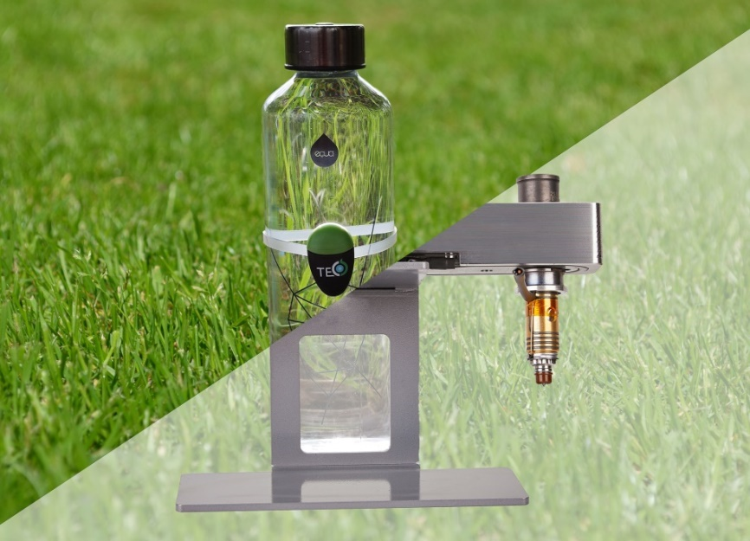
Typical applications of Oerlikon HRSflow’s new S Series hot runner line include small technical parts such as the housing for a smart Hydration Reminder. ©Tecos/Oerlikon HRSflow
Please find the text and the image of this press release for downloading at https://www.konsens.de/hrsflow

