Media Release
Hall A2
Stand A2-2217
Oerlikon HRSflow at Fakuma 2021:
Family moulds with FLEXflow Evo hot runner technology enable significant cost savings
San Polo di Piave/Italy and Friedrichshafen/Germany, 12 October 2021 -- At Fakuma 2021, Oerlikon HRSflow will be using the example of a family mould for the one-shot production of three very different-sized, high-quality door module parts for automotive interiors to demonstrate how FLEXflow Evo technology can enable cost savings without compromising moulded part quality.
Family moulds for injection moulding several plastic parts in one shot reduce production costs compared to separate production of the individual components. One challenge is their often very different volumes and geometries. When using conventional sequential injection moulding systems, small cavities are often overfilled, while large ones are not completely filled.
In contrast, FLEXflow Evo servo-driven valve gate technology enables precise control of the mould filling process because it allows the stroke and force for each individual nozzle to be precisely controlled during the opening and closing phases. This makes it possible to overcome previously existing limitations and fill all cavities simultaneously without the risk of overfilling, underfilling or flash formation, even with large weight differences between individual parts. The combination of family mould and FLEXflow Evo technology reduces the production costs of moulded parts by up to 30 %, reduces the number of moulds required and thus their set-up costs, and increases plant utilisation.
Oerlikon HRSflow will be demonstrating this at Fakuma using the example of a 3-cavity family mould for three modules of a car door inner lining with weights of 53, 352 and 613 g and wall thicknesses between 2.3 and 3 mm. FLEXflow Evo provides individual control of the servo-electric drives for all eight hot runner valve gates used in this application. This allows the force and stroke of each valve gate to be sensitively regulated to optimise the appropriate pressures, flow rates and volumes of melt in all three cavities. The result is low-distortion, defect-free parts with finely grained surfaces.
About Oerlikon HRSflow
Oerlikon HRSflow (www.hrsflow.com), part of the Swiss technology group Oerlikon and its Polymer Processing Solutions Division, is based in San Polo di Piave/Italy and specializes in the development and production of advanced and innovative hot runner systems for the injection molding industry. The business unit employs about 1,000 people and is present in all major global markets. Oerlikon HRSflow manufactures hot runner systems at its European headquarters in San Polo di Piave, Italy, its Asian headquarters in Hangzhou, China, and its Byron Center facility near Grand Rapids, MI, USA.
Your contact at Fakuma
Grit Reifer
Marketing Manager Oerlikon HRSflow D-A-CH
HRSflow GmbH, Frankfurt/M.
Mobile: +49 160 7407058
Grit.reifer@oerlikon.com
www.oerlikon.com/hrsflow
For further information, please contact:
Chiara Montagner  Marketing & Communication Manager  Oerlikon HRSflow  Tel: +39 0422 750 127  Fax: +39 0422 750 303  chiara.montagner@oerlikon.com  www.oerlikon.com/hrsflow | Erica Gaggiato  Marketing & Communication Specialist  Oerlikon HRSflow  Tel: +39 0422 750 120  Fax: +39 0422 750 303  erica.gaggiato@oerlikon.com  www.oerlikon.com/hrsflow
Please send voucher copies to:
Dr.-Ing. Jörg Wolters
Konsens PR GmbH & Co. KG
Im Kühlen Grund 10, D-64823 Groß-Umstadt, Germany
Tel: +49 6078 9363 0,
mail@konsens.de
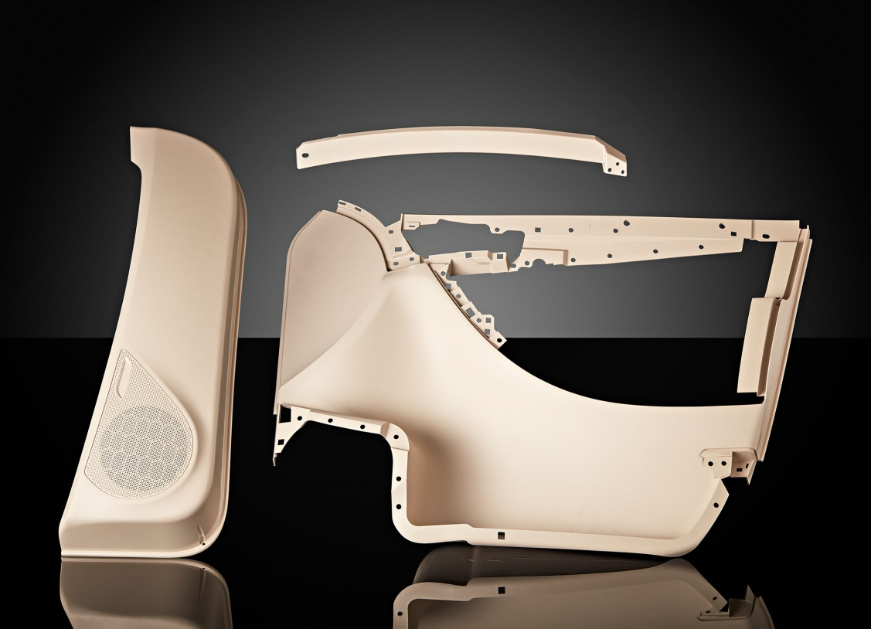
At Fakuma, Oerlikon HRSflow will be demonstrating the advantages of using FLEXflow Evo valve gate technology in family moulds by means of a 3-cavity mould for different sized components of a car door interior trim. © Oerlikon HRSflow
Please find the text and the image of this press release for downloading at https://www.konsens.de/hrsflow

